Programming Project

bishop challoner catholic college - 20027| Candidate Number: 6053

Jumping man

Tyreese Green

2022

Table of Contents

3.1. Analysis of the problem 2

3.1.1 Problem identification 2

3.1.2 Stakeholders 3

3.1.3 Research the problem 3

Interview 1 plan 3

Interview 1 script 3

Interview 1 Review 5

Interview 2 Plan 8

Interview 2 Script 9

Interview 2 Review 10

Software requirements 11

Hardware requirements 11

3.1.4 Specify the proposed solution 11

Thinking abstractly 11

Thinking ahead 12

Thinking procedurally 12

Thinking logically 12

Conclusion 12

Success criteria 13

3.2 Design of the solution 14

3.2.1 Decompose the problem 14

Diagram 14

3.2.2 Describe the solution 15

Playing the game 15

Main menu 16

End game 17

3.2.3 Describe the approach to testing 18

Algorithms 18

Usability features 38

Variables and data structures 43

Test data 48

Acceptance testing 51

3.3 Developing the solution 54

3.3.1 Iterative development process 54

1. Creating the window 54

2. Creating the player and adding movement 56

3. Adding a background and text which displayed the users perfomance. 59

4. Adding platforms 62

6. Scrolling 70

7. Adding UI 75

8. Adding powerups 92

9. Adding sound 102

3.4 Evaluation 115

3.4.1 Testing to inform evaluation 115

Main menu 115

Playing the game 115

End game 117

Usability features 118

3.4.2 Success of the solution 125

Main menu 125

Playing the game 125

End game screen 126

3.4.3 Describe the final product 127

3.4.4 Maintenance and development 127

Maintenance 127

Limitations 127

Full code: 129

# 3.1. Analysis of the problem

## 3.1.1 Problem identification

I have decided to make a game because games appeal to many people in the world. It will be inspired by games similar to “Doodle Jump”. This game will have similar controls to Doodle Jump and a similar style.

This game will work by having an endless level where platforms fall down and the player has to jump onto it or they will fall and lose, their score will be saved and added to a leader board. The score will increase from the time the player has survived and coins picked up along the way.

When the user opens the game, there will be a menu where they can choose to play the game, open an options menu and to quit.

## 3.1.2 Stakeholders

This project would be recommended to be played by 6-18 year olds. The game will be controlled using A and D for horizontal movement and the player will jump automatically.

An example of a stakeholder is Harley Nemeth; he is a 17-year-old who enjoys gaming and has lots of free time available so he can play the game during that time. Harley has also played the games, which this project will be inspired by so he will understand many of the features of the game.

## 3.1.3 Research the problem

### Interview 1 plan

This interview will give an idea of what will be necessary for the game and additional features, which will help, meet the needs and wants of the stakeholders. I will ask Harley Nemeth as he plays many games so he would know some necessary features that a game needs.

Questions:

Are visuals and sounds important?

* Would you like the environment of the level to change, as you get further?
* How do sounds affect your experience?
* What type of style should the game have?
* Should there be animations?
* How does the quality of the visuals affect your experience?

What makes a game enjoyable?

* How could the player interact with the game?
* Does multiplayer make the game better, if so, why?
* How could the game be made to be more challenging?
* Should there be different levels, which vary?
* Are the controls important?

Are extra features important?

* Would you like a timer to be visible playing and why?
* How could the score indicate how good the player is doing?
* What other small features could be added to keep the player engaged?
* What additional options should there be, such as the ability to change brightness?
* How could a leader board be used?

### Interview 1 script

**Are visuals and sounds important?**

Would you like the environment of the level to change, as you get further?

Yes, it makes the game feel unique while playing so it is more enjoyable to play for longer periods. It also gives a sense of progression

How do sound affect your experience?

Sounds do affect the players experience because it keeps them engaged and makes the game feel better.

What type of style should the game have?

The game should have a simple style to ensure the game is accessible to all stakeholders.

Should there be simple animations

Yes, it keeps the game exciting as it makes it more visually pleasing.

How does the quality of visuals affect your experience?

The quality makes the game more appealing and keeps the players focused on the visuals.

**What makes a game enjoyable?**

How could the player interact with the game?

Players could interact by having enemies or objects to attack.

Does multiplayer make the game better, if so, why?

Yes, because being able to play with other people makes players’ experience much more enjoyable and it can make the game competitive as players could compete for a higher score.

How could the game be made to be more challenging?

The game could have different sized platforms to make it harder for the player to survive.

Should there be different levels, which vary?

The game should be an endless game as it lets players compete for a high score without a limit.

Are the controls important?

Yes, because they need to be easy to get used to, which allows players to play the game without it being hard to control which affects their overall experience.

**Are extra features important?**

Would you like a timer to be visible while playing and why?

Yes, because it could show the player how well they are doing, as the timer should be used in the calculation of the score.

How could the score indicate how good the player is doing?

The score could be decided by time survived, distance travelled, and collectibles picked up while playing.

What other small features could be added to keep the player engaged?

Power-ups such as a speed boost could make the game more exciting.

What additional options should there be, such as the ability to change brightness?

Toggle sounds, change the difficulty, change the volume, and change controls.

How could a leader board be used?

A leader board could be implemented by allowing a user to input their name after finishing and it is added to the leader board. The leader board could be accessed in the main menu

### Interview 1 Review

This interview was designed to get ideas from stakeholders, which could be used to help improve this project to make it appeal to stakeholders.

For visuals and sounds, each level should have a slightly different design to keep a unique feeling to the game while playing in free time. In addition, the style should be kept simple to appeal to the younger ages. To ensure the game does not become boring or repetitive, items such as coins can be picked up to increase score and power-ups such as jump boosts.

To keep the game enjoyable, the player will be able to destroy any obstacles, which are obstructing their path, which could make the player lose if they collide with the object. There will be some power ups that appear, which will help the player to progress quicker.

Finally, there will be additional simple features that stakeholders could be interested in such as the timer, leader boards and adjustable settings.

Research into Doodle Jump

Doodle jump is a mobile-based game where the objective is to get as far as possible without falling off. The player can encounter enemies along the way or obstacles, which could cause them to fail. The player can also attack these enemies to avoid them by tapping on the screen to shoot a bullet. On mobile, the user has to tilt their screen in order to move left or right. On PC versions, the user has to use arrow keys or A/D to move left or right.

Playing the game:

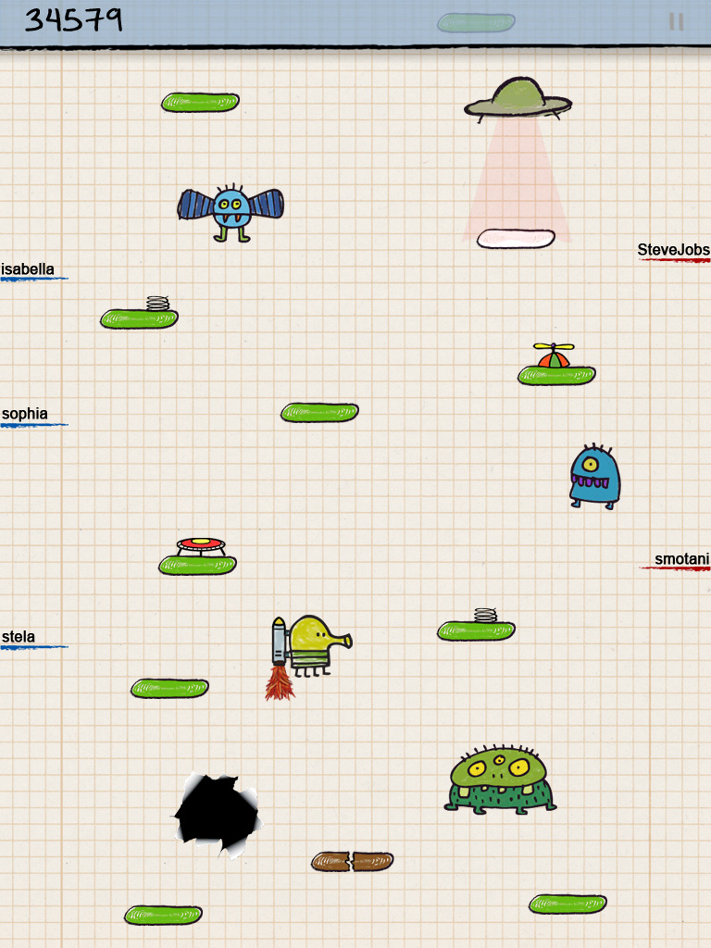

The player has to jump onto solid platforms to reach higher platforms

Pause button that can be used at any point while playing

Variety of different platforms, which makes the game more challenging as different platforms have different properties such as disappearing when touched.

Objects can cause the game to be over when the player makes contact

Enemies, which can cause the game to be over if the player makes contact

Different power-ups to assist the player

Shows other players’ score

Score displayed at the top of the screen. This is calculated from the distance travelled by the player

Game Over screen:

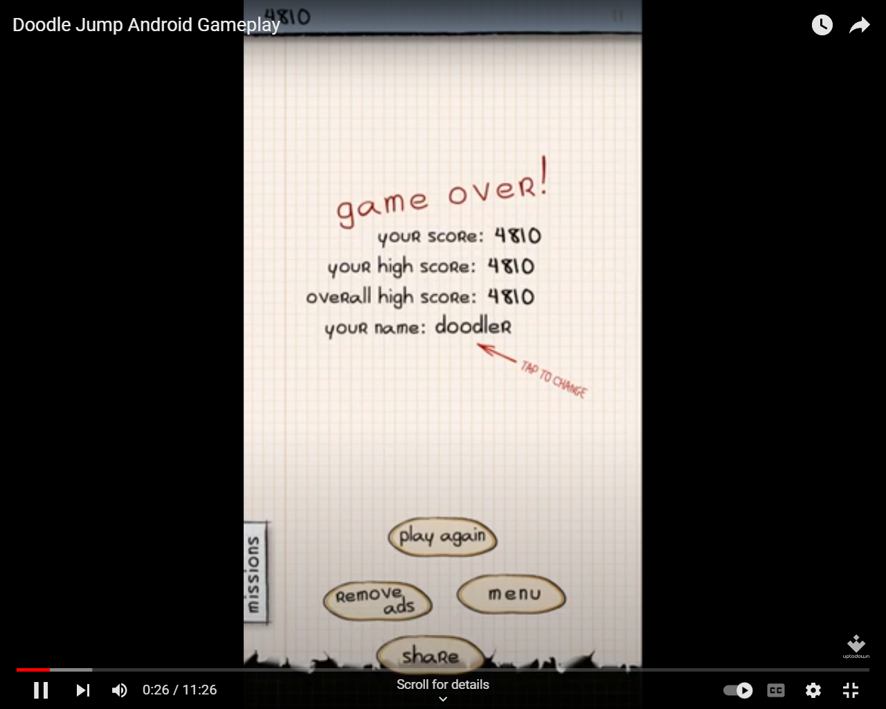

The user can change their name after each run, allowing different people to add their names to the leader board

The user can choose to play again or go to the menu

Displays the users current score and the overall highest score

### Interview 2 Plan

In this interview I aim to get an idea of specific requirements for the game from Harley Nemeth to help develop and improve ideas.

Questions:

Gameplay

1. Should there be a pause menu?
2. What type of power ups should there be?
3. What should be shown on the end game screen?
4. How often should power ups appear and how long should they last?
5. How else could the leaderboard be used while playing the game?

Sound and visuals

1. Should there be different animations for different actions such as jumping and falling?
2. When should sounds be played?
3. What type of background should the game have?
4. How should the users’ score be displayed while playing?
5. What should power-ups look like when they appear?

Scoring and difficulty

1. How could the game be made to be more difficult?
2. Should the user be able to view the leaderboard?
3. How could obstacles be used to make the game more difficult?
4. Should the number of platforms on screen change overtime?
5. Should there be different types of platforms to jump on?

### Interview 2 Script

Gameplay

Should there be a pause menu?

Yes, because this gives the user the option to take a break and by adding a pause menu, the user could adjust some settings similar to most pause menus in games.

What type of power ups should there be?

There should be power ups like jump boosts or immunities to any obstacles if there are any. There could also be negative power ups that give the player a disadvantage such as inverting controls.

What should be shown on the end game screen?

The user should be able to save their score to the leaderboard and be able to instantly replay the game.

How often should power ups appear and how long should they last?

Power-ups should spawn in around every 10 jumps and a power up such as a speed increase should last for about 10 seconds.

How else could the leaderboard be used while playing the game?

When you reach another players score on the leaderboard while in your current attempt, that persons score could appear on screen.

Sound and visuals

Should there be different animations for different actions such as jumping and falling?

Yes as this makes the game more visually appealing. However, there shouldn’t be too many as most of the time the user would miss animations for smaller actions such as an animation for collecting a coin.

When should sounds be played?

Sounds should be played when the user is in a menu such as the start or end screen. Also, sounds should be played when jumping on platforms and failing their current attempt.

What type of background should the game have?

The game should have a background that gives the effect that the player is moving up or that they have been going for a long time. For example, clouds could be in the background to give the effect that they are going into the sky.

How should the users score be displayed while playing?

The users score should be displayed at the top of the screen to give an indication of how well they are doing. This could be split into different components of the score by displaying distance, time and coins.

What should power-ups look like when they appear?

Power-ups should have a unique icon so the player knows which power up they are about to use if they make contact with it.

Scoring and difficulty

How could the game be made to be more difficult?

Negative power ups such as freezing the player or inverting controls could be used to make the game harder as players get further into the game.

Should the user be able to view the leaderboard?

The user should only be able to view the top scores on the leaderboard as they wouldn’t need to see lower scores and this could give the user an idea on how far they need to go to reach the leaderboard.

How could obstacles be used to make the game more difficult?

Obstacles could appear randomly to obstruct the player or end their current attempt if they make contact with the object.

Should the number of platforms on screen change overtime?

The number of platforms should start of high and should slowly decrease overtime to make the game more difficult as the user has to think quicker as they get further into the game.

Should there be different types of platforms to jump on?

Yes, there could be fake platforms that disappear when jumped on or platforms that move. This makes the game more interesting and platforms that negatively affect the player make the game more difficult.

### Interview 2 Review

The interview gave an idea of specific needs for the game. Gameplay could be improved by allowing the user to pause while playing. They also gave an idea on how power-ups could work if they get added. Finally, the leaderboard can be used within the game by showing when the users current attempt passes a previous score and allowing them to access it when they have ended their attempt.

Sound and visuals could be improved by adding animations for actions that happen often such as jumping. These animations can also be played with a sound to make the game more appealing. They also helped with the design of power ups as they suggested that each power up could be given a unique icon so the user can make a decision on if they want to collect it.

To make the game more difficult, some power ups could have a negative effect on the user and different platforms could appear to make the game more interesting and the number of platforms could decrease as the game progresses. It was also suggested that the user should be able to view the top scores to give them an idea on how far they need to go to try and beat that score.

### Software requirements

Software:

* Python 3.3 or higher with pygame installed
* OS - Windows 7 or higher

### Hardware requirements

|  |  |
| --- | --- |
| Hardware | Justification |
| Monitor | To display the game to the user |
| At least 2GB of RAM to run python | So the game and python can run smoothly |
| At least 500MB of storage | To install and run python and to store the assets and code for the game |
| Speakers | So the game can play audio such as when the player jumps |
| Keyboard | So the user can move the character to play the game |
| CPU with at least 2 cores and 2.00 GHz | Requirements to run python and run the game smoothly |

## 3.1.4 Specify the proposed solution

### Thinking abstractly

Abstraction could be used in this game to remove many unnecessary parts and keeping everything that is necessary.

Abstraction for this game:

* Have the current score and time visible during a level to indicate how well the player is doing.
* Remove unnecessary animations such as an idle animation, which likely would not be seen by the player.
* Add a menu and pause menu where the user can choose to play, exit the game, and adjust some options in a settings menu.
* Remove some unnecessary visuals such as leaves moving in the background, as they are harder to see and would not affect the experience of the player.
* Keep the same simple retro style throughout the game.
* Reuse multiple sounds instead of having different sounds for the same action such as using the sounds for different types of objects when they are destroyed

### Thinking ahead

* I will use python as my language for this project as it is easy to understand and will be easy to use for a simple game.
* There will be a visible score and timer on the screen to indicate how good the player is going
* There will be simple inputs such as left and right on the keyboard and space to jump
* The player will be able to increase their score based on the amount of coins they collect during their level.

### Thinking procedurally

The project can be split apart into multiple elements, which will help create the game.

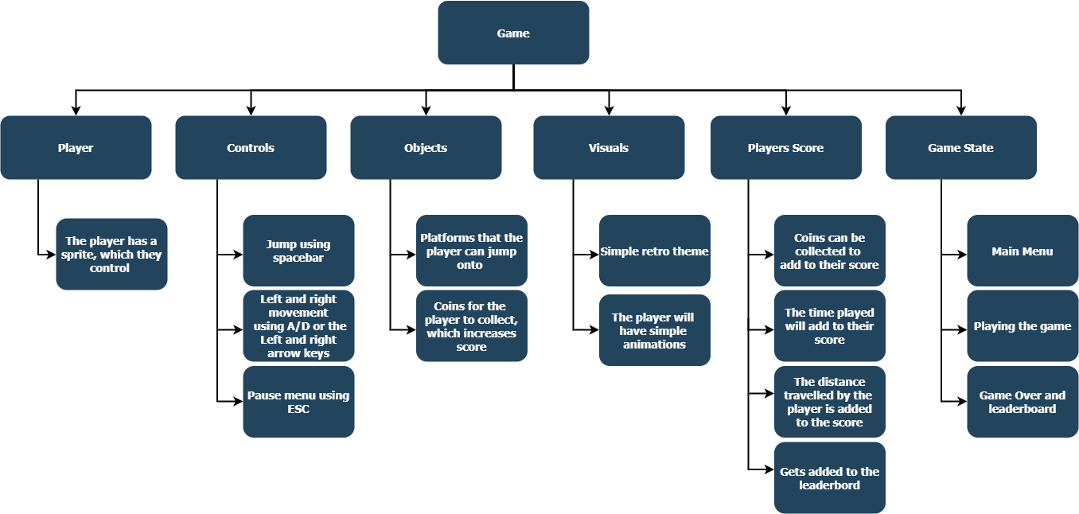

### Thinking logically

The game will be, and endless runner and platforms will be generated using the random function in python, which will be imported from the random library. The player must die for the game to bring up the game over screen. This will be detected by checking if the player has fallen past the x co-ordinate at the bottom of the screen and it will check if the player overlaps with any obstacles. Furthermore, as the player moves forward the score will increase as it is calculated by distance, time, and coins. Once the game has detected that, the player has died, the game over screen appears and their total score is added up by adding the distance, time (in seconds) and the number of coins collected. This score will be added to the leader board when the player goes back to the menu or presses play again.

### Conclusion

The elements of the game shown through the different parts of computational thinking have shown the initial solution to producing the game with the minimum requirements, which were found from the interview to find some of the initial requirements for one stakeholder.

### Success criteria

|  |  |  |  |
| --- | --- | --- | --- |
| Number | Requirement | Justification | Reference |
| 1 | Create a game window | Needed for the game to work | Game requirement |
| 2 | Menu screen with options to play and quit | Allows the user to interact with the game | Interview 1 |
| 3 | Move the player using inputs | Used for the user to move the player | Interview 1 |
| 4 | Platforms spawn for the player to jump on | Needed to gain score and progress | “Doodle Jump” feature |
| 5 | End game screen | To display the users score and allow them to add it to a leader board | Interview 2 |
| ­6 | Button to play again on end game screen | Game is more accessible as the user doesn’t have to go back to the main menu to play | Interview 2 |
| 7 | Button to go to main menu on end game screen | If the user wants to quit through the main menu or view options | “Doodle Jump” Feature |
| 8 | Ability to add scores to leader board on end game screen | Allow the user to interact with other players’ score | Interview 1 |
| 9 | Different types of obstacles | Make the game more difficult | “Doodle Jump” Feature |
| 10 | View leader board on menus | Allow the user to view the top 10 scores | Interview 2 |
| 11 | Coins for the player to collect | Gives the player more options to get a higher score | Interview 1 |
| 12 | Player jumping | Needed to play the game | Interview 1 |
| 13 | Moving background | To make the game more visually appealing to the user | Interview 2 |
| 14 | Power ups that allow the player to do extra things such as super jump | Make the game more enjoyable for the user | Interview 2 |
| 15 | Allow the user to view the controls | Help new users to understand the game | Interview 1 |
| 16 | Sounds when something happens | Makes the game more accessible as the user doesn’t have to rely on looking at everything on the screen | Interview 2 |

# 3.2 Design of the solution

## 3.2.1 Decompose the problem

### Diagram

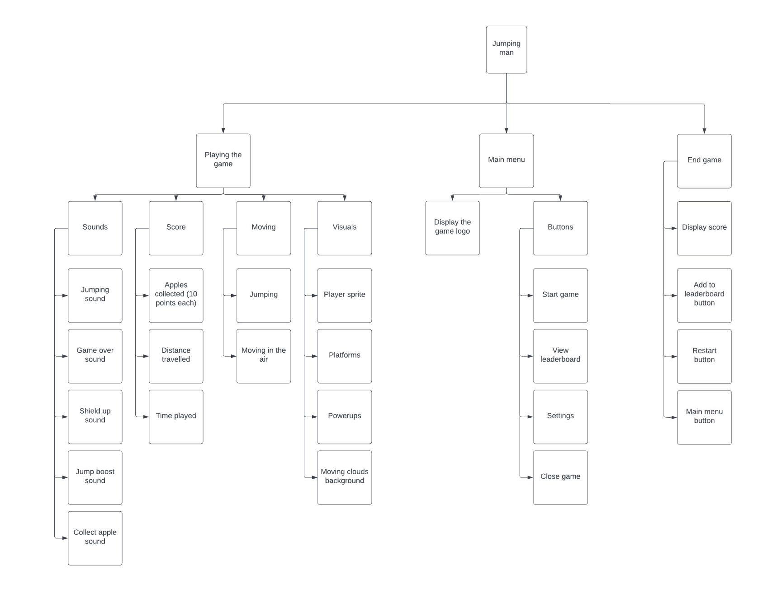

#### Why did I choose a flowhart?

I decided to use a flowchart because it clearly displays the different components of the game and where they belong. This makes it easier to understand what has to be worked on in each section.

## 3.2.2 Describe the solution

### Playing the game

#### Sounds:

##### jumping sound

The jumping sound will play when the user jumps onto a platform.

##### Game over sound

The game over sound will play when the user dies, which also means the end game screen will appear.

##### Shield up/down sound

These sounds will play when the user gains a shield and another sound will play when the user loses the shield.

##### Jump boost sound

The jump boost sound will play when the user jumps on a platform after they have picked up the jump boost powerup.

##### Collect apple sound

The collect apple sound will play when the user collects an apple, which also adds to their score.

#### Score

##### apples

When an apple is collected, the user gains an additional 10 points. This makes it easier to gain score. This will be displayed on the screen while the user plays the game.

##### Distance travelled

The distance travelled will also be displayed on the screen and it will be the total distance the user has travelled since they started the game.

##### Time played

Time played will also add to the score and will be calculated by the number of seconds the user has played for

#### Moving

##### Jumping

Jumping is a core feature of the game as it will be used for the user to move further and it will also allow new platforms to spawn. The player will automatically jump whenever they hit a platform.

##### Moving in the air

The user will be able to control their character by moving left and right by using the keys “A” for left and “D” for right. The user will also be able to use the arrow keys instead of “A” and “D”.

#### Visuals

##### player sprite

The players sprite will be visible on the screen at all times while playing and will likely be animated. When the sprite collides with a platform, they will jump. When it hits the bottom of the screen the game over screen will appear. The user will also be able to use the sprite to collide with powerups to collect them to use them.

##### Platforms

Platforms will spawn in from the top of the screen and will begin to scroll down when the user reaches a certain height on the screen. Sometimes platforms may spawn in with powerups on them. When a platform reaches the bottom of the screen it will despawn.

##### Powerups

Powerups will spawn at a set rate to make the game more enjoyable. There will be powerups such as a jump boost and a forcefield which have different uses. The jump boost powerup will make the user jump higher than usual on their next jump and the forcefield powerup will prevent the user from dying for 10 seconds.

##### Moving clouds background

The background will have clouds which move across the sky to give the effect that the user is in the sky, making the game more immersive

### Main menu

#### Game logo

The game logo will appear at the top of the screen in the main menu.

#### Buttons:

##### Start game button

The start game button will allow the user to start playing the game. It will be able to be clicked, or a key can be pressed to use it.

##### ViEW LEADERBOARD BUTTON

The view leaderboard will display the top 10 scores in order. This will be able to be clicked or a key can be pressed to use it.

##### settings button

The settings button will allow the user to open the settings screen which will give the user the option to do things like muting the audio. This can be clicked, or a key can be pressed to use it.

##### CLOSE GAME BUTTON

The close game button will close the window. This can be pressed, or a key can be pressed to use it.

### End game

##### Display score

The users score will be displayed at the top of the screen. The score will be added up by adding the time played, distance travelled and the by getting the number of apples collected and multiplying that by 10.

##### Add to leaderboard button

The add to leaderboard button will allow the user to input their name and add their score to the leaderboard. Their name can then be viewed on the leaderboard if it is one of the top 10 scores. This can be clicked, or a key can be pressed to use it.

##### Restart button

The restart button will allow the user to restart the game without having to go back to the main menu. This can be clicked, or a key can be pressed to use it.

##### Main menu button

The main menu button will allow the user to go back to the main menu. This can be clicked or a key can be pressed to use it

## 3.2.3 Describe the approach to testing

### Algorithms

#### Playing the game

#### Sounds

Jumping sound

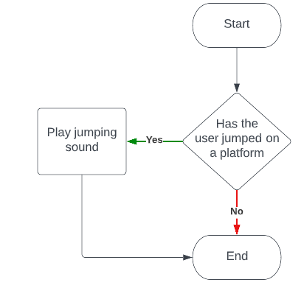

Game over sound

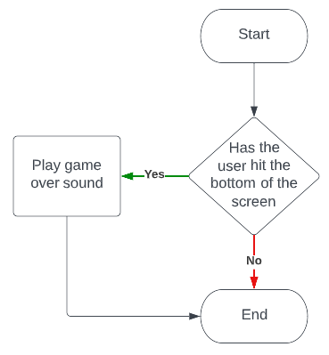

Shield up sound

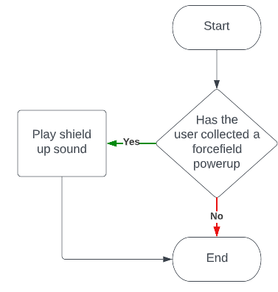

Shield down sound

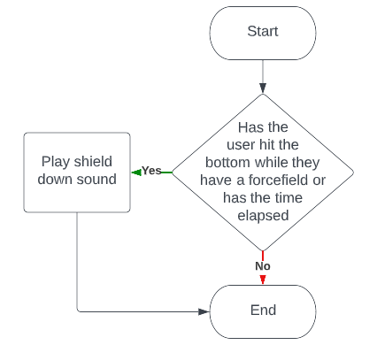

Collect apple sound

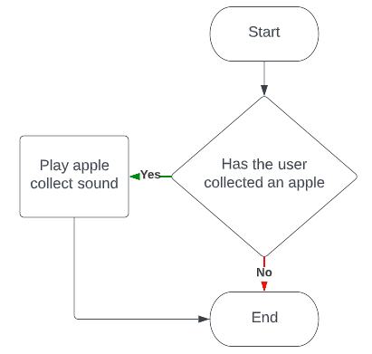

Jump boost sound

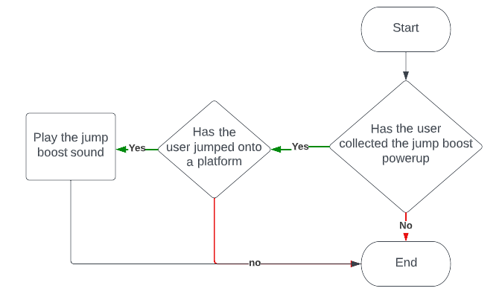

#### Score

Apples

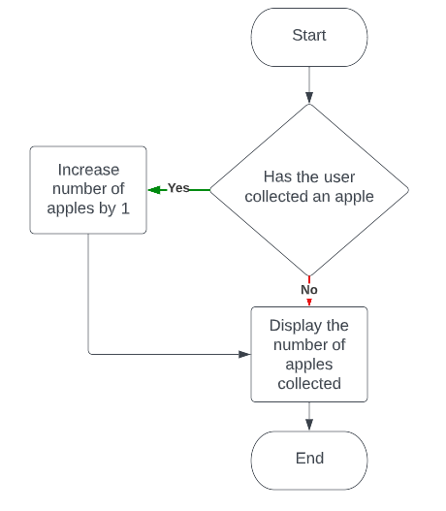

Distance travelled

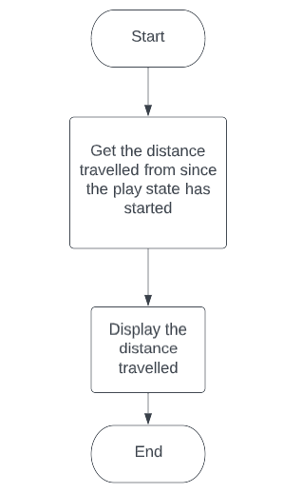

Time played

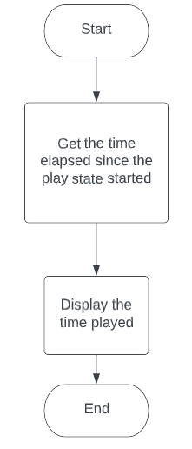

#### Movement

Jumping

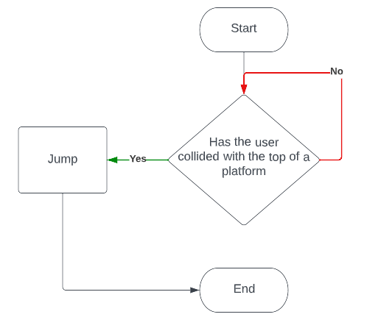

Moving in the air

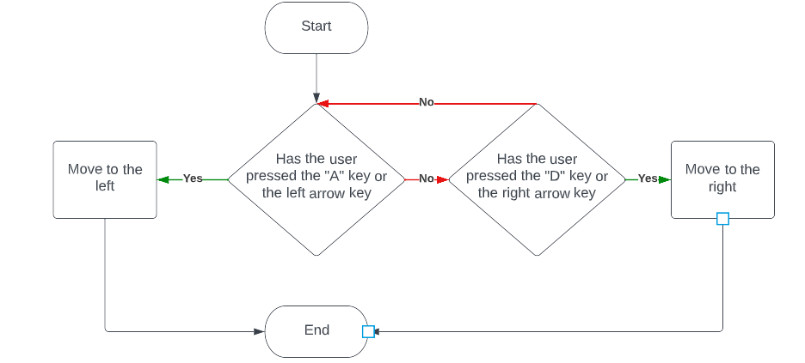

#### Visuals

Player sprite

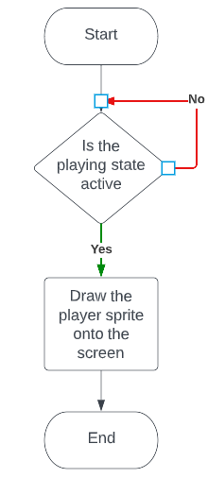

Platforms

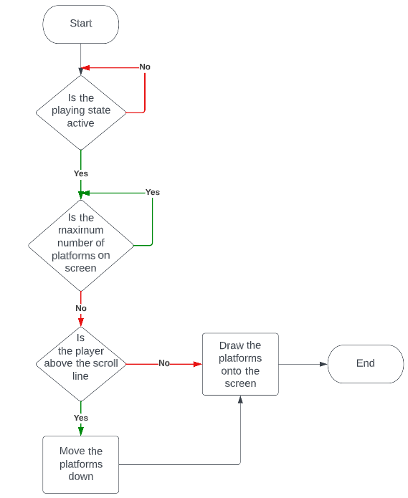

Powerups

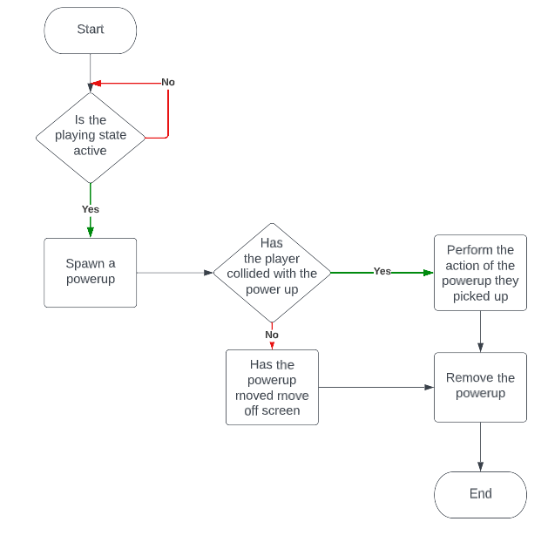

Moving clouds background

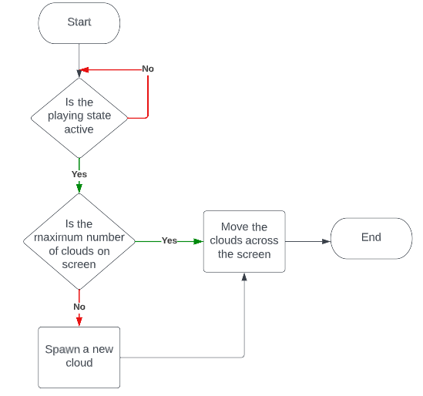

#### Main menu

Display the main menu

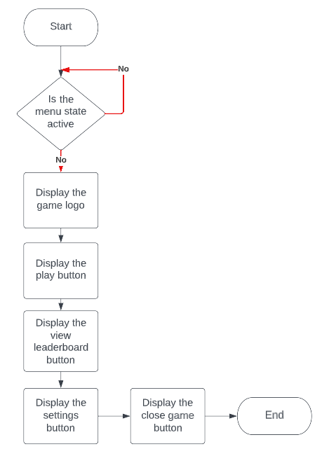

Play button

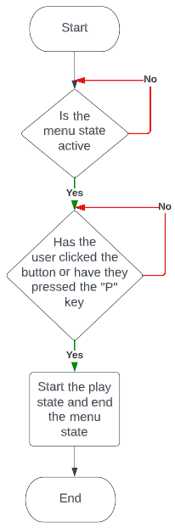

View leaderboard button

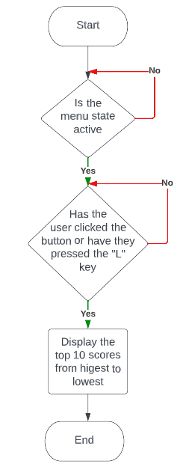

Settings button

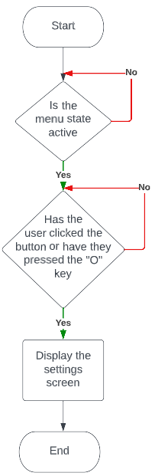

Close game button

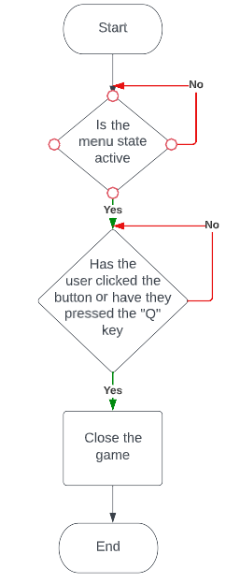

#### End game screen

Display endgame screen

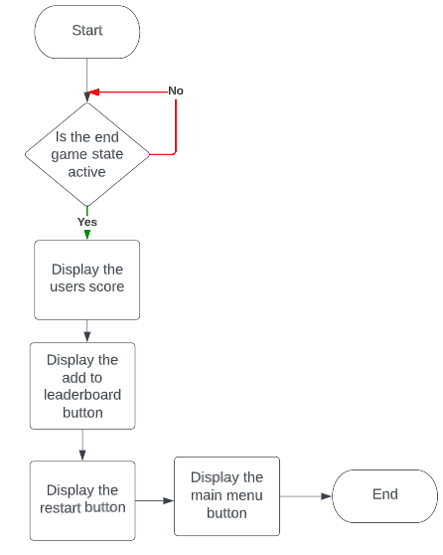

Add to leaderboard button

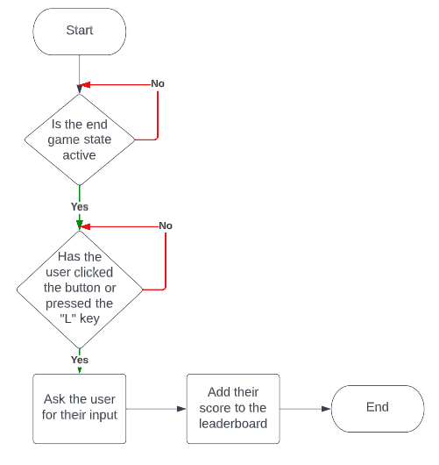

Restart button

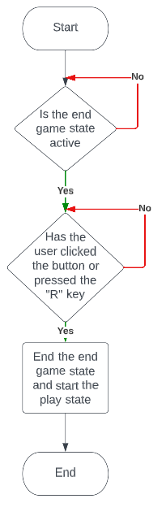

Main menu button

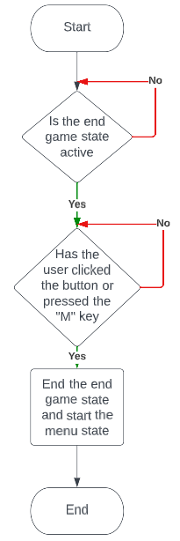

### Usability features

#### Main menu

Main menu screen

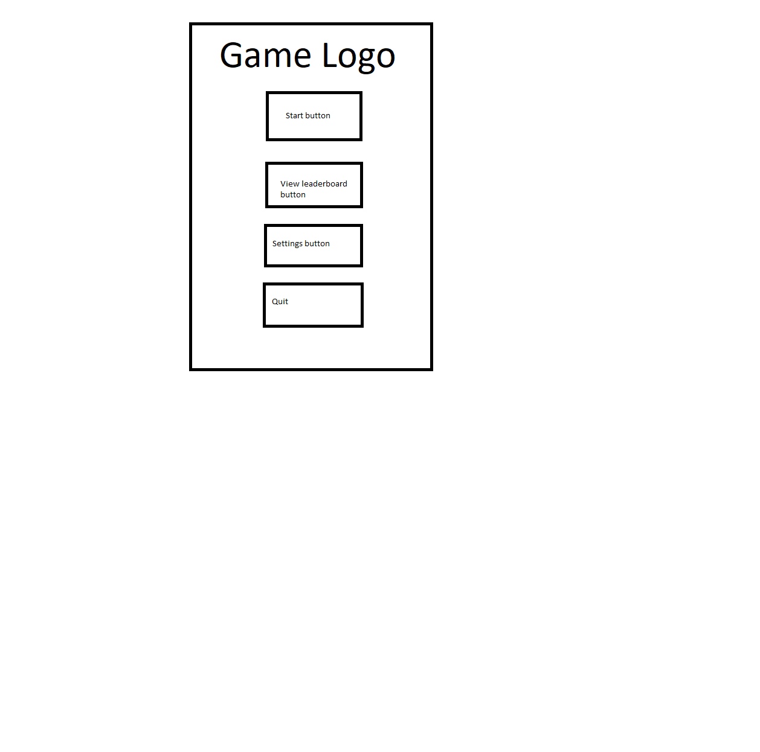

Quit button so the user can exit the game

Settings button to open the settings menu

Button to open the leaderboard to view the top scores

Start button to put the game into the playing state

The game title at the top of the screen, which will have a design

Leaderboard screen:

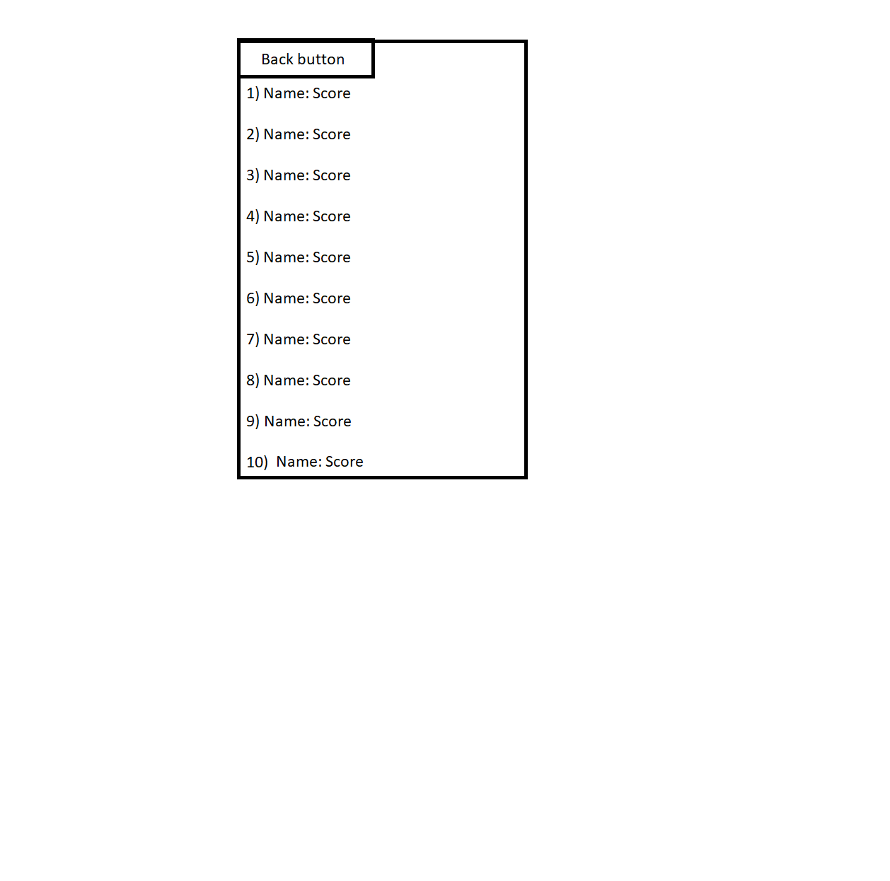

Users score from highest to lowest

Back button so the user can go back to the main menu

Options screen:

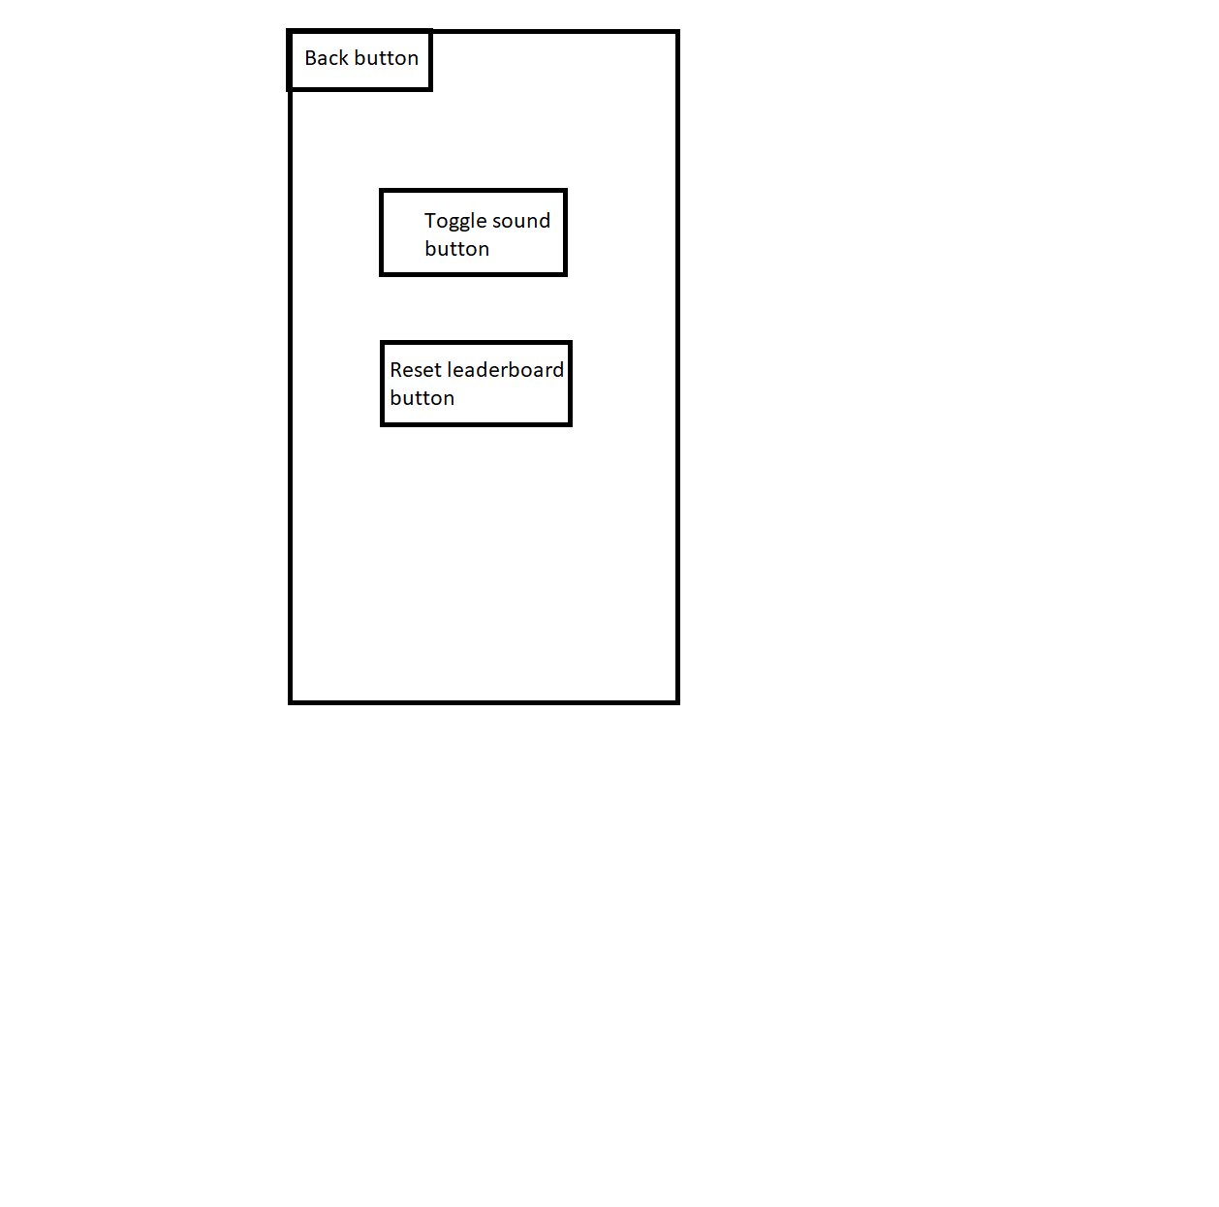

Button to reset the leaderboard

Button to enable / disable sound

Back button to go back to the main menu

#### Playing the game

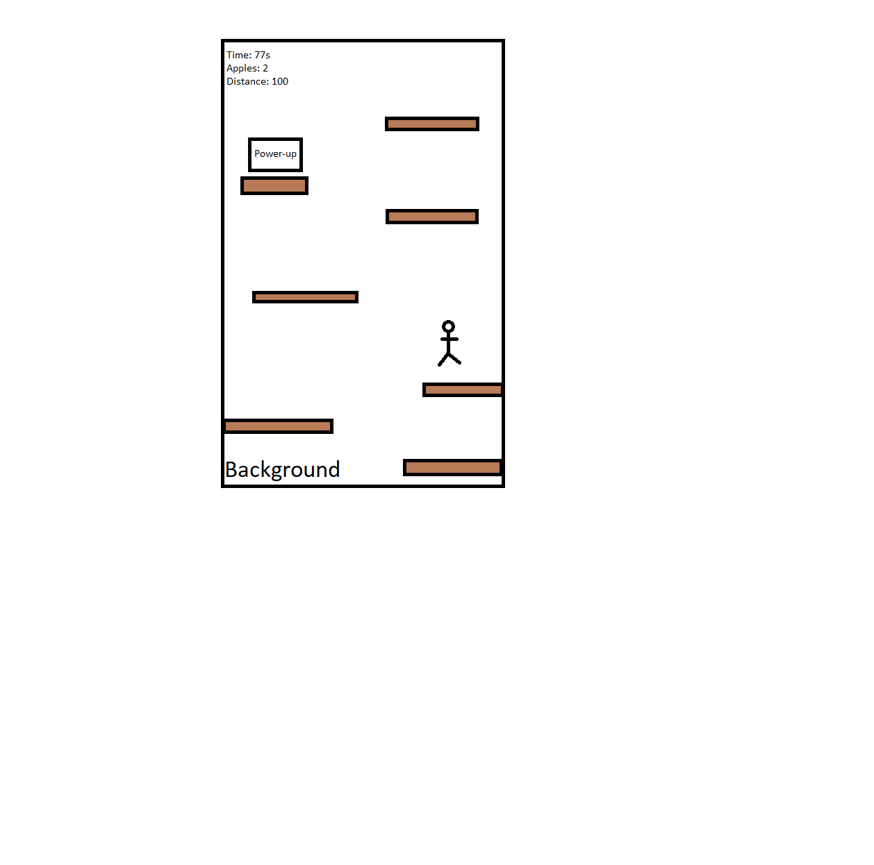

Players sprite which will have a jumping animation

A random powerup, which will spawn randomly

Platforms for the user to jump on

Players statistics so they know if they are doing well

The background which will be visible behind everything else

Platforms, which will spawn when a visible platform leaves the screen

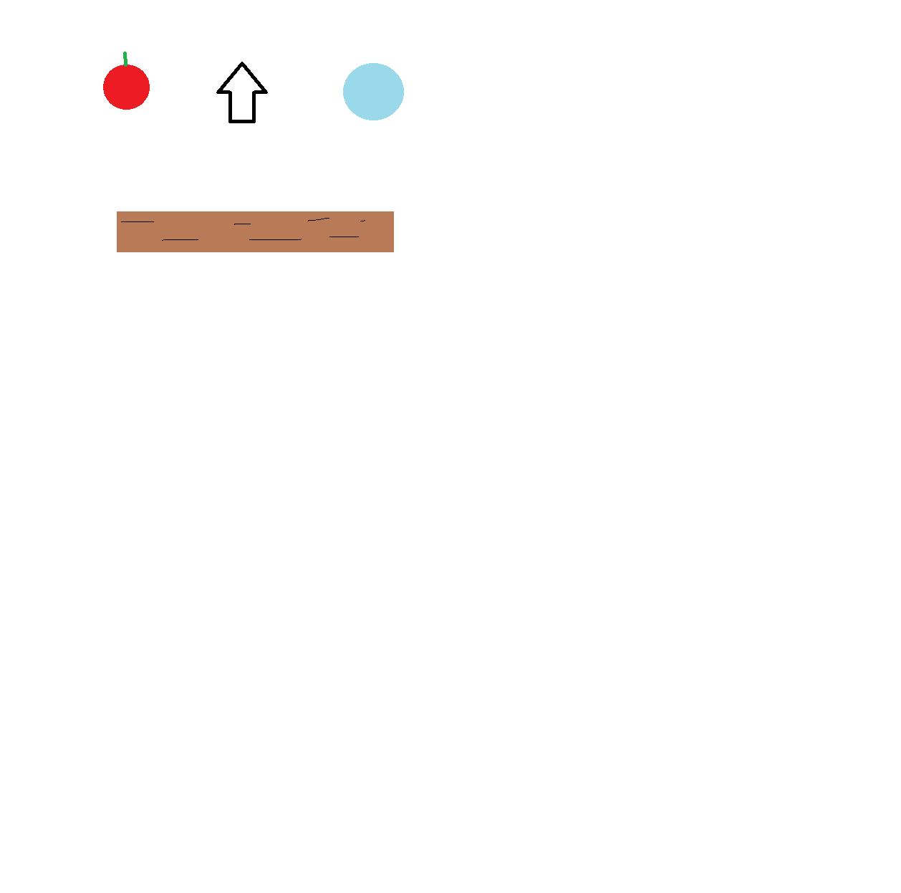



Forcefield powerup which gives the user temporary protection when they collect it

Jump boost powerup, which gives the user a bigger jump when they next jump onto a platform

Apples, which give the user additional score when they collect it

Background

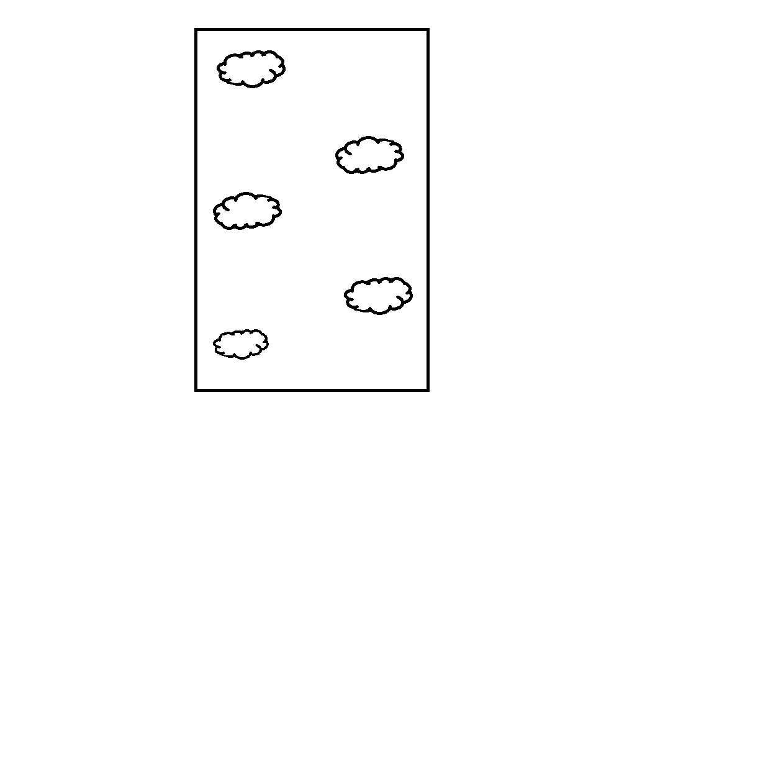

Clouds with different designs, which move across the screen

The background will be visible behind everything when playing the game

#### End game

The users score will be displayed at the top of the screen and will be the sum of the distance, time and apples

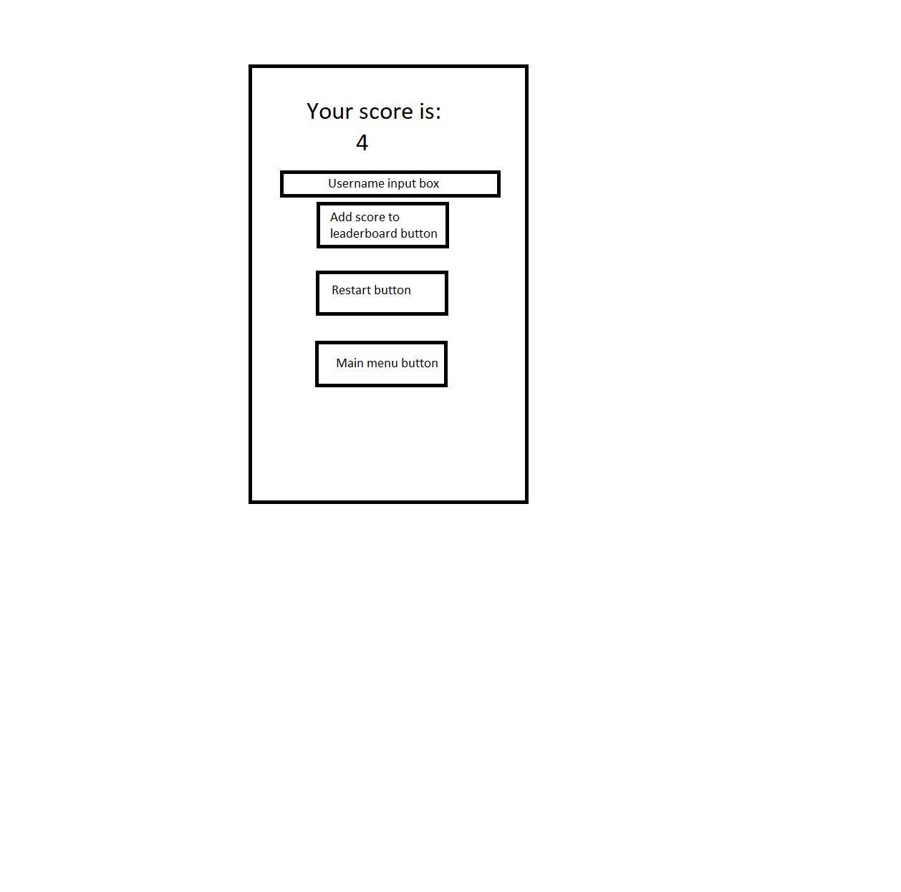

Main menu button so the user can go back to the main menu

Restart button so the user can play again straight away

Username input box so the user can enter their username when they press the add score to leaderboard button

### Variables and data structures

#### Main menu

|  |  |  |  |  |
| --- | --- | --- | --- | --- |
| Method | Name | Data type | Explanation | Justification |
| Function | Draw_main_menu() | - | So the user can see the game logo and the buttons to interact with the game | Contains the code to draw buttons, text and the logo |
| Variable | Options_menu | Boolean | If the user opens the options menu, the variable changes to true. | So the options screen is displayed and only the objects on the options screen work |
| Variable | Leaderboard_menu | Boolean | If the user opens the leaderboard menu, the variable changes to true | So only the leaderboard screen is displayed and so that only the objects on the leaderboard screen are functional |
| Class | Button | - | Has functions and attributes for the buttons such as the clicked function | So I can easily create multiple buttons as they will be used in the main menu, pause menu and the end game menu |
| Function | Leaderboard_button() | - | So the user can press the button and view the leaderboard | Makes the leaderboard button object and creates the text for the object |
| Function | Play_button() | - | So the user can press the button and start playing the game | Makes the play button object and creates the text |
| Function | Options_button() | - | So the user can press the button and open the options menu | Makes the options button and creates the text for it |
| Function | Quit_button() | - | So the user can press the button and close the game | Makes the quit button and creates the text for it |
| Variable | LOGO | .png | To show the game logo for the user to see | Loads the logo image and then scales it to the appropriate size |
| Function | Hover() | - | To indicate to the user that their mouse is hovering over the button | Changes the colour of the button when the mouse is within the button rectangle |
| Function | Clicked() | - | So the user can click onto buttons instead of pressing a key | Returns true when the button is clicked so the button can work |
| Variable | Sounds | Boolean | To enable or disable sounds within the options menu | Used to indicate whether sounds are enabled are disabled and is changed when the sounds button is clicked |
| Variable | Leaderboard | List | A list containing tuples which consists of a string for the users name and an integer to store their score | So the users scores can be saved using the pickle module in an external text file, which allows it to be accesed when the user launcher the game again |
| Function | Load_leaderboard | - | So the leaderboard can be displayed in the view leaderboard menu | Opens the leaderboard from the text file and is used to create the leaderboard variable |
| Function | Enable_sound | - | Used to go through the list of sounds and set the volume to 100 | To give the toggle sound button functionality by enabling sounds in the options menu |
| Function | Disable_sound | - | Used to go through the list of sounds and set the volume to 0 | To give the sound button functionality by disabling sounds in the options menu |
| Variable | SOUNDS | list | A list of the sounds in the game | So the sounds can be easily managed, for example muting them all. |

#### Playing the game

|  |  |  |  |  |
| --- | --- | --- | --- | --- |
| Method | Name | Data type | Explanation | Justification |
| Class | Player | - | Contains the attributes and methods for the player object | So the player object can be easily managed and to add more functionality to the player by creating new functions |
| Class | Clouds | - | Contains the attributes and methods for the cloud objects in the background | So the clouds could be added to a sprite group making them easier to manage. |
| Class | Powerups | - | Contains the attributes and methods for the different powerups to spawn in | So the powerups could be added to a sprite group so they were easier to manage |
| Function | Move_clouds | - | Moves the clouds across the screen | To give the effect that the player is in the sky, making the game more immersive |
| Function | Spawn_clouds | - | Spawns clouds in on the screen | So clouds appear on the screen while the user is playing to maintain the sky effect |
| Function | Start_platforms | - | Creates the initial platforms when the game starts | It spawns a platform below the user so the user doesn’t die immidiately, it also spawns in the platform used to track the distance the player has travelled |
| Function | Spawn_platforms | - | Creates platforms when a platform comes off screen | So the user can continue to progress further and increase their score |
| Variable | Player | Player object | Creates an object using the Player class with its attributes and methods | So the user can play the game using the player and its sprite |
| Variable | Platforms | Pygame group | Contains all of the active platform object sprites | Makes them significantly easier to manage as there are functions to draw and update when using groups |
| Variable | Clouds | Pyame group | Contains all of the active cloud object sprite | Makes them significantly easier to manage as there are functions to draw and update when using groups |
| Variable | Tracker | Platform object | The initial platform which the player spawn on and also doesn’t get removed when it goes off screen | So the game can track how far down the platform has moved from the start and that value is used as the distance travelled |
| Variable | Powerups | Pygame group | Contains all of the active powerup object sprites | Makes them significantly easier to manage as there are functions to draw and update when using groups |
| Variable | Run | Boolean | Decides if the game is active | Changes to True when the program is opened and changes to false when it is closed |
| Variable | dead | Boolean | Used to indicate if the player has hit the bottom of the screen and dies | Changes when the user hits the bottom of the screen and is used to start the end game state and end the play state |
| Variable | Pause | Boolean | Decides if the pause menu is active or not | Changes to True when the user presses the “ESC” key to open the pause menu and presses “B” to leave the pause menu |
| Variable | Keys_pressed | - | Gets the key the user is pressing | Returns the current key being pressed so that the correct action happens when the associated button is pressed |
| Variable | JUMPSOUND | .wav | Contains the jump sound | Used to play the jump sound when the user jumps onto a platform. This makes the game more immersive for the user |
| Variable | JUMPBOOSTSOUND | .mp3 | Contains the jump boost sound | Used to play the jump boost sound when the user jumps onto a platform after collecting the jump boost powerup |
| Variable | GAMEOVERSOUND | .mp3 | Contains the game over sound | Used to play the game over sound when the user dies and the end game screen starts |
| Variable | SHIELDUPSOUND | .mp3 | Contains the shield up sound | Used to play the shield up sound when the user picks up the forcefield power up |
| Variable | SHIELDBREAKSOUND | .mp3 | Contains the shield break sound | Used to play the shield break sound when the user loses their forcefield after 10 seconds or by hitting the bottom while the forcefield is active |
| Variable | APPLESOUND | .mp3 | Contains the collect apple sound | Used to play the apple collect sound when the user picks up an apple |
| Variable | CLOUDS | List | Contains the variables of the cloud sprite images | So a cloud image can be randomly selected when a cloud spawns in |
| Variable | POWERUP_SPRITES | List | Contains the variables of the powerup sprites | So a powerup image can be randomly selected then based on the image selected the powerup will be assigned the corresponding action |
| Variable | jumpanim | list | Contains the images for the jumping animation | So the while the user is jumping, the list is cycled through to animate the player |
| Variable | APPLE | .png | The apple sprite image | To give the apple a sprite so the user can see it can collect it |
| Variable | FORCEFIELD | .png | The forcefield sprite image | To give the forcefield a sprite so the user can see it to collect it |
| Variable | JUMPBOOST | .png | The jump boost image sprite | To give the jump boost powerup a sprite so the user can see it to collect it |

#### End game

|  |  |  |  |  |
| --- | --- | --- | --- | --- |
| Method | Name | Data type | Explanation | Justification |
| Variable | Dead | Boolean | Changes to true when the player collides with the bottom of the screen | So the end game state can start |
| Variable | User_input | String | Contains the users name when they are typing it in | So it can be displayed onto the screen and so it can be saved to the leaderboard when they press enter |
| Function | Restart_button | - | Contains the button object and checks if is clicked | So the game can be restarted when the user clicks the button |
| Function | Home_button | - | Contains the home button object | So the player can go back to the main menu when the user clicks the button |

### Test data

#### Main menu

Display game title

|  |  |
| --- | --- |
| Test data | Type |
| Game has started | Valid |
| Player sprite is visible | Invalid |

Press start button

|  |  |
| --- | --- |
| Test data | Type |
| ‘P’ key pressed | Valid |
| Button is clicked | Valid |
| ‘T’ key is pressed | Invalid |

Press view leaderboard button

|  |  |
| --- | --- |
| Test data | Type |
| ‘L’ key pressed | Valid |
| Button is clicked | Valid |
| ‘Y’ key is pressed | Invalid |

Press Options button

|  |  |
| --- | --- |
| Test data | Type |
| ‘O’ key pressed | Valid |
| Button is clicked | Valid |
| ‘R’ key is pressed | Invalid |

Press quit button

|  |  |
| --- | --- |
| Test data | Type |
| ‘Q’ key pressed | Valid |
| Button is clicked | Valid |
| ‘M’ key is pressed | Invalid |

#### End game

Display high score

|  |  |
| --- | --- |
| Test data | Type |
| Player collided with the bottom of the screen | Valid |
| Player still moving | Invalid |

Press add to leaderboard button

|  |  |
| --- | --- |
| Test data | Type |
| ‘L’ key pressed | Valid |
| Button is clicked | Valid |
| ‘V’ key is pressed | Invalid |

Press restart button

|  |  |
| --- | --- |
| Test data | Type |
| ‘R’ key pressed | Valid |
| Button is clicked | Valid |
| ‘T’ key is pressed | Invalid |

Press main menu button

|  |  |
| --- | --- |
| Test data | Type |
| ‘M’ key pressed | Valid |
| Button is clicked | Valid |
| ‘F’ key is pressed | Invalid |

#### Playing the game

Display game window and background

|  |  |
| --- | --- |
| Test data | Type |
| Play state is active | Valid |
| Play state is inactive | Invalid |

Player jump

|  |  |
| --- | --- |
| Test data | Type |
| Player collision with platform | Valid |
| Player in the air | Invalid |

Move player to the left

|  |  |
| --- | --- |
| Test data | Type |
| “A” key is pressed | Valid |
| Left arrow key is pressed | Valid |
| “J” key is pressed | Invalid |

Move player to the right

|  |  |
| --- | --- |
| Test data | Type |
| “D” key is pressed | Valid |
| Right arrow key is pressed | Valid |
| “N” key is pressed | Invalid |

Jump sound

|  |  |
| --- | --- |
| Test data | Type |
| Player collides with platform | Valid |
| Play collides with the bottom | Invalid |

Game over sound

|  |  |
| --- | --- |
| Test data | Type |
| Player collides with bottom of the screen | Valid |
| Play collides with the apple | Invalid |

Shield up sound

|  |  |
| --- | --- |
| Test data | Type |
| Player collides with forcefield powerup | Valid |
| Play collides with platform | Invalid |

Shield down sound

|  |  |
| --- | --- |
| Test data | Type |
| 10s elapsed after collecting powerup | Valid |
| Play collides with the bottom while powerup is active | Valid |
| Player collides with platform | Invalid |

Jump boost sound

|  |  |
| --- | --- |
| Test data | Type |
| Player collides with platform after collecting jump boost powerup | Valid |
| Play collides with an apple | Invalid |

Collect apple sound

|  |  |
| --- | --- |
| Test data | Type |
| Player collides with an apple | Valid |
| Play collides with a forcefield powerup | Invalid |

Timer increments

|  |  |
| --- | --- |
| Test data | Type |
| Increments by 1 every second | Valid |
| Increments by 7 every second | Invalid |

Distance increases

|  |  |
| --- | --- |
| Test data | Type |
| Increases when player moves up | Valid |
| Increases when player moves down | Invalid |

Apples increase

|  |  |
| --- | --- |
| Test data | Type |
| Increments when player collides with an apple | Valid |
| Increments when player collides with a platform | Invalid |

### Acceptance testing

|  |  |  |  |
| --- | --- | --- | --- |
| Number | Requirements | Input | Expected outcome |
| 1 | Game title and button are displayed | - | Game title and buttons are displayed so the user knows which buttons to click |
| 2 | The leaderboard screen is displayed when the button or “L” key is pressed | Valid: “L” key  Valid: Button clicked  Invalid: “T” key | Leaderboard screen is displayed and top 10 scores are displayed in order |
| 3 | Options screen is displayed when the button or “O” key is pressed | Valid: “O” key  Valid: Button clicked  Invalid: “A” key | The options screen is displayed with various options such as turning sound on/off |
| 4 | Game quits when the user presses the button or the “Q” key | Valid: “Q” key  Valid: Button clicked  Invalid: “Z” key | The game window closes and the program stops running |
| 5 | Game state starts when the user presses the button or presses the “P” key | Valid: “P” key  Valid: Button clicked  Invalid: “I” key valid | The game state starts and the players sprite, platforms and the background are visible and the main menu is no longer visible |
| 6 | The jumping sound plays when the user jumps on a platform | Valid: Player collides with a platform  Invalid: player collides with a powerup | The jump sound plays when the user jumps on a platform |
| 8 | The game over sound plays when the user hits the bottom of the screen | Valid: Player collides with the bottom of the screen  Invalid: Player collides with a platform | The game over sound plays when the user hits the bottom of the screen |
| 9 | The shield up sound plays when the user picks up a forcefield powerup | Valid: Player collides with a forcefield sprite  Invalid: Player collides with an apple | The shield up sound plays when the user collects a forcefield powerup |
| 10 | The shield down sounds plays when 10 seconds have passed since collecting the powerup or they hit the bottom while the forcefield is active | Valid: Player collides with the bottom while forcefield is true  Valid: time left for the powerup = 0  Invalid: Time left for the powerup = 5 | The shield down sound plays when the shield time expires or they hit the bottom of the screen while the forcefield is active |
| 11 | The jump boost sound plays when the user picks up a jump boost and then jumps onto a platform | Valid: The player collides with a platform when jumpboost = true  Invalid: Player collides with the forcefield sprite | The jump boost sound plays when the user picks up a jumpboost sound then jumps onto a platform |
| 12 | The apple collect sound plays when the user collects an apple | Valid: The player collides with an apple sprite  Invalid: The player collides with a platform | The apple collect sound plays when the user collides with an apple |
| 13 | Number of apples collected increases | Valid: Player collides with an apple sprite  Invalid: Player collides with a platform | The number of apples increments by 1 when the user collides with an apple |
| 14 | Distance increases | Valid: Player moves up the screen  Invalid: Player moves down the screen | The distance increases as the player gets further up the screen |
| 15 | Time played increases | Valid: Time played increases by 1 every second  Invalid: Time played increases by 7 every second | The time played updates and displays the amount of seconds the user plays for |
| 16 | Player moves left when the “A” key or left arrow key is pressed | Valid: “A” key  Valid: Left arrow key  Invalid: “Q” key | The player moves left when the user presses the “A” key or the left arrow key |
| 17 | Player moves right when the “D” key or the right arrow key is pressed | Valid: “D” key  Valid: Right arrow key  Invalid: “Y” key | The player moves to the right when te user pressed the “D” key or the right arrow key |
| 18 | Users score is displayed when the end game state is active | - | The users score is displayed at the top of the screen when the end game state is active after the play state |
| 19 | Users score is added to leaderboard when the “L” key or the button is pressed | Valid: “L” key  Valid: button pressed  Invalid: “H” key | Users score is added to the leaderboard when they press the button or the “L” key |
| 20 | Game restarts when the “R” key or the button is pressed | Valid: “R” key  Valid: button pressed  Invalid: “O” key | Play state is active and end game state is inactive when they press the “R” key or the button |
| 21 | Main menu state is active when the user pressed the “M” key or the button | Valid: “M” key  Valid: button pressed  Invalid: “J” key | The main menu state is active when they press the “M” key or the button and the end game screen is no longer visible |

# 3.3 Developing the solution

## 3.3.1 Iterative development process

Developing the coded solution

### Creating the window

I had to create the main loop to create a screen for me to view. I also decided to create a function for drawing sprites onto the screen, as this would help for the next step, which was to create the player and add movement. I learnt the basics for pygame after watching a youtube video then I started to apply it to my project.

Code:

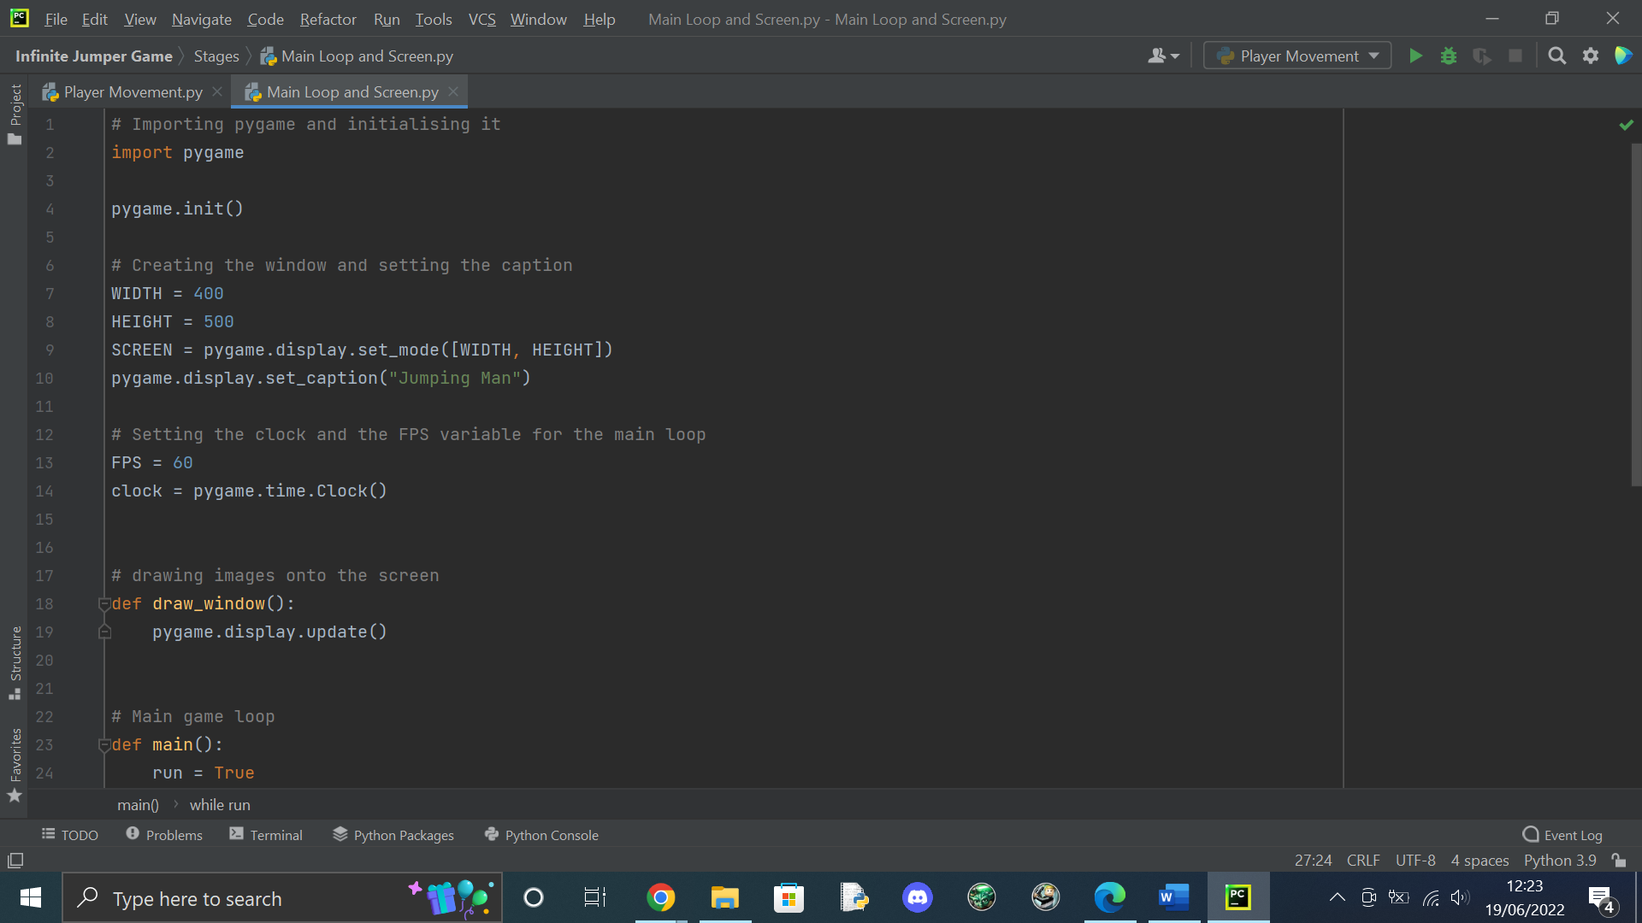

Creating the draw_window function for drawing images such as the player onto the screen

Setting the width and height variables as they will be used later in the code. Then creating the window size using the variables

Setting the FPS and clock variables, which are used in the main loop

Importing pygame then initialising it to use it

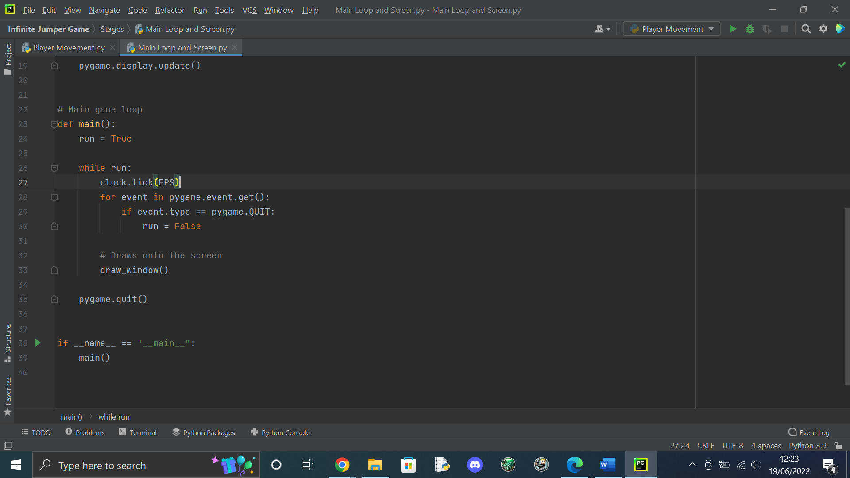

Setting run to True to create an infinite loop so the game can run

Calling the draw_window function to constantly update the position of each image

Checking if the user has quit the game by setting run to False. This will be used to check other events later in the development of the game

Result:

A black screen as I did not choose to fill the screen with a colour or add any sprites. I knew that this was the intended result because the window didn’t crash meaning the loop was running correctly. Also, when the window was closed the game didn’t give any errors so everything was working correctly.

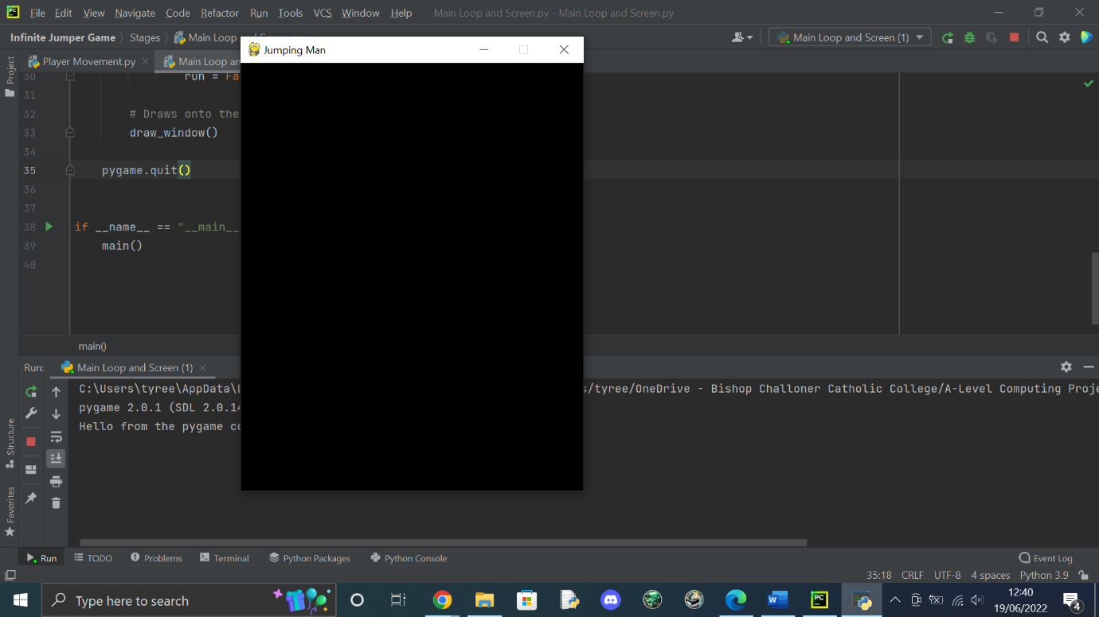

#### Success Criteria met

|  |  |  |  |
| --- | --- | --- | --- |
| Success Criteria number fulfilled | Requirement | Justification | Reference |
| 1 | Create a game window | Needed for the game to work | Game requirement |

#### Testing

|  |  |  |
| --- | --- | --- |
| Test | Expectation | Result |
| Run the program | Black window appears | Black window appears |

### Creating the player and adding movement

For the game to work, the player needs to be able to move left and right to move along the platform they are on. They would need to be able to jump onto other platforms. However, I decided to program jumping into the game later on as there were no platforms for the user to jump on so I thought that it would be easier to test if platforms and jumping are working at the same time.

I chose this sprite because it suited the simple retro theme as it had a pixel art style.

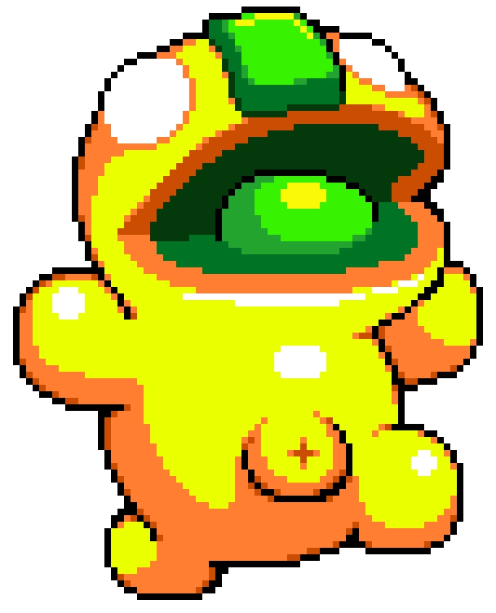

Code:

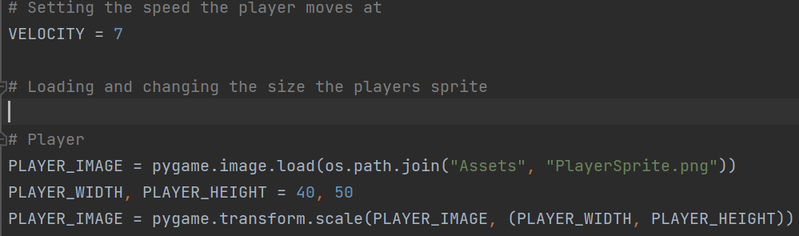

Setting the speed of the player, this will make it easy to adjust the speed later in development if needed

Creating the player class and creating a constructor. This constructor allows me to change the dimensions of the players’ hitbox and allows me to move the player

Loading in the image then scaling it to a suitable size

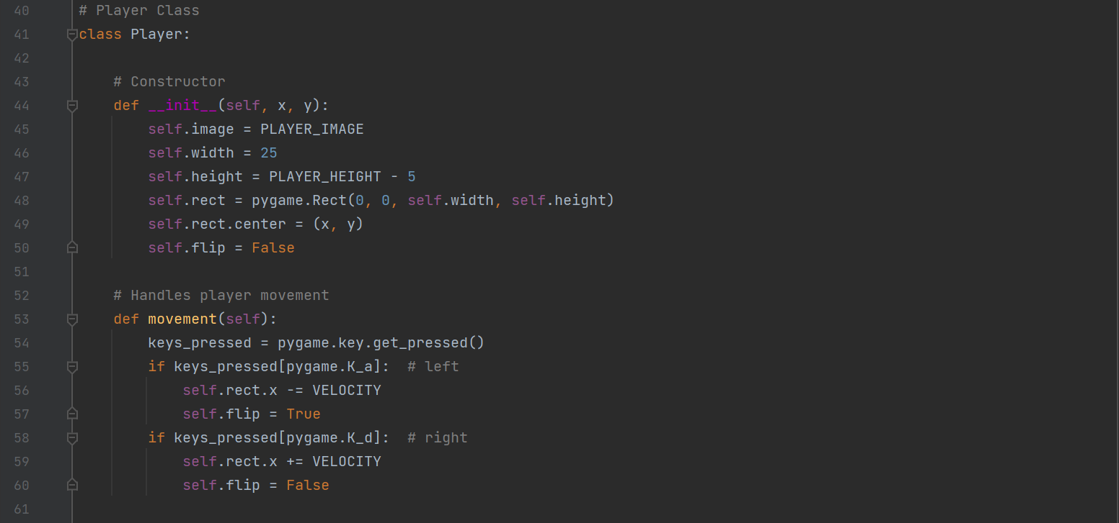

Creating the movement for the player. It detects the key being pressed. If the player moves in a different direction, it flips the sprite, so it is always facing the direction it is moving.

Creating the boundaries function to check if the player is within the boundaries of the game. This stops the sprite from leaving the screen

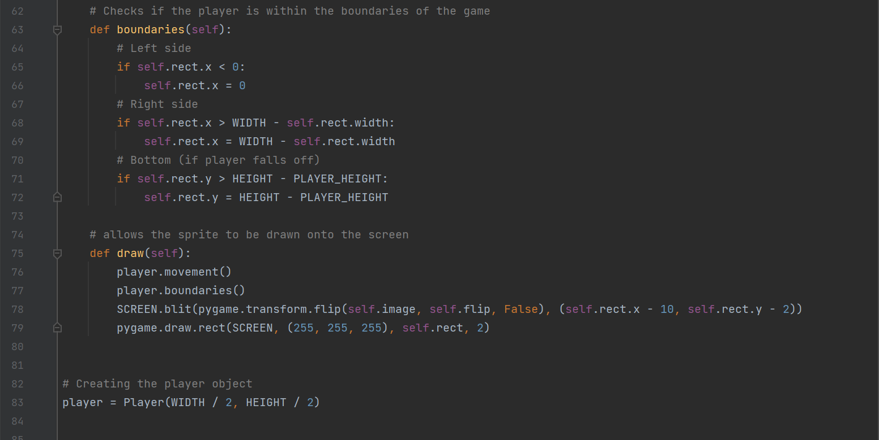

Creating the draw function for the player which can be called in the draw window function, so the player appears on the screen.

Creating the player object

Places the image on the screen and creates a hitbox around the player which is used to detect collisions. The hitbox will only be used for testing.

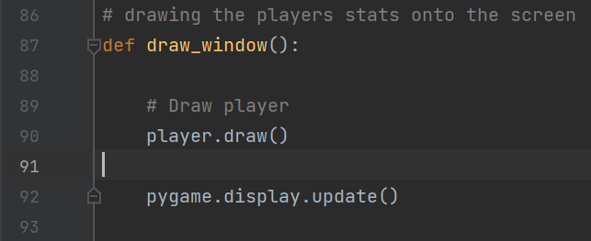

Adding player.draw() to the draw window function so the player appears on the screen

#### Success Criteria

|  |  |  |  |
| --- | --- | --- | --- |
| Success Criteria number fulfilled | Requirement | Justification | Reference |
| 3 | Move the player using inputs | Used by the user to move the player | Interview 1 |

#### Testing

|  |  |  |
| --- | --- | --- |
| Test | Expectation | Result |
| ‘A’ key pressed | Player moves to the left | Player moved to the left |
| ‘D’ key pressed | Player moves to the right | Player moved to the right |
| Run the program | Sprite is drawn onto the screen | The sprite from the previous frame isnt drawn over so it stays on the screen |

Result:

The player can move left using “A” and right using “D”. When the player hits the right, left or bottom border they are unable to move past it. This also shows a small white box which is the hitbox and it will be removed after testing.

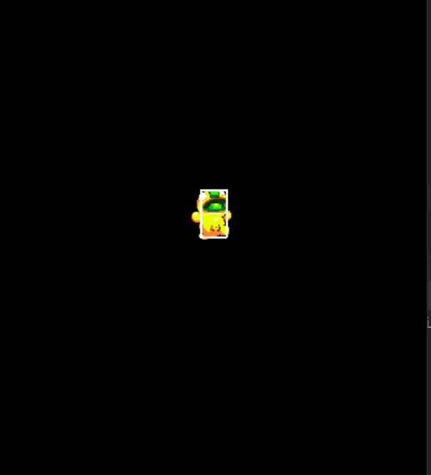

However, this created an error which caused the players sprite to remain in the previous position after moving

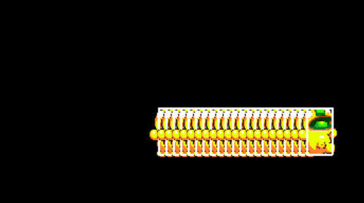

This was happening because there wasn’t a background being drawn so the previous frame was still visible. This was fixed when I added a background in the next milestone.

### Adding a background and text which displayed the users perfomance.

For this section. I wanted to add a background to solve the logical error shown in the previous milestone. Also, I wanted the user to be able to see their distance, time and amount of coins they picked up as this would be used to calculate their final score. I decided to use apples instead of coins as red apples were dark enough to be easily visible compared to coins.

Code:

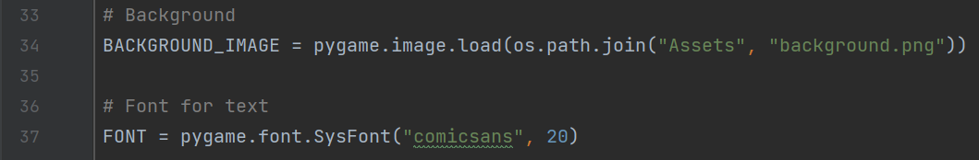

Loading the background and creating a font for text to be written in

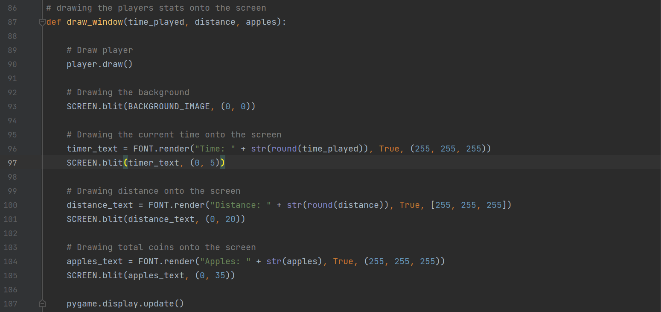

Drawing the players stats onto the screen. These values had to be rounded or they would show multiple decimal digits

Drawing the background onto the screen



Importing time so I could use a function when displaying the time played

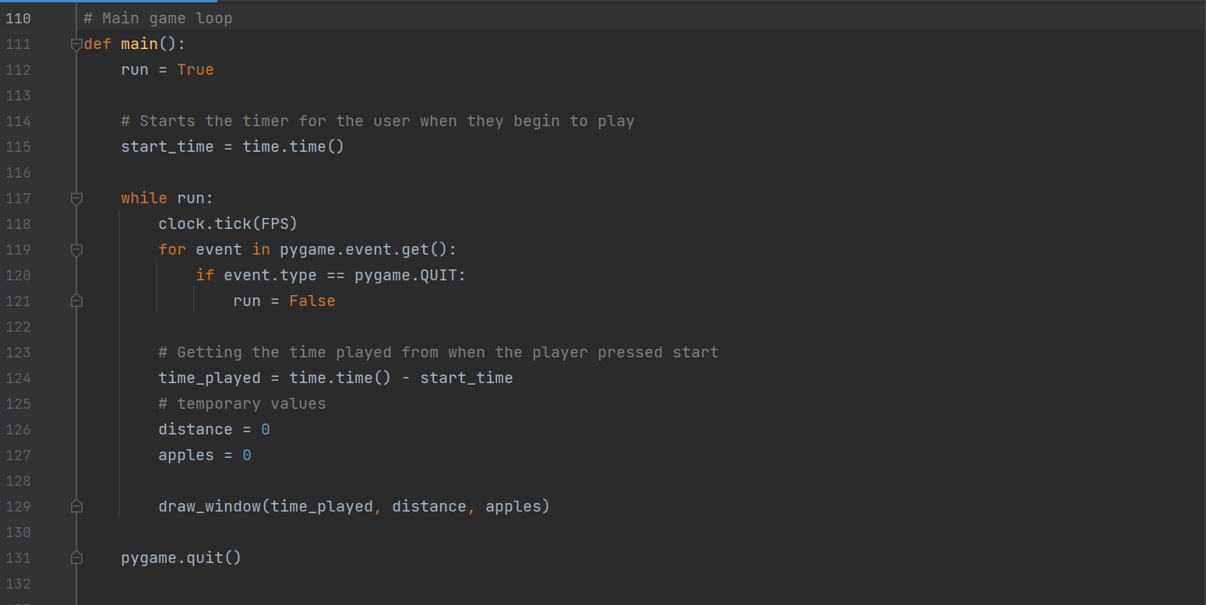

Creating the total distance and total apples variables which have been given temporary values as they haven’t been programmed yet

Creating the starting time variable, which uses a function from the time module

Calculating the time elapsed since the player started.

Calling the draw window function to draw the given time, distance, and total apples onto the screen

Result:

The game displays a background which fixes the logical error from the previous milestone. Also, the time is displayed and increments by 1 every second. The distance and apples show 0, which will change once they are implemented.

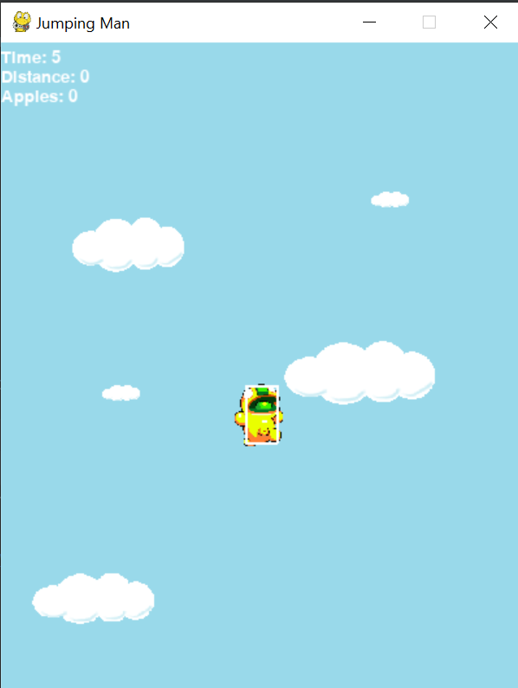

#### Success Criteria

|  |  |  |  |
| --- | --- | --- | --- |
| Success Criteria number fulfilled | Requirement | Justification | Reference |
| 3 | Move the player using inputs | Used by the user to move the player | Interview 1 |

#### Testing

|  |  |  |
| --- | --- | --- |
| Test | Expectation | Result |
| Run the program | Background appears | Background appears |
| Wait for timer to increment | Timer increments by 1 every second | Timer increments |

### Adding platforms

Platforms are a vital part of the gameplay so it was important that they worked correctly so the player could play the game. Platforms would spawn in and have a random x position and new ones would spawn in when a platform leaves the screen. To implement this I had to make sure there was always a platform for the player to start on and make sure all of the platforms woud be within reach of the player so they wouldn’t get stuck.

Adding the maximum platforms variable

Code:



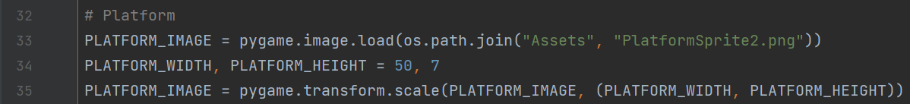

Loading in the platform sprite and scaling it.

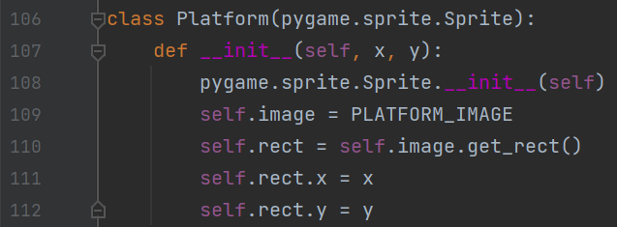

Creating the sprite groups for the platforms. It functions like a list, but it is from the pygame module

Creating the platform class and constructor

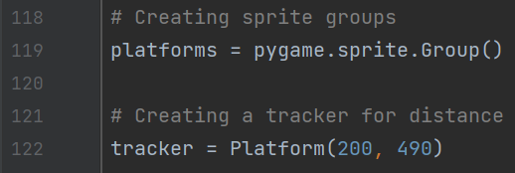

Creating a platform which will be used to calculate the distance

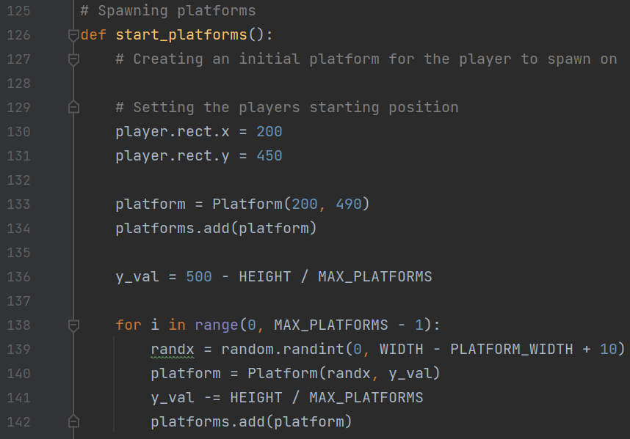

Creating a function for the initial platforms

Creating the function for spawning other platforms

Randomly spawning platforms with a fixed distance between each other and adding it to the sprite group

Creating the initial platform for the player to start on

Setting the player’s initial position

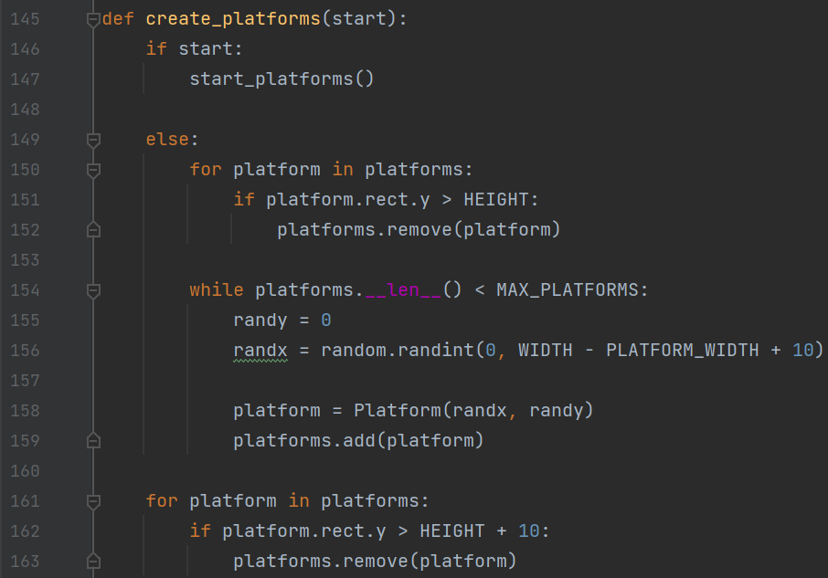

Spawns a platform if there is less than the maximum amount

Removes a platform if it has moved off the screen

Checks if the program should spawn the initial platforms

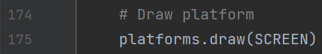

Drawing each platform in the sprite group onto the screen

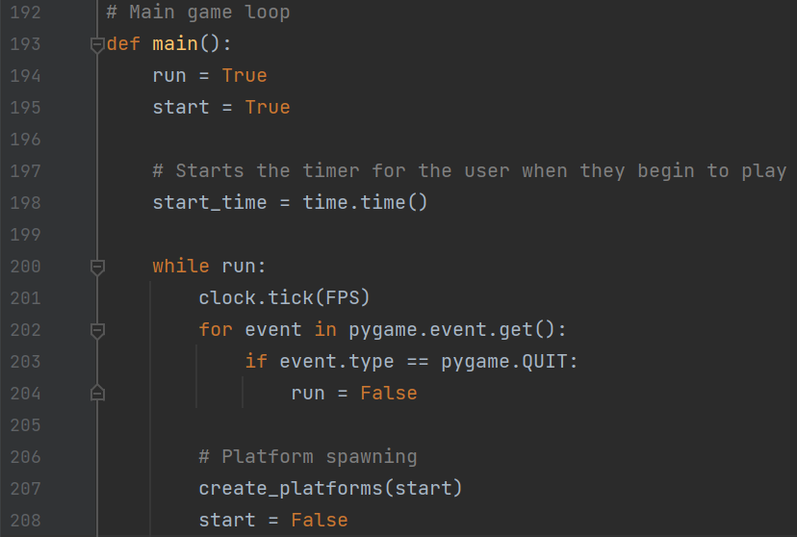

Calling the create platforms function.

Creating and setting the start variable to true to indicate that the starting platforms function should be called



Updating the draw window function so the distance updates

Results:

The platforms spawned how they were intended. However, I couldn’t test if the create platforms function was working correctly as my player couldn’t jump yet. I also couldn’t test if the distance would update because of this.

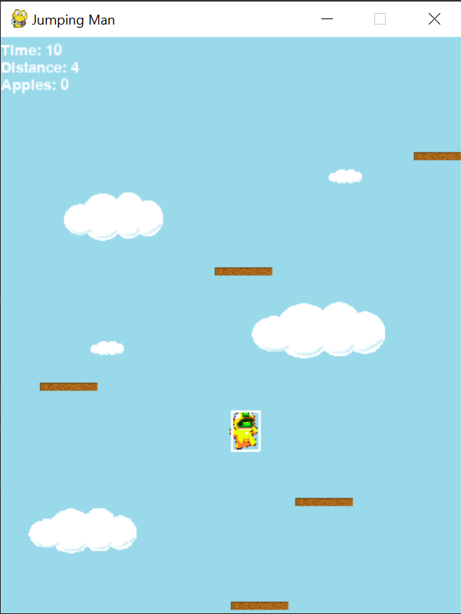

#### Success Criteria

|  |  |  |  |
| --- | --- | --- | --- |
| Success Criteria number fulfilled | Requirement | Justification | Reference |
| 4 | Platforms spawn for the player to jump on | Needed to gain score and play | “Doodle Jump” feature |

#### Testing

|  |  |  |
| --- | --- | --- |
| Test | Expectation | Result |
| Run the program | Platforms appear | Platforms appear |

Error:

However, when the player would appear on a platform, the platform would spawn above them, this was because of the order of the code when drawing the window

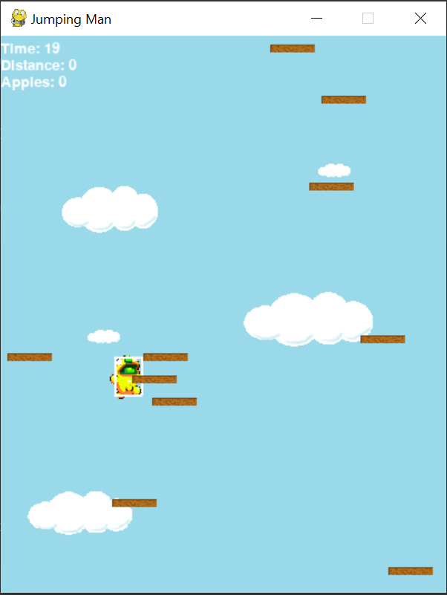

Fix:

I swapped the order of the code code for drawing the platforms and the player so the players sprite is always drawn above the platform so the player sprite will now overlap the platform.

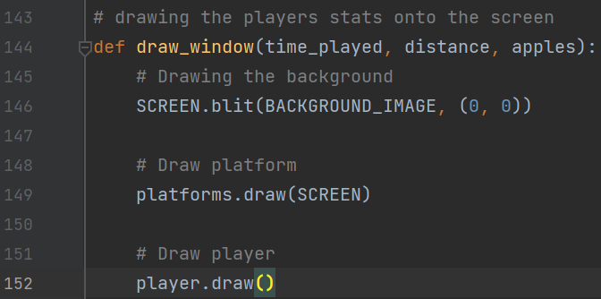

#### Adding Jumping

Adding the jumping mechanic to the game was the most difficult part of the code so far as I had to make sure it was working consistently working correctly as it was a core feature for the game. I encountered many issues while doing this section as many of my ideas caused logical errors.

Code:

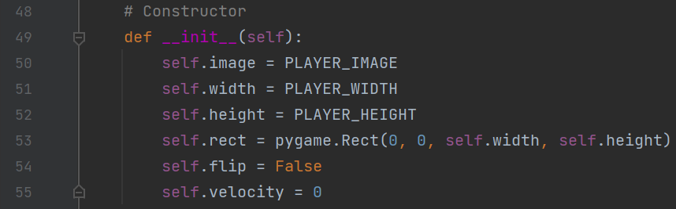

Player class

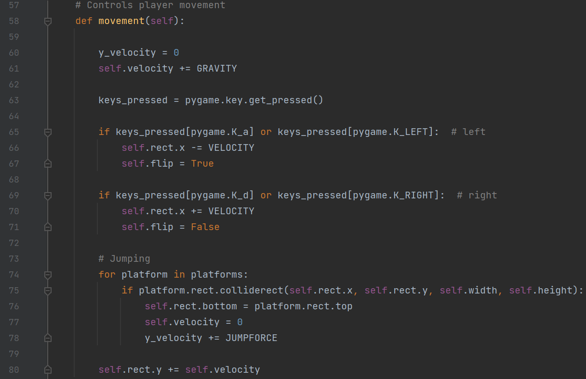

Updating the players rectangle position

Making the player jump when they collide with the top of a platform

Making the player move down with gravity

Result:

The result of this code caused the player to jump when they collide with the top of the platform and the user is able to jump through the bottom of the platform to get to the top



#### Success Criteria

|  |  |  |  |
| --- | --- | --- | --- |
| Success Criteria number fulfilled | Requirement | Justification | Reference |
| 12 | Player jumping | Needed to play the game | Interview 1 |

#### Testing

|  |  |  |
| --- | --- | --- |
| Test | Expectation | Result |
| Player collides with platform | Player bounces up from the platform | Player stays still when they touch a platform |
| Player jumps | They can pass through the platform above them | They pass through any platforms above them |

Error:

The player wasn’t moving correctly due to the wrong variable being adjusted on line 78

Solution:

I changed the code so that the players’ velocity would change according to the jump force instead of a variable, which was no longer in use.

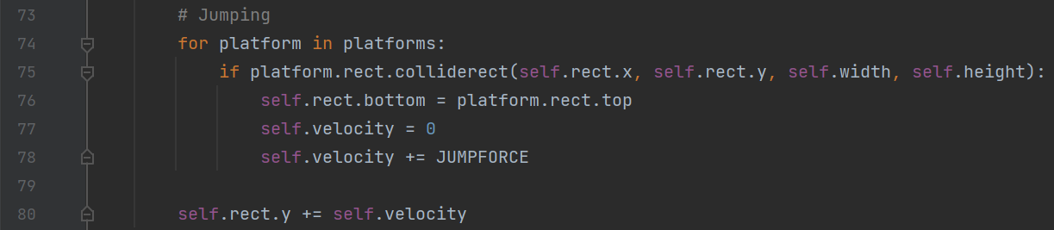

Error:

Now that jumping was working, I encountered more issues. When the player jumped on a platform, their sprite would go through the platform, or they would jump a few pixels above the platform. Another issue was that when the player jumped through a platform, they would immediately jump again without landing on the top of the platform they jumped on.



The issue where the player would jump too high was caused by the players’ velocity being changed by the jump force when colliding with the platform above causing the player to move faster. To fix this, I had to change the code so that the player would only jump when landing on the top of a platform and if the player was falling.

### Scrolling

Scrolling was necessary for the player to progress in the game as the platforms needed to scroll down so more would spawn in. I also changed the background to make the game more immersive.

Code:

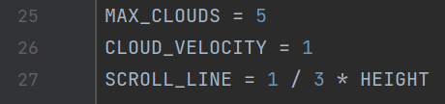

Setting variables for the clouds

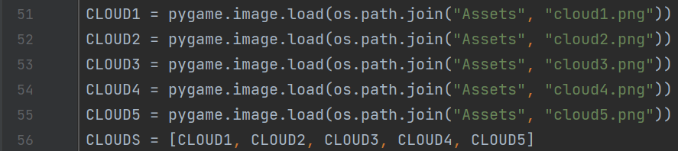

Loading all the cloud images and adding them to an array

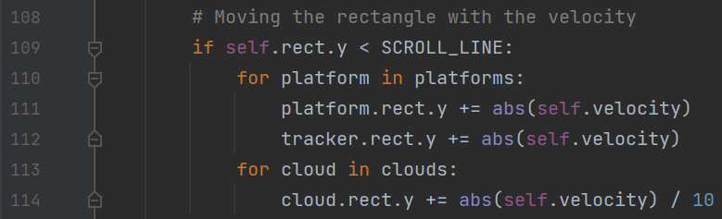

Moving the position of platforms if the player passes the scrolling line

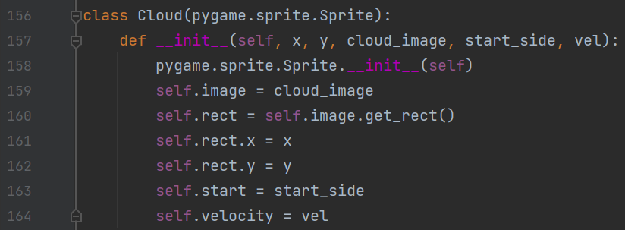

Creating the cloud class and adding pygame groups to manage them

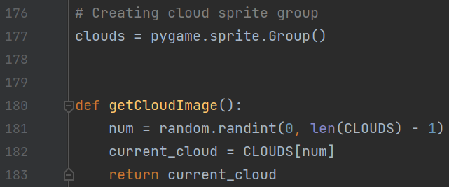

Randomly choosing a cloud image

Creating the cloud group

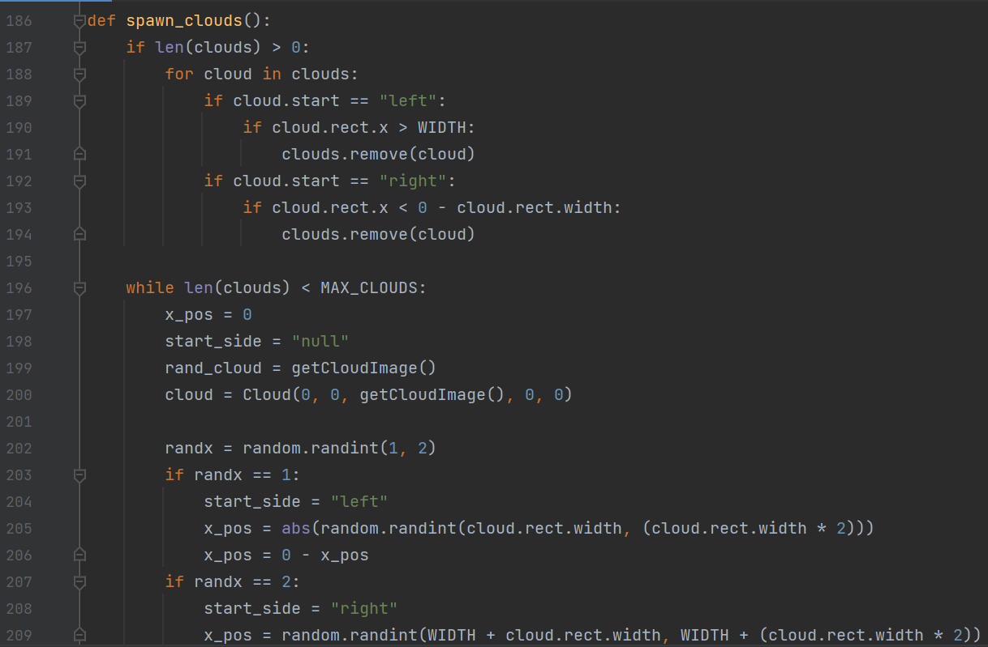

Spawning clouds on a random side of the screen

Removing clouds if they leave the screen to allow new clouds to spawn

Getting the cloud image and adding a cloud to the sprite group

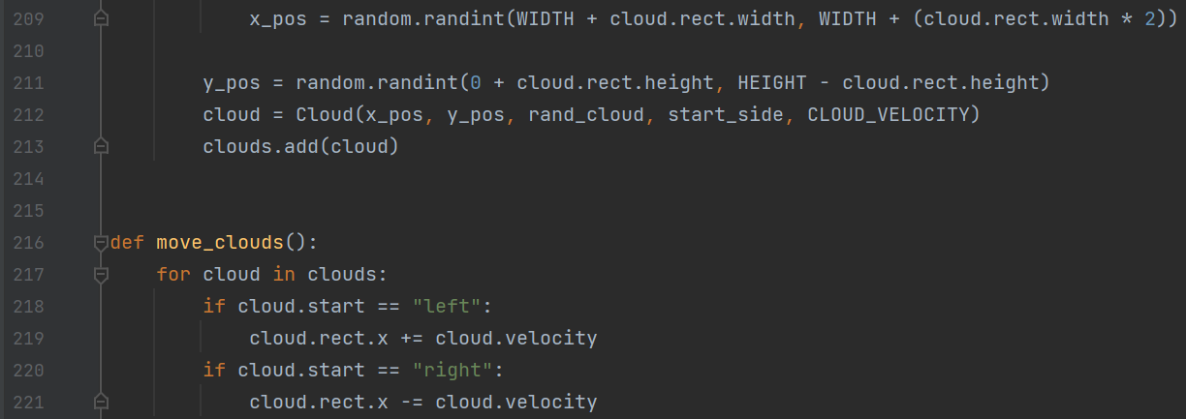

Moving clouds across the screen based on their set velocity

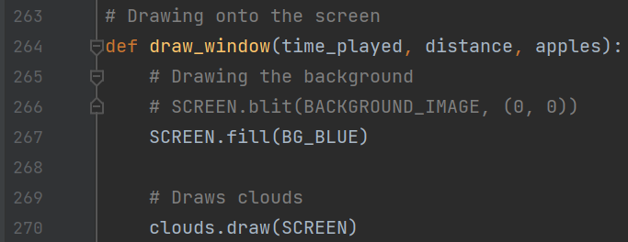

Drawing the cloud group onto the screen

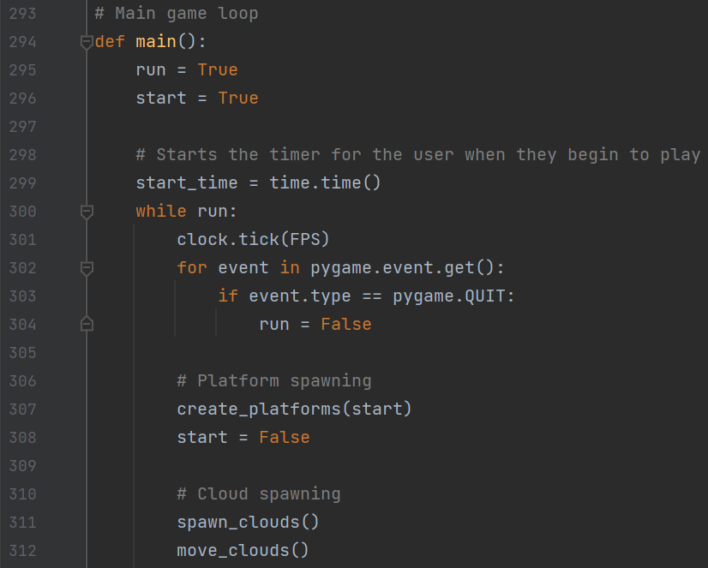

Managing clouds within the main loop

Result:

The platforms would scroll down and spawn correctly and the distance would update meaning the code from the previous section was working correctly. The newly added clouds would also spawn in and move across the screen and scroll at a slower rate, which gives the effect that the player is getting higher.

#### Success Criteria

|  |  |  |  |
| --- | --- | --- | --- |
| Success Criteria number fulfilled | Requirement | Justification | Reference |
| 13 | Moving background | Make the game more visually appealing | Interview 2 |

#### Testing

|  |  |  |
| --- | --- | --- |
| Test | Expectation | Result |
| Player reaches the scrolling line | The platforms start to scroll down | Platforms scroll down |
| Platform comes off the screen | New platforms spawn in at the top | New platforms spawn in |

Error:

The scrolling was very fast, which caused platforms to spawn on top of each other and the player would jump off screen a lot of the time.



To fix the platforms scrolling too fast, I added a variable to determine how fast platforms would go instead of having platforms move at the same velocity as the player.

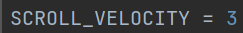

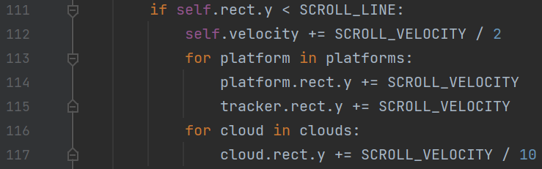

Managing clouds within the main loop

While doing this, I also changed the code so the player would slow down when above the scrolling line so it was harder to reach the top of the screen.

### Adding UI

Adding a user interface was another important part of the game as the player needed to be able to access a leader board, settings, start menu and pause menu.

Importing pickle and itemgetter to save and load the leaderboard

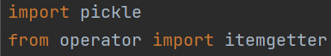

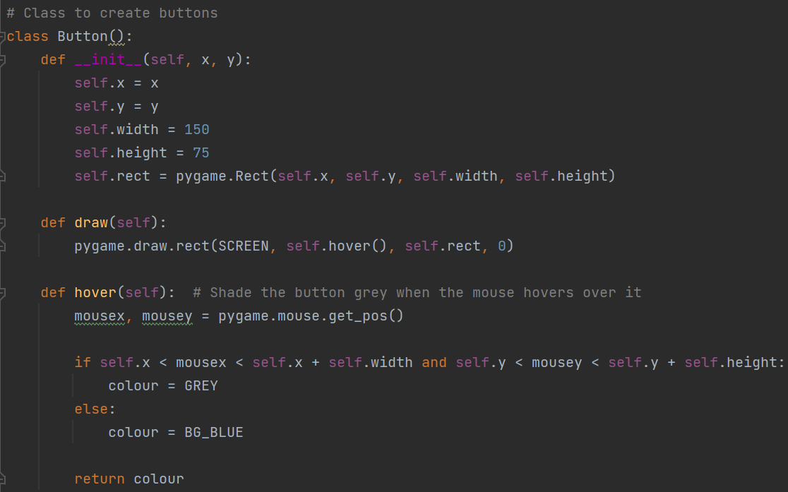v

Function to check if the mouse is hovering over a button so it changes colour to indicate that it can be clicked

Function to draw the button onto the screen

Creating a class for buttons to easily add and manage them

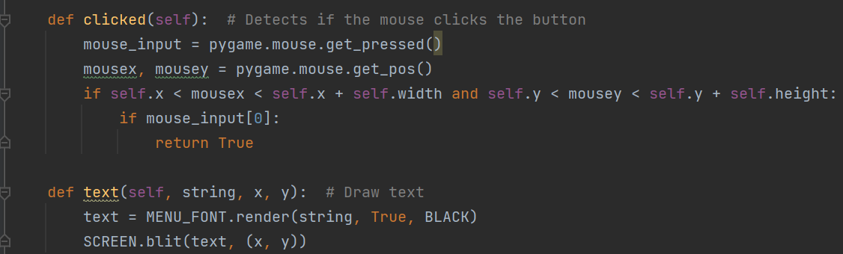

Function to more easily draw text onto the screen for the buttons

Function to check if the mouse has been clicked

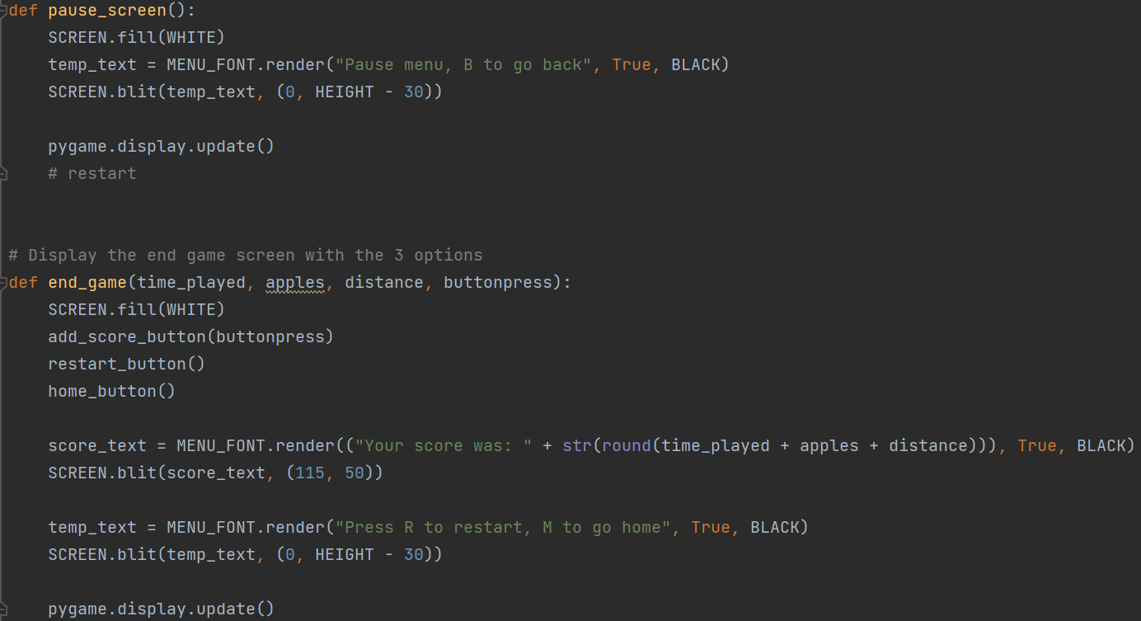

Function to draw the end game screen for when the user dies

Calling all of the button functions

Function to draw the pause screen

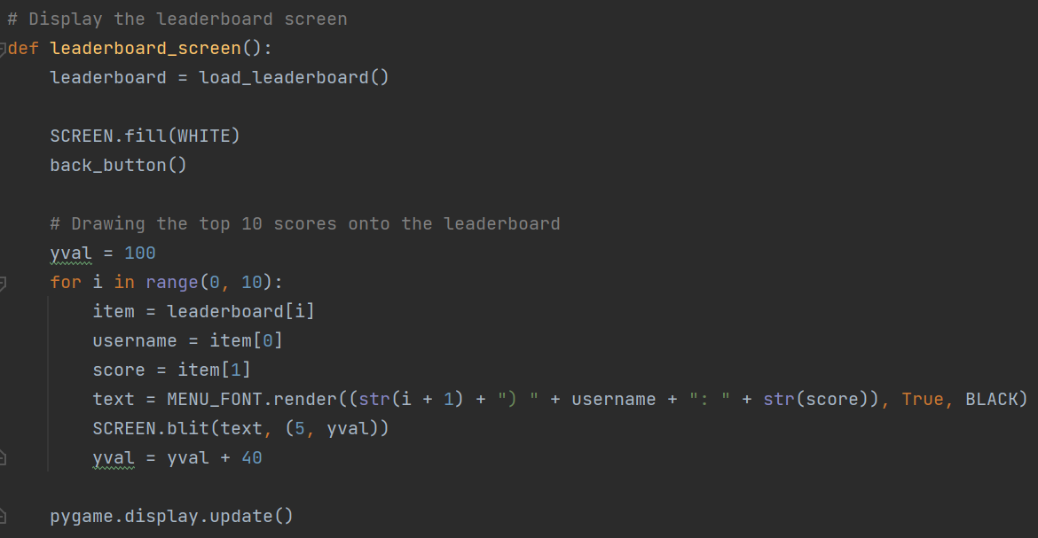

Loop which goes through the first 10 tuples in the leaderboard list and displaying them onto the screen in order of highest to lowest

Function to draw the leaderboard screen

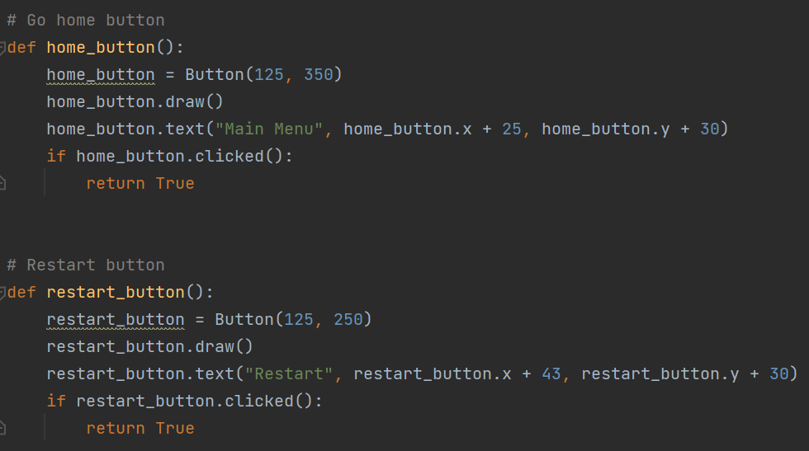

Creating the restart button object to reset the game

Creating the button to go back to the main menu

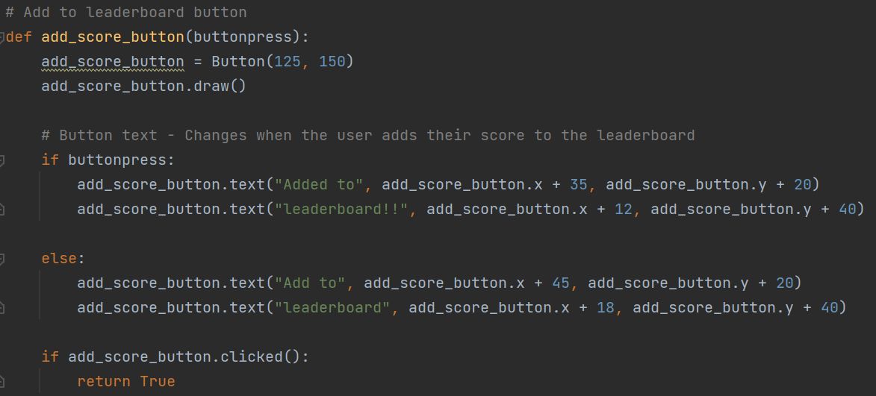

Creating the add to leaderboard button, which changes once clicked so the user cannot input their name multiple times

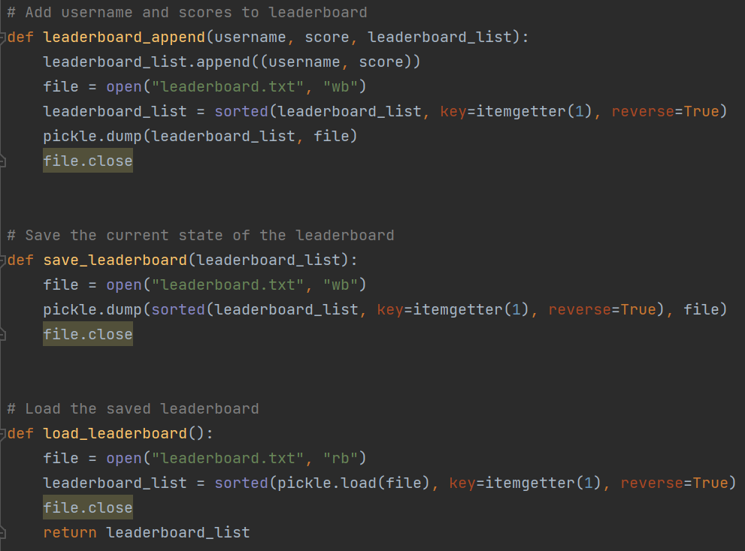

Function to load and return the leaderboard so it can be displayed

Function to save the leaderboard

Saving the updated leaderboard

Function which allows the user to add their name and score as a tuple to the leaderboard array

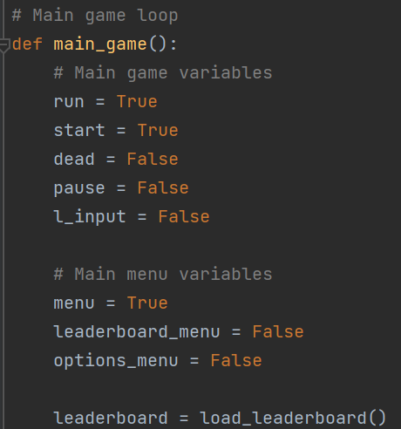

Variables which are used to display which part of the menu should currently be shown

Creating the leaderboard variable

Indicates if the user has added their score to the leaderboard so it can only be added once per attempt

Adding new variables

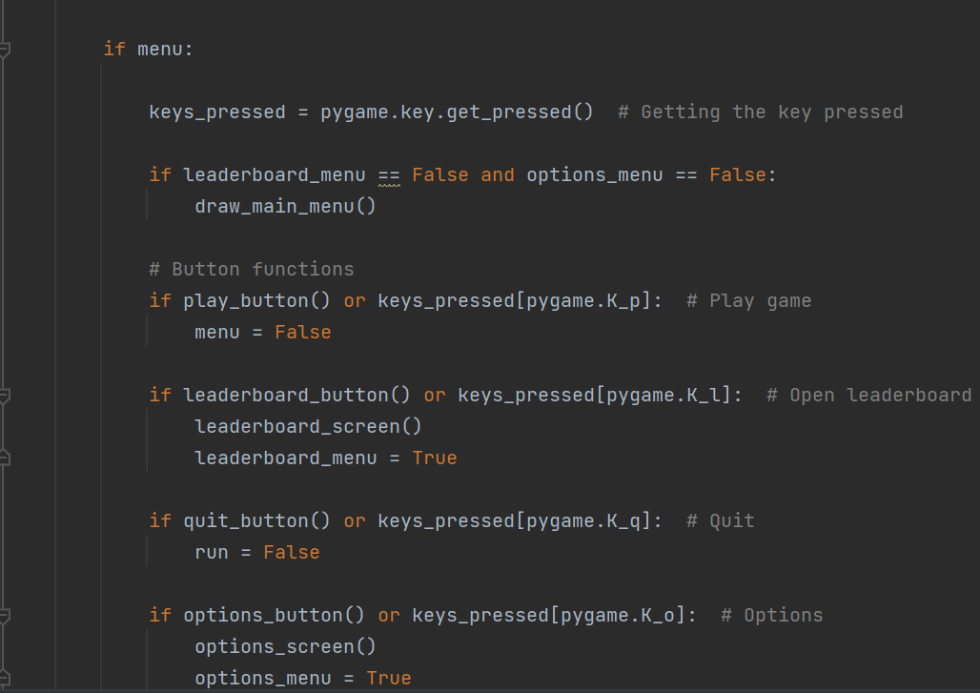

Displays the options screen if the key or button was pressed

Checks if the quit button or key has been pressed then ending the loop to close the program

Displays the leaderboard screen if the button or key is pressed

Calling the play button. If clicked the main game starts

Drawing the main menu if the leaderboard and the options screens aren’t active

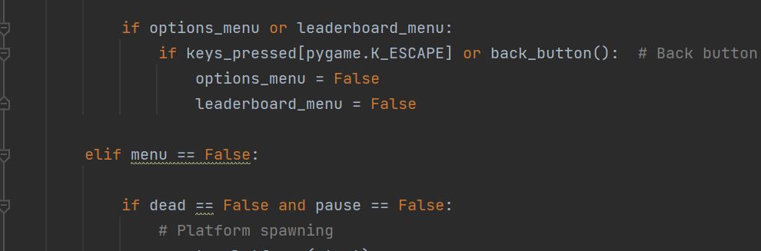

When the play button is pressed, menu is set to false, which allows the main game to run

Checking if the user has pressed the button or key while in the leaderboard or options menu so It goes back to the main menu

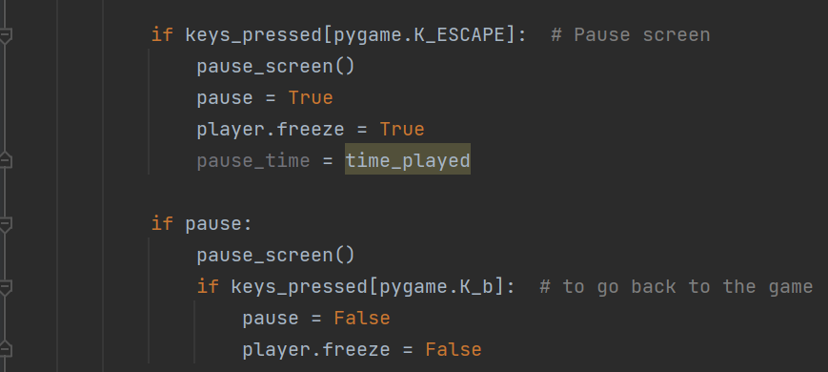

Passing the score variables so they can be displayed on the end game screen and the l_input variable so the text changes when the user adds their score

Checks if the user has left the pause menu and continues to run the main game

Checks if the user has pressed the escape key to display the pause menu, which also stops the player from moving

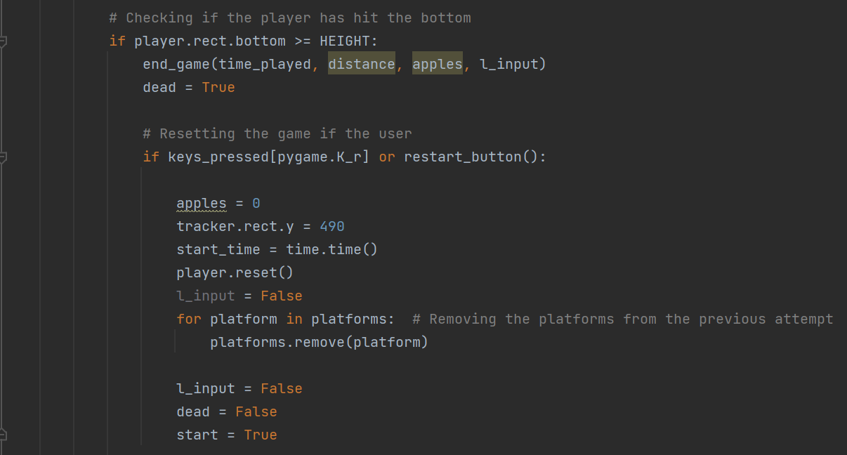

Changing the main variables so the game spawns the starting platforms

Checks if the user has pressed the restart button or key

Resets all the variables and platforms when the user restarts

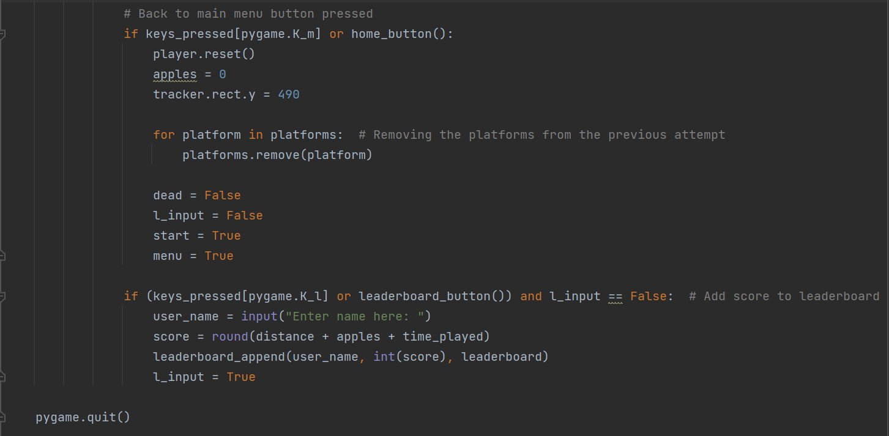

Allows the user to add their score to the leaderboard when they press the button

Resetting the game when they go back to the menu

Checks if the user has pressed the home button or the key

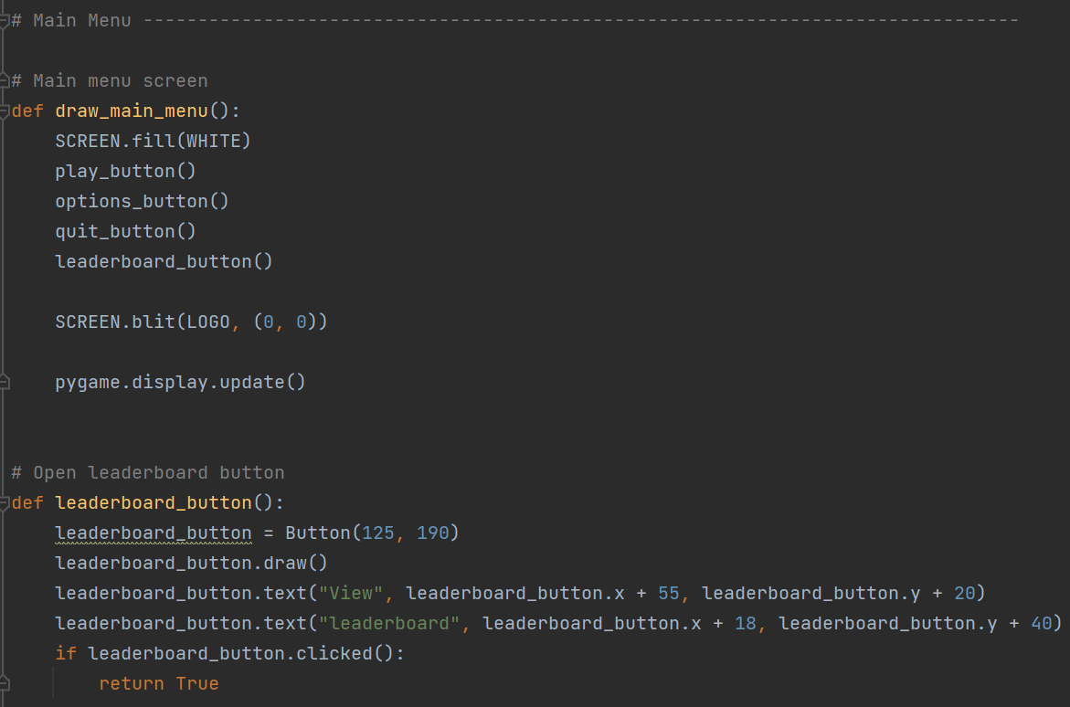

Creating the leaderboard button and text

Drawing the main menu

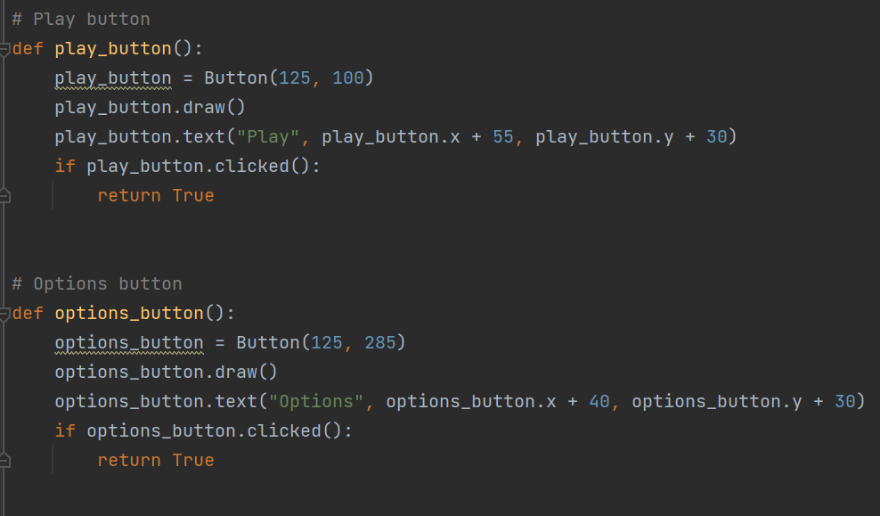

Creating the options button and text

Creating the play button and text

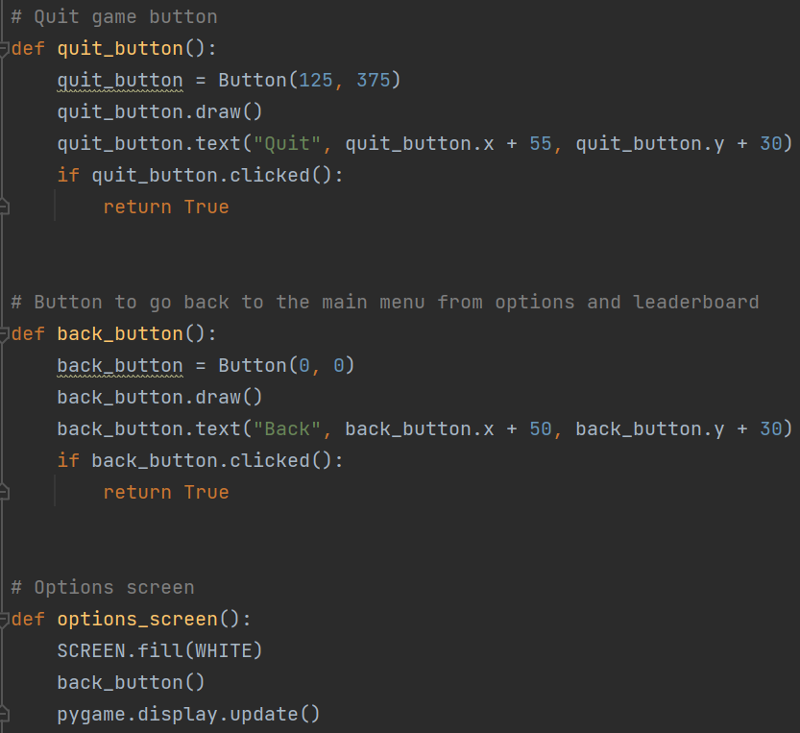

Drawing the options screen

Creating the back button and text

Creating the quit button and text



External leaderboard file where they get saved

Result:

When the program runs, the main menu is displayed with all of the buttons. Each button becomes grey when hovered over and can all be clicked. When the play button is pressed, the game starts. When the leaderboard button is pressed, the leaderboard screen is displayed and correctly shows users scores and the back button is present to allow the user to go back to the main menu. When the options button is pressed, the options screen is displayed. However, I have decided to finish the options menu and the pause menu at a later time as not all of the features had been added yet such as sound and the pause menu is going to display the options menu as well as a button to end. The quit button closes the game.

Main menu:

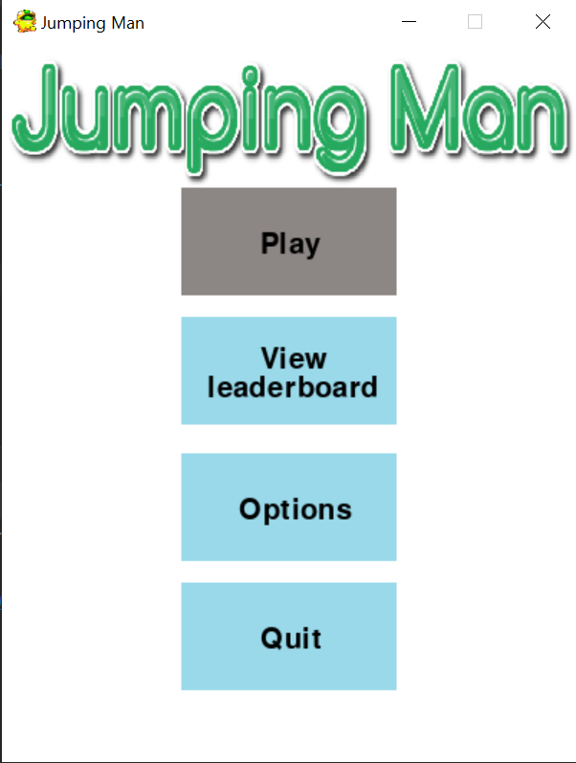

Leaderboard screen with scores and names from testing:

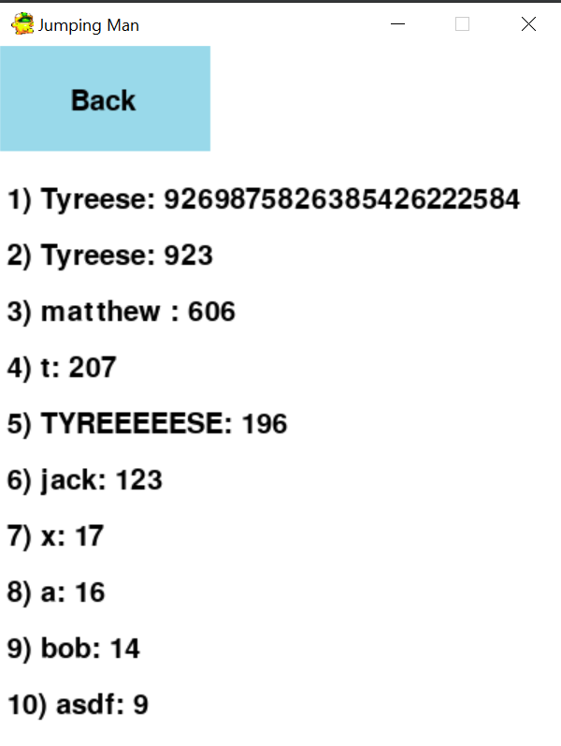

Unfinished options screen:

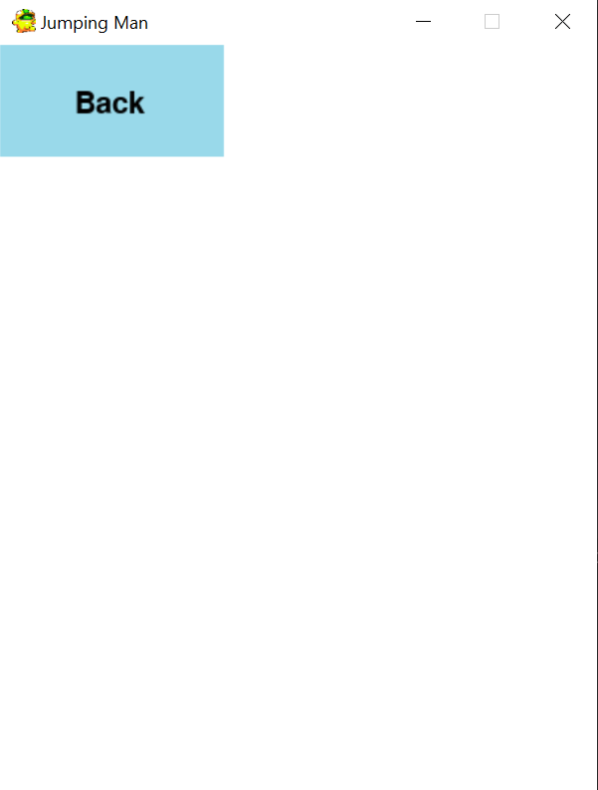

Unfinished pause menu:

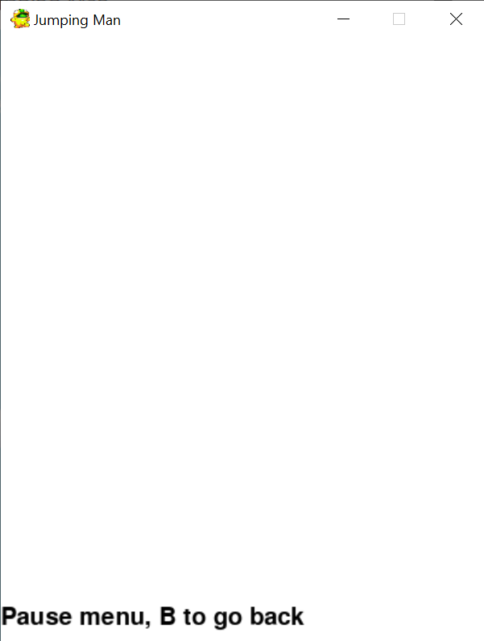

End game screen:

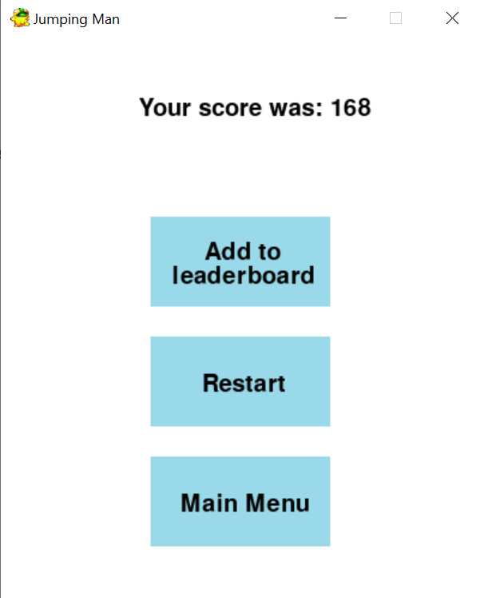

Pause menu after the button had been pressed once:

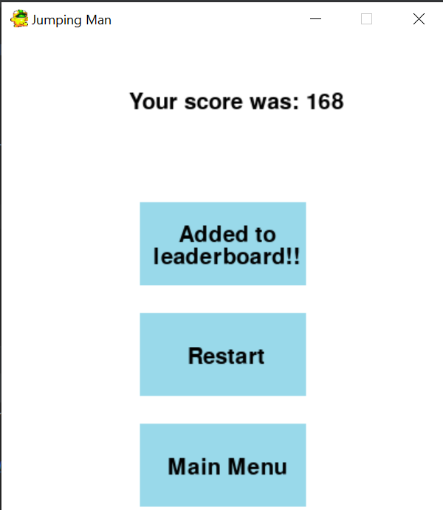

#### Success Criteria

|  |  |  |  |
| --- | --- | --- | --- |
| Success Criteria number fulfilled | Requirement | Justification | Reference |
| 2 | Menu screen with buttons to play and quit | Allow the user to interact with the game through a GUI | Interview |
| 5 | End game screen | To display the users score and to save it to the leaderboard | Interview 2 |
| 6 | Button to play again on the end game screen | Make the game more accessible as it is quicker to play as the user doesn’t have to go back to the main menu to restart | Interview 2 |
| 7 | Main menu button on the end game screen | Allow to user to access the main menu to do things such as check their position on the leaderboard | “Doodle Jump” feature |
| 8 | Button to add scores to the leaderboard on the end game screen | To allow the user to interact with other players through comparing scores on the leaderboard | Interview 1 |
| 10 | Button to view the leaderboard | So the user can view the top 10 scores and compare them | Interview 2 |

#### Testing

|  |  |  |
| --- | --- | --- |
| Test | Expectation | Result |
| On main menu, the user presses “P” or clicks on the play button | The main game starts | Main game starts |
| On main menu, the user presses “L” or clicks on the leaderboard button | Leaderboard menu opens | Leaderboard menu opens |
| On main menu, the user presses “O” or clicks on the options button | Options menu opens | Option menu opens |
| On main menu, the user presses “Q” or clicks on the quit button | Pygame window closes | Pygame window closes |
| Opens the leaderboard menu | Top 10 scores are displayed in order of highest to lowest and a back button appears | Top 10 scores are displayed in order of highest to lowest and a back button appears |
| Opens the options menu | Options menu opens | Options menu opens |
| When on options menu or leaderboard menu, the back button is clicked | Main menu opens | Main menu opens |
| Mouse hovers over any of the buttons | Buttons turn grey to indicate that they are being hovered over | All buttons turn grey except for the back button on the options and leaderboard menu |
| Escape key is pressed when the main game is playing | Pause screen appears and timer and distance freezes while it is open | Pause screen appears  Timer and distance freeze while it is open |
| User hits the bottom | End game screen appears | End game screen appears |
| End game screen opens | High score is displayed  Buttons are displayed | High score is displayed and buttons appear |
| Add to leaderboard button Is pressed or “L” key is presed | Program asks the user to input their name and the button can only be pressed once | Sometimes, nothing happens when the button is clicked but works when the “L” key is pressed |
| User enters their name to the program | Score is added to the leaderboard | Score is added to the leaderboard |
| Restart button is pressed | Game starts again | Game starts again |
| Main menu button is pressed | Goes back to the main menu | Game quits |

Error:

I encountered many logical errors during this time. The first one is that when starting the program the timer begins so when the user starts playing it displays the time the program has been running for

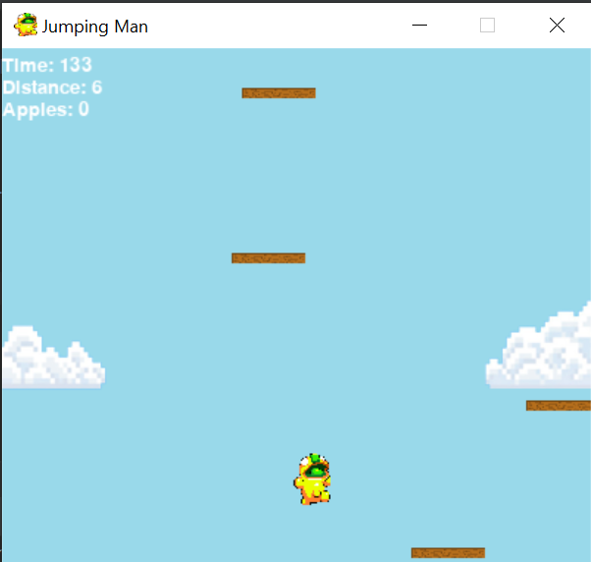

Solution:

I moved the line of code to start the timer into the if statement which starts the game when the button is pressed. When adding the menus I forgot to move the timer start.

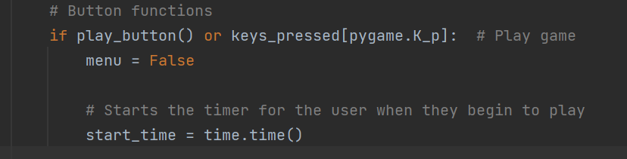

Error:

When clicking on a button, the button press would still register between menus so any buttons which have the same position would also be pressed. For example, when pressing main menu on the end game screen, it would also press the quit button on the Main menu when it appears causing the game to quit even though it should’ve opened the main menu. This is because the mouse was in the same position and the left click is still registered as true when the main menu opens.

Solution:

To fix this, I added a very small delay for the restart button and the main menu button on the end game screen so that the time taken to click is shorter than the time taken to switch between menus.

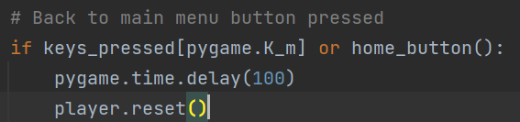

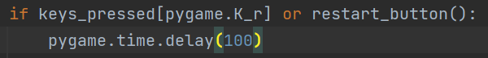

Error:

When on the leaderboard and options menu, the back button doesn’t appear grey when hovered over. However, it can still be clicked. Also, the other buttons on the main menu screen could still be clicked in the leaderboard and options screen even though they weren’t visible.

Solution:

I indented the highlighted region of code so that the button objects would only be created if the leaderboard and options menu weren’t showing meaning they couldn’t be pressed unintentionally.

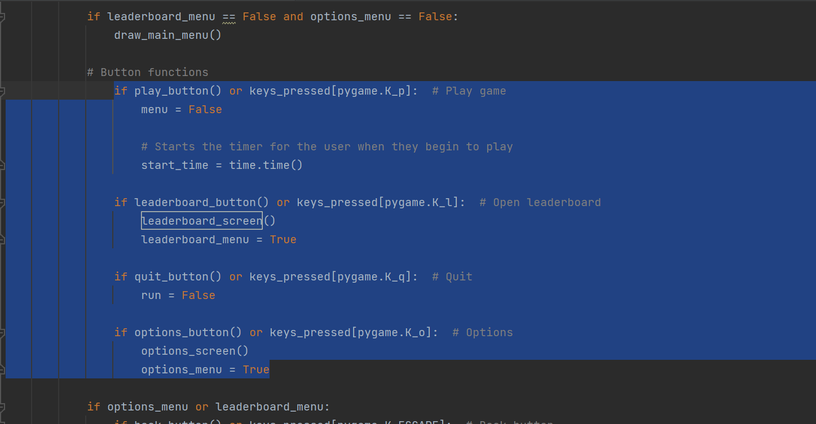

And to fix the issue with the buttons not appearing grey, I moved the code in the leaderboard screen and options screen methods into the draw main menu method. When I did this the back buttons would appear grey when hovered over.

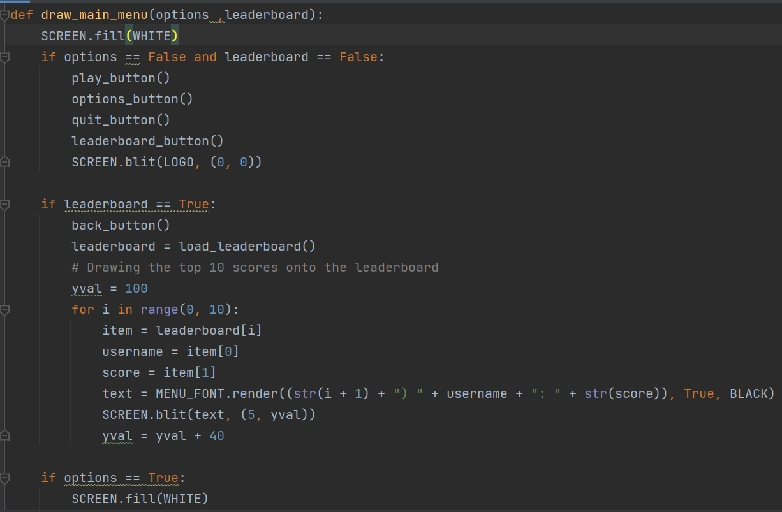

I also had to pass the leaderboard_menu and options_menu variable to display the correct menus

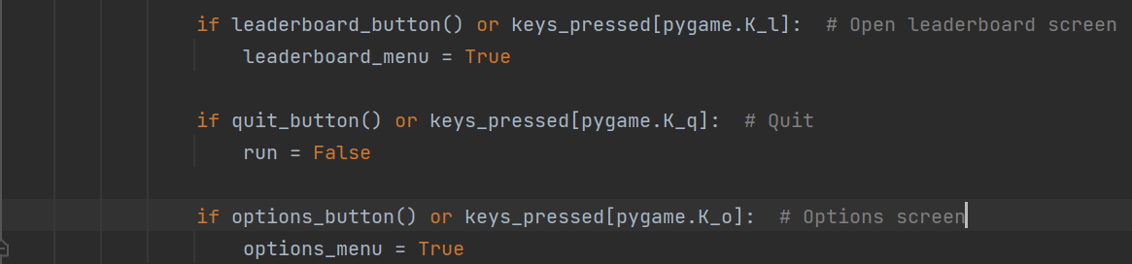



### Adding powerups

Now that the main game was functional, I decided to add power-ups to make the game more enjoyable. I will do this by implementing a power-up class and creating methods within the class to perform the power up, such as a function to increase the players jump height. I also decided to implement the apples as a powerup as it would be easy to manage.

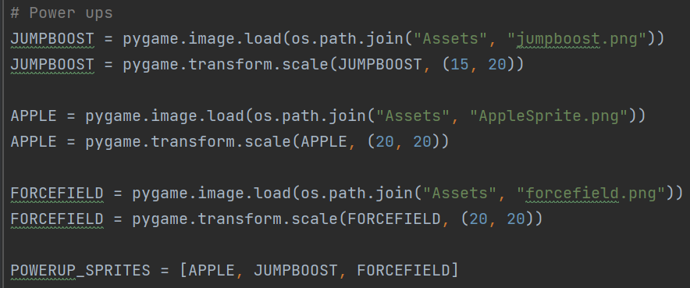

Loading the images for each powerup and adding them to a list

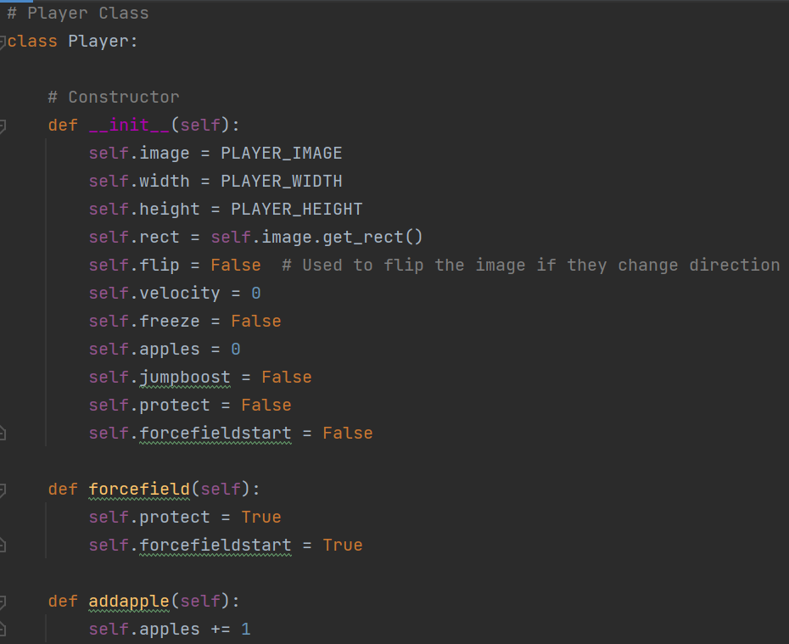

Creating a function to increment the number of apples by 1

Creating a function to identify that the player has an active forcefield

Adding 4 attributes to the player class, which are being used to use powerups

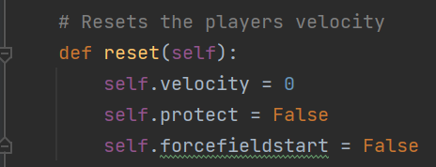

Adding the protect and forcefield start flag to the reset function so they don’t interfere with new attempts

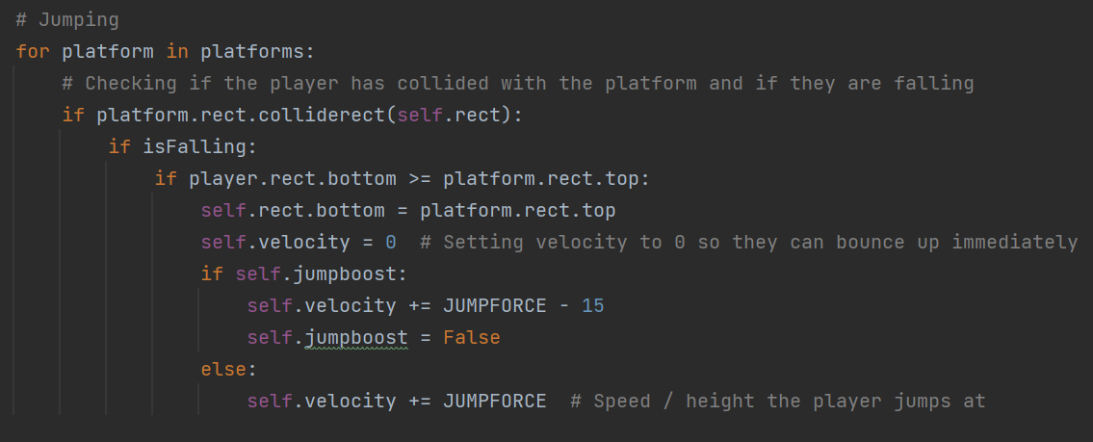

Setting the jump boost to false so it isn’t permanent

Adding extra height to the players jump if the jump boost is active

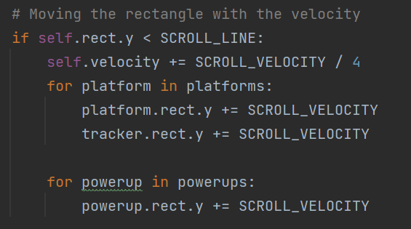

Creating the powerup class

Moving the powerups at the same rate as the platforms

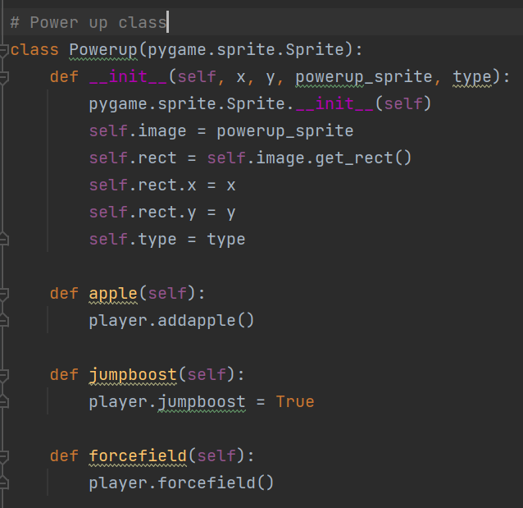

Method to call the players forcefield function

Method to set the players jump boost to True

Creating a method to add an apple

Adding the type attribute to indicate which powerup the object is

Creating the rectangle

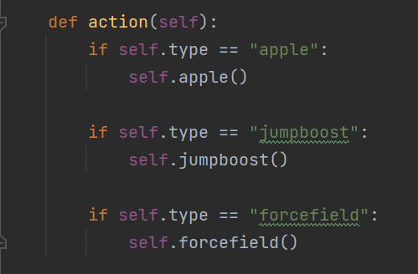

Creating the powerups pygame group

Creating a method to call the correct method based on the type of powerup the object is

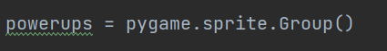

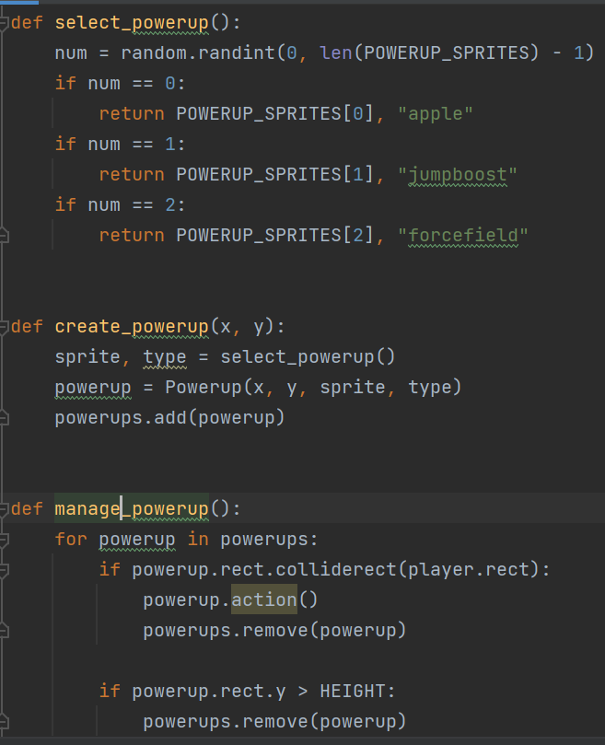

Checking if the powerup is off screen then removing it from the sprite group

Calling the action method to call the correct method based on the type

Removing the powerup from the sprite group so it cant be used again

Checking if a powerup collides with the player

Adding the powerup to the pygame group

Creating a powerup based on the results of the method above

Assigning the image and type based on the random number chosen

Selecting a random number

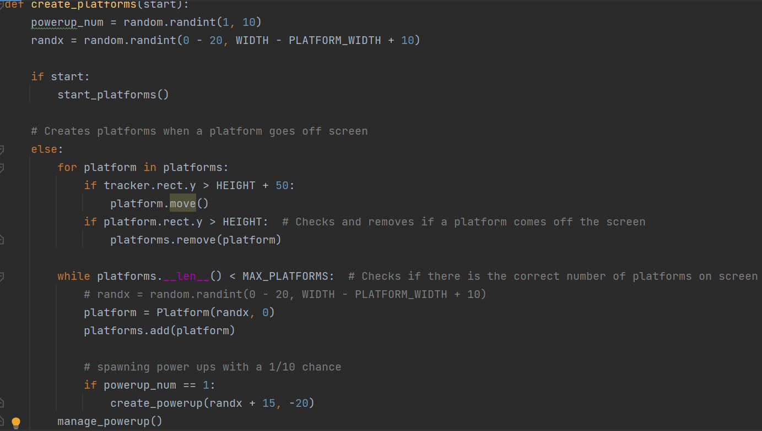

Calling the manage powerup method

Creating a powerup if the random number is 1. So there is a 10% chance a powerup spawns

Creating a random number

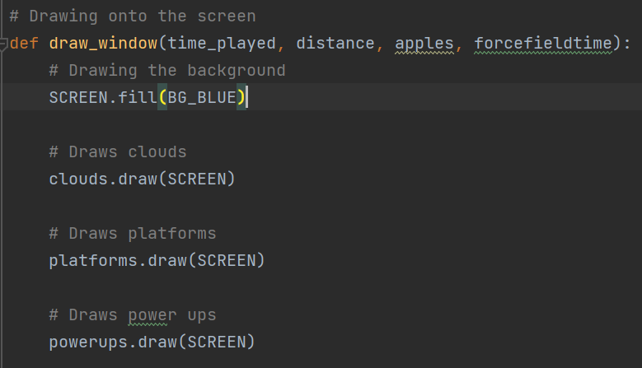

Drawing the powerups onto the screen

Adding the time left for the forcefield argument

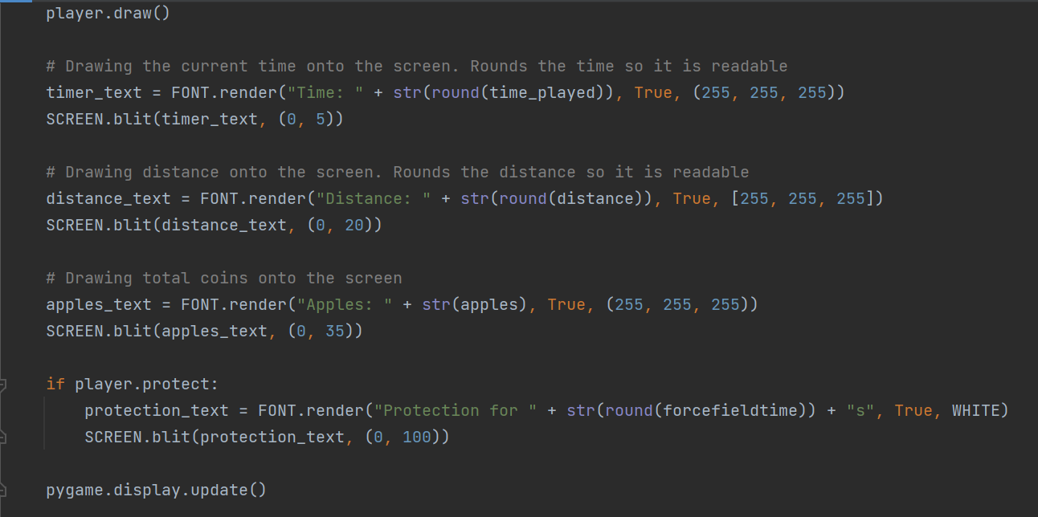

Drawing the text onto the screen if the forcefield is active

Checking if the forcefield is active

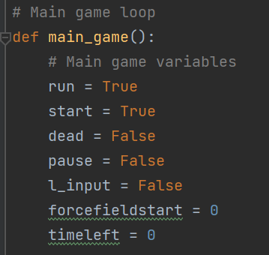

Creating the force field start time and the time left variables

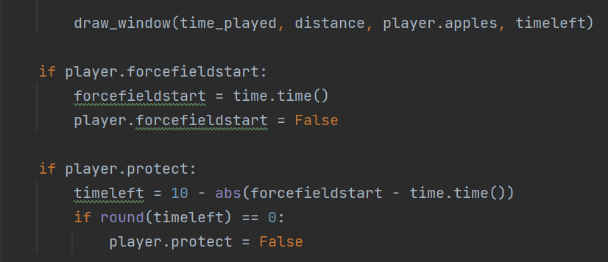

Calculating the time remaining and removing the forcefield if the 10 seconds ends

Setting the forcefield start time

Passing the apples collected and time left into the draw window function

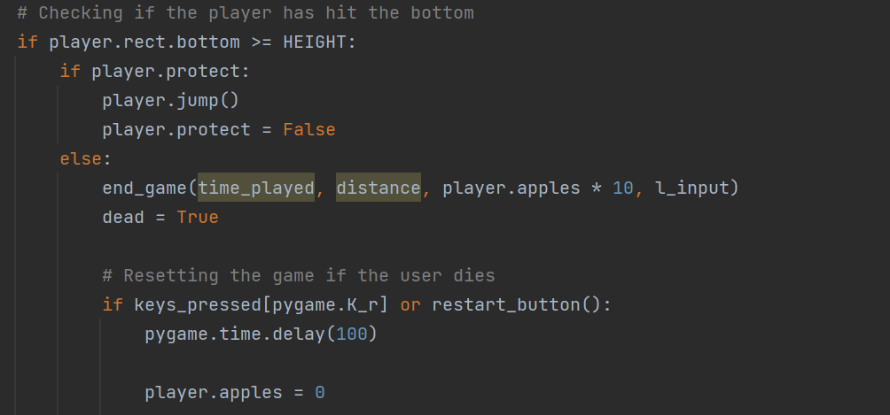

Removing the forcefield if they hit the bottom

Jumping if the player hits the bottom while the forcefield is active

I used these three images for the powerups that I currently had in the game

Apple:

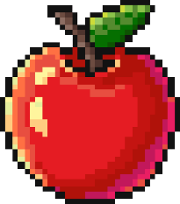

Forcefield:



Jump boost:

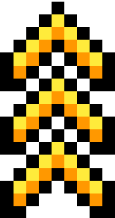

Result:

Powerups would occasionally appear on platforms and move down at the same speed as the platforms. When the player collided with a powerup, it would disappear and the player would get the boost from the powerup they picked up. The forcefield powerup protects the player for 10 seconds, however it breaks if they hit the floor. The jumping powerup gives the user a large jump boost on their next jump and the apples gives the user an addition 10 points to their final score. Also, when the user collided with a forcefield, text would appear indicating how much time remains of the forcefield.

Screenshot showing the powerups spawning:

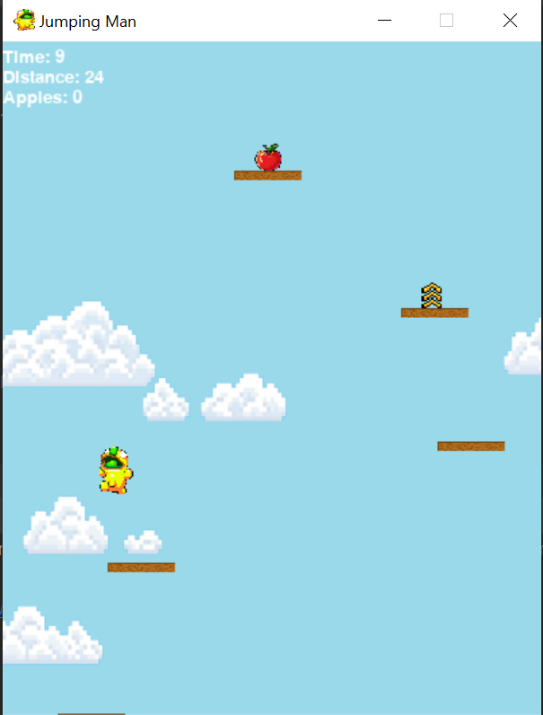

Screenshot showing the forcefield time remaining text after picking up the forcefield power up:

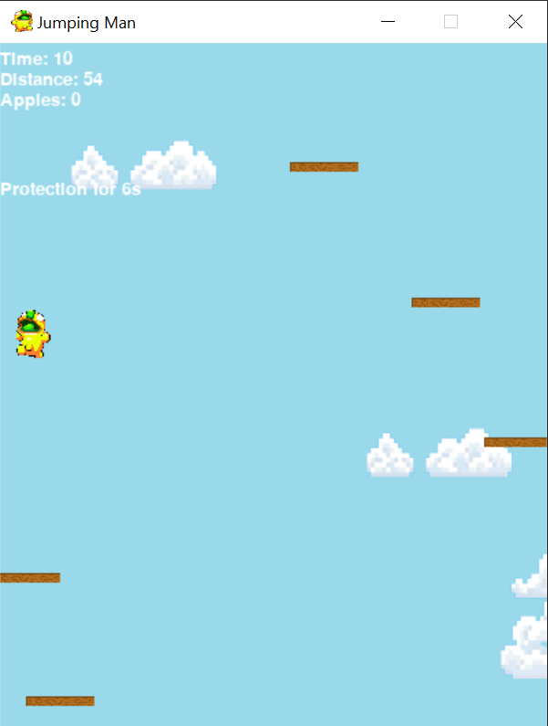

#### Success Criteria

|  |  |  |  |
| --- | --- | --- | --- |
| Success Criteria number fulfilled | Requirement | Justification | Reference |
| 14 | Powerups that allow the player to do things such as a super jump | Make the game more enjoyable | Interview 2 |
| 11 | Coins for the player to collect | More options for the player to increase their score | Interview 1 |

#### Testing

|  |  |  |
| --- | --- | --- |
| Test | Expectation | Result |
| Player reaches the scrolling line | Powerups move down with the platforms | Powerups move down |
| New platform appears | Powerup spawns in above the platform | Powerups spawn in |
| Player collides with an apple | The apple is picked up and the number of apples increments by 1 | The apple disappears and number of apples increments by 1 |
| Player collides with a jump boost | Jump boost is picked up and the players next jump has a boost | The players next jump has a boost |
| Player collides with a forcefield | Forcefield is picked up, text showing a 10s countdown appears. The player also doesn’t die if they hit the bottom | The forcefield is picked up, the countdown appears. However, sometimes the player dies even though the countdown is still active |
| Game ends where apples have been collected | Apples add 10 points to the users score | Apples add 10 points to the users score |

Error:

The program stopped running because when a random number was chosen to choose a random sprite. This was because I left the -1 inside of the bracket so it was an unrecognised variable.

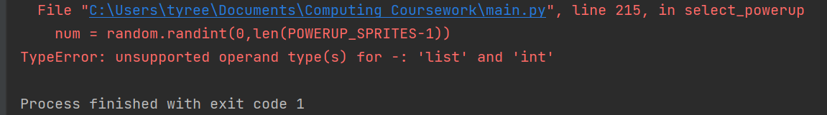

Solution:

I put the -1 on the outside of the bracket

Error:

When a platform was created, the program would stop because it said that there was no attributes called move. This was because while I was creating the class, I left the functions indented within the constructor

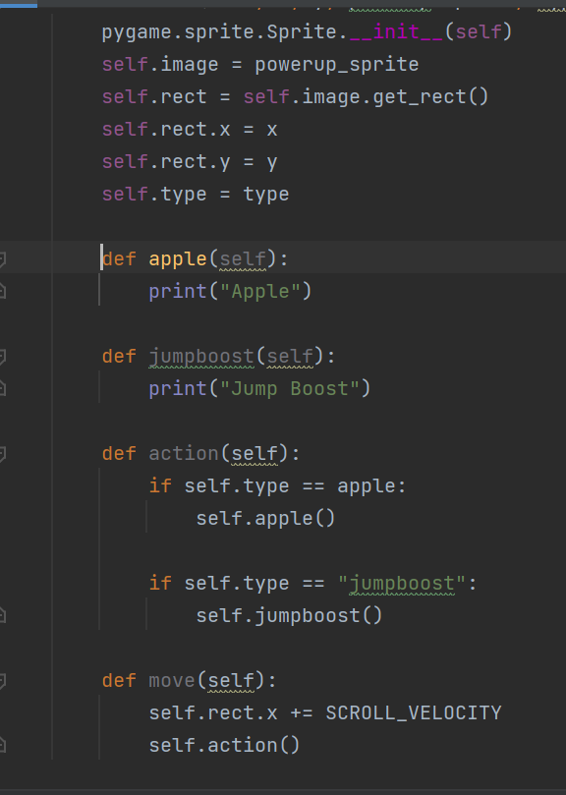



Solution:

I unindented the functions within the class so that they belonged to the class and not the constructor for the class.

### Adding sound

Adding sound to the game is an easy process, however I needed to add sounds to the game so I could start working on the options menu, which is also completed in this section.

Initialising pygame mixer so I can use sounds

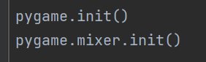

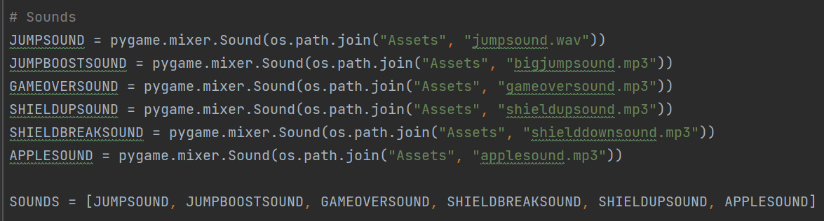

Loading the sounds

Adding the sounds to a list to make them easier to manage

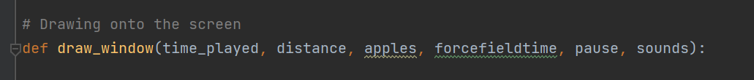

Adding pause and sounds as arguments in the draw window method

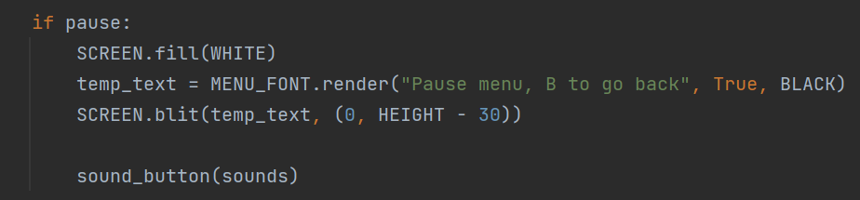

Creating the enable sound method

Calling the sound button function and passing sounds to check if sound is on or off

Drawing the pause screen if pause is passed as true.

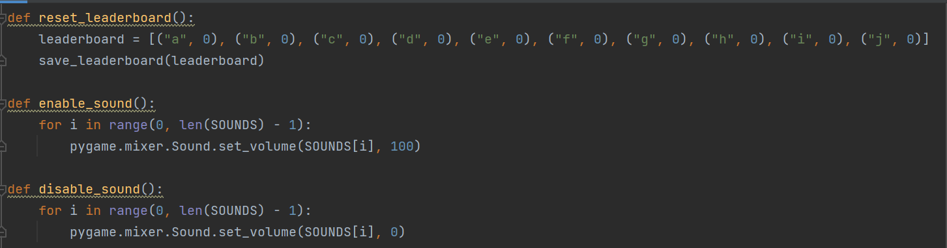

Creating the disable sound method

Going through the sound list and setting the volume to 0

Going through the sound list and setting the volume to 100

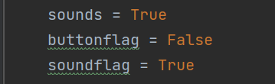

Adding new variables

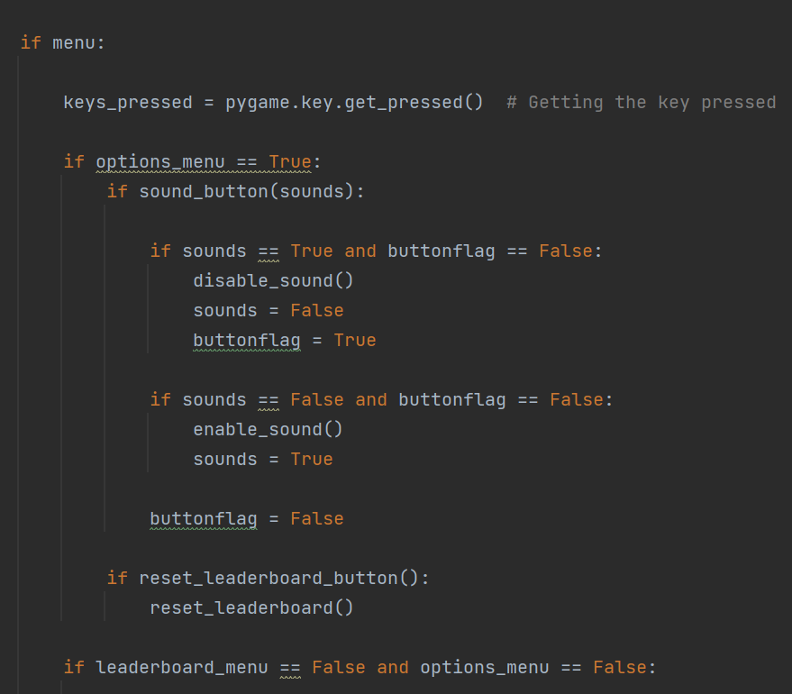

Setting button flag to true so the next if statement isn’t used

Enabling the sound if the sound is off when it is clicked

Muting the sound if the sound is on when it is clicked

Checking if the sound button is clicked

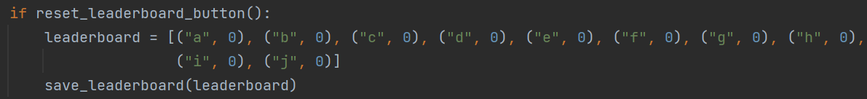

Clearing the leaderboard by saving it as 10 tuples with 0 score

Enabling the sound if the sound is off when it is clicked



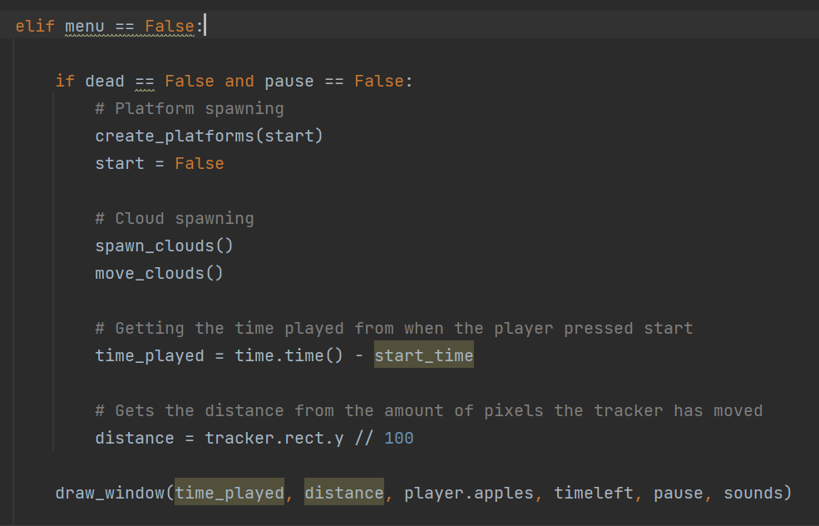

Passing sounds to the draw main window method

Passing sounds to the draw main menu method

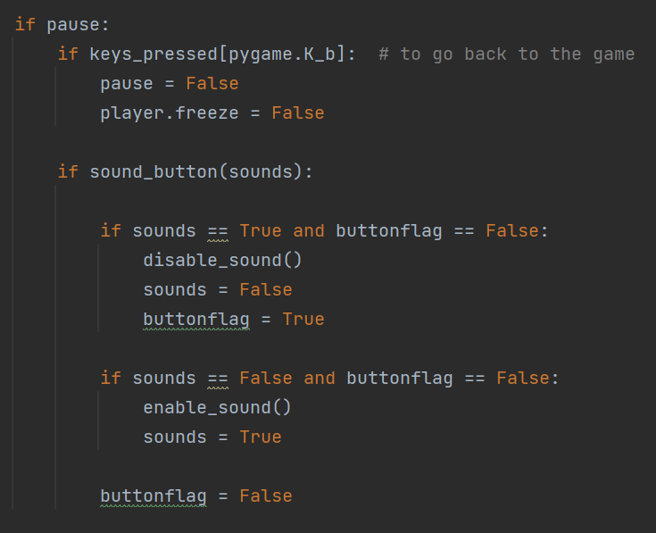

Enable / disabling sound if the sound button is clicked in the pause menu



Adding sounds as an argument

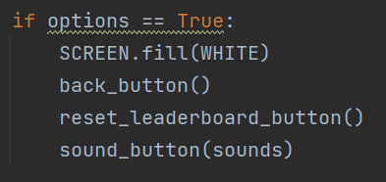

Drawing the options screen and creating the buttons

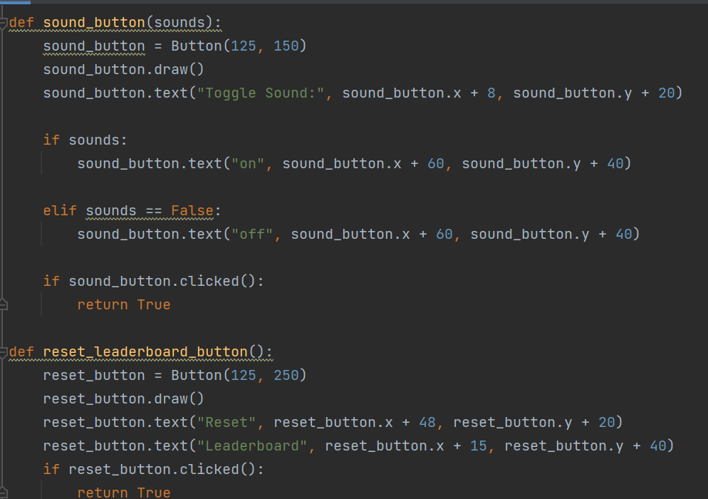

Creating the reset leaderboard button

Changing the on/off text depending on if the sound is enabled or disabled

Creating the sound button object

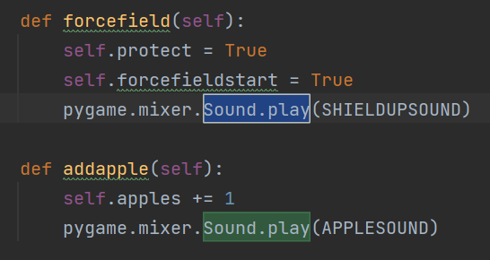

Playing the apple sound when the user collects an apple

Playing the shield up sound when the user gets their forcefield

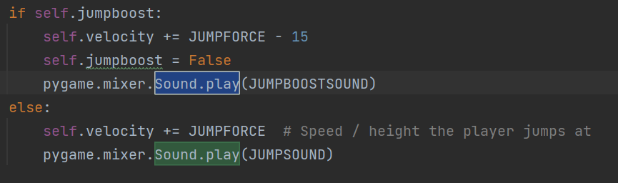

Playing the normal jump sound when the user jumps

Playing the jump boost sound when the user uses the jump boost powerup

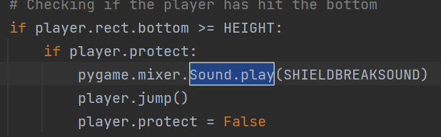

Playing the game over sound when the user hits the bottom without a forcefield

Playing the shield break sound when the users shield breaks

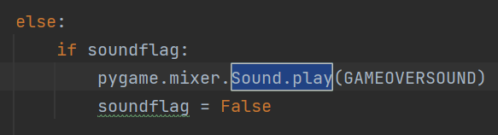

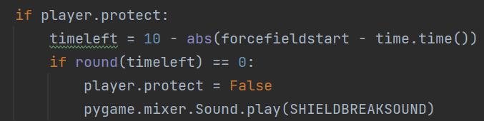

Playing the shield break sound when the shield timer expires

Result:

The options menu now displayed the option turn sounds on and off and to reset the leaderboard. I added the option to reset the leaderboard as sometimes the leaderboard file becomes corrupt and resetting it allows it to be used again.

Options menu:

When the toggle sound button is clicked, the text below “toggle sound” changes depending on whether the sound is on or off.

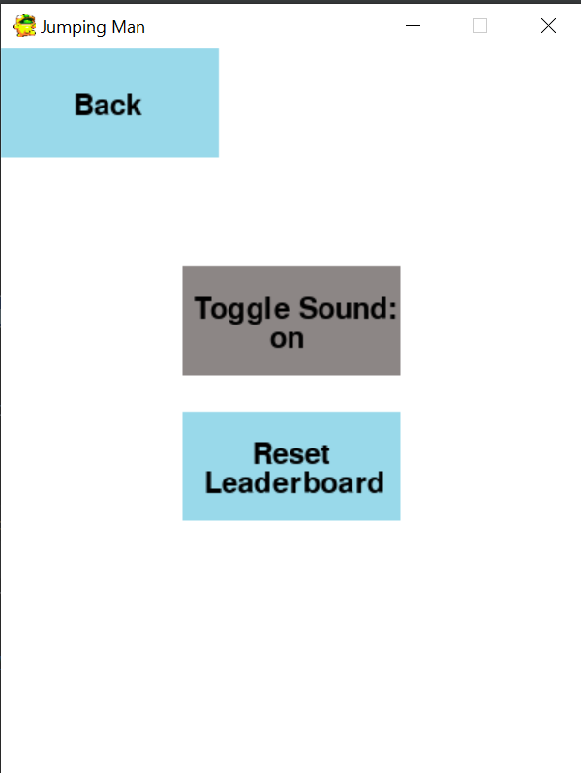

Pause menu:

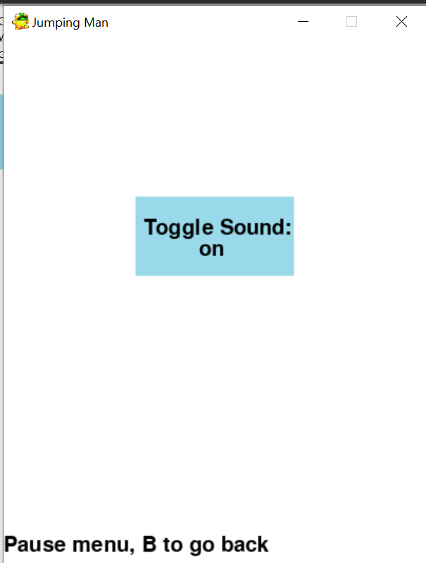

Options menu when the sound button is clicked:

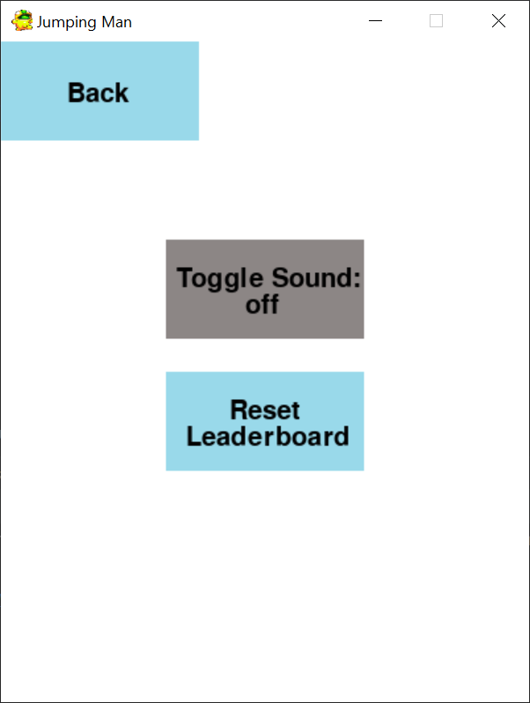

Leaderboard before pressing reset:

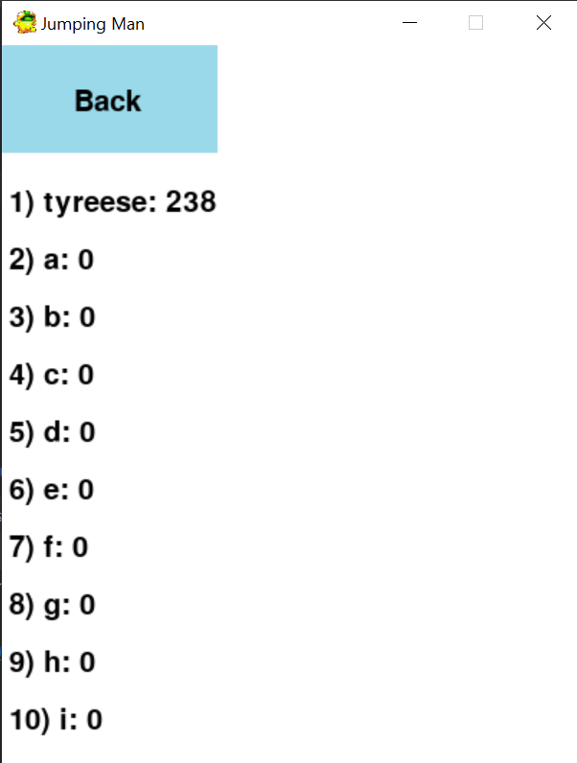

After pressing reset:

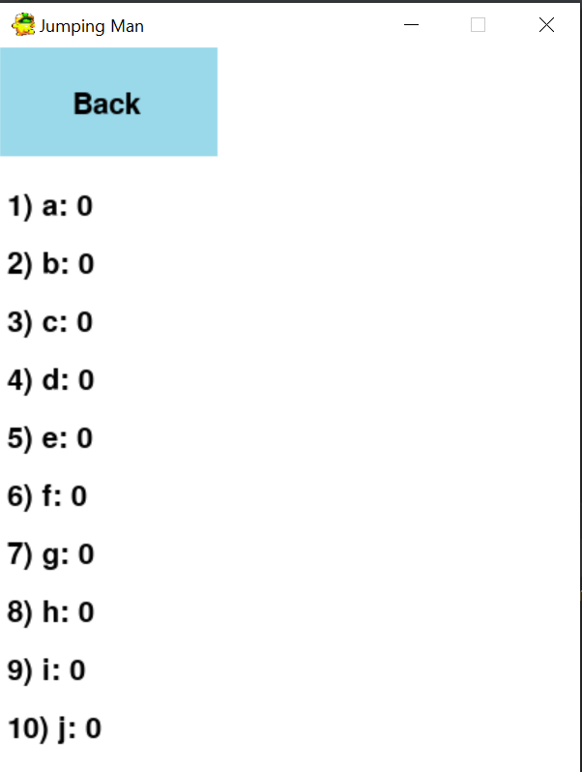

Sounds also played at key points such as when the user jumps, dies and collects one of the power ups. They all have unique sounds to make them identifiable based on the sound.

#### Success Criteria

|  |  |  |  |
| --- | --- | --- | --- |
| Success Criteria number fulfilled | Requirement | Justification | Reference |
| 16 | Add sounds | Makes the game more accessible as the user doesn’t have to rely on looking at everything on the screen | Interview 2 |

#### Testing

|  |  |  |
| --- | --- | --- |
| Test | Expectation | Result |
| Options menu button is pressed | Toggle sound and reset leaderboard button appears | Toggle sound and reset leaderboard button appears |
| Sound button is pressed on options screen | Text changes to on or off depending on if it is muted or not and sounds play or do not play based on what the text displays | Text changes to on or off depending on if it is muted or not and sounds play or do not play based on what the text displays |
| Reset leaderboard button is presed | Names added to the leaderboard by the user are removed and the leaderboard only displays scores of 0 | Names added to the leaderboard by the user are removed and the leaderboard only displays scores of 0 |
| User presses “ESC” key when playing the main game | Pause menu displays toggle sound button | Pause menu displays toggle sound button |
| Player jumps on platform | Jump sound plays | Jump sound plays |
| Player hits the bottom without the forcefield powerup | Game over sound plays | Game over sound loops |
| Player hits the bottom with the forcefield powerup | Shield break sound plays | Shield break sound plays |
| Player picks up forcefield powerup | Shield up sound plays | Shield up sound plays |
| Player jumps after collecting jump boost powerup | Jump boost sound plays | Jump boost sound plays |
| Player picks up an apple | Apple collect sound plays | Apple collect sound plays |

Error:

When the game would end, the game over sound would loop until the user restarted the game or until they went back to the main menu. This was because the code for the sound to play was placed inside the end game menu loop so the sound would loop.

Solution:

To fix this issue, I created a flag to indicate if the sound had been played then set it to False once is had been played. The flag was then reset once the user went back to the main menu or pressed restart so the sound would play when the user plays again.

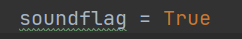

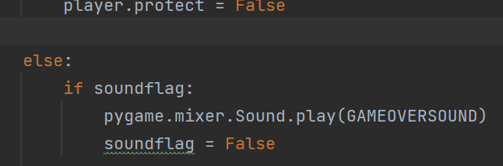

Resetting it on the highlighted line:

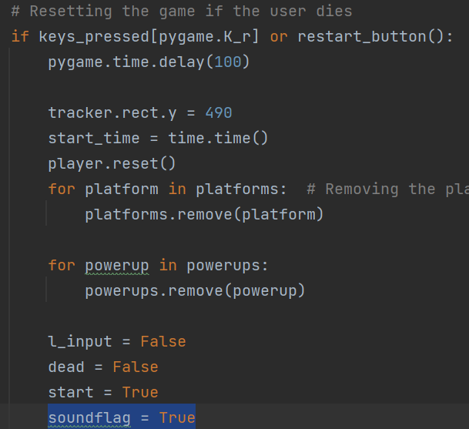

# 3.4 Evaluation

## 3.4.1 Testing to inform evaluation

### Main menu

|  |  |  |  |  |
| --- | --- | --- | --- | --- |
| Number | Requirements | Input | Expected outcome | Requirement met |
| 1 | Game title and button are displayed | - | Game title and buttons are displayed so the user knows which buttons to click | Requirement met |
| 2 | The leaderboard screen is displayed when the button or “L” key is pressed | Valid: “L” key  Valid: Button clicked  Invalid: “T” key | Leaderboard screen is displayed and top 10 scores are displayed in order | Requirement met |
| 3 | Options screen is displayed when the button or “O” key is pressed | Valid: “O” key  Valid: Button clicked  Invalid: “A” key | The options screen is displayed with various options such as turning sound on/off | Requirement met |
| 4 | Game quits when the user presses the button or the “Q” key | Valid: “Q” key  Valid: Button clicked  Invalid: “Z” key | The game window closes and the program stops running | Requirement met |
| 5 | Game state starts when the user presses the button or presses the “P” key | Valid: “P” key  Valid: Button clicked  Invalid: “I” key valid | The game state starts and the players sprite, platforms and the background are visible and the main menu is no longer visible | Requirement met |

### Playing the game

|  |  |  |  |  |
| --- | --- | --- | --- | --- |
| Number | Requirements | Input | Expected outcome | Requirement met |
| 5 | Game state starts when the user presses the button or presses the “P” key | Valid: “P” key  Valid: Button clicked  Invalid: “I” key valid | The game state starts and the players sprite, platforms and the background are visible and the main menu is no longer visible | Requirement met |
| 6 | The jumping sound plays when the user jumps on a platform | Valid: Player collides with a platform  Invalid: player collides with a powerup | The jump sound plays when the user jumps on a platform | Requirement met |
| 8 | The game over sound plays when the user hits the bottom of the screen | Valid: Player collides with the bottom of the screen  Invalid: Player collides with a platform | The game over sound plays when the user hits the bottom of the screen | Requirement met |
| 9 | The shield up sound plays when the user picks up a forcefield powerup | Valid: Player collides with a forcefield sprite  Invalid: Player collides with an apple | The shield up sound plays when the user collects a forcefield powerup | Requirement met |
| 10 | The shield down sounds plays when 10 seconds have passed since collecting the powerup or they hit the bottom while the forcefield is active | Valid: Player collides with the bottom while forcefield is true  Valid: time left for the powerup = 0  Invalid: Time left for the powerup = 5 | The shield down sound plays when the shield time expires or they hit the bottom of the screen while the forcefield is active | Requirement met |
| 11 | The jump boost sound plays when the user picks up a jump boost and then jumps onto a platform | Valid: The player collides with a platform when jumpboost = true  Invalid: Player collides with the forcefield sprite | The jump boost sound plays when the user picks up a jumpboost sound then jumps onto a platform | Requirement met |
| 12 | The apple collect sound plays when the user collects an apple | Valid: The player collides with an apple sprite  Invalid: The player collides with a platform | The apple collect sound plays when the user collides with an apple | Requirement met |
| 13 | Number of apples collected increases | Valid: Player collides with an apple sprite  Invalid: Player collides with a platform | The number of apples increments by 1 when the user collides with an apple | Requirement met |
| 14 | Distance increases | Valid: Player moves up the screen  Invalid: Player moves down the screen | The distance increases as the player gets further up the screen | Requirement met |
| 15 | Time played increases | Valid: Time played increases by 1 every second  Invalid: Time played increases by 7 every second | The time played updates and displays the amount of seconds the user plays for | Requirement met |
| 16 | Player moves left when the “A” key or left arrow key is pressed | Valid: “A” key  Valid: Left arrow key  Invalid: “Q” key | The player moves left when the user presses the “A” key or the left arrow key | Requirement met |
| 17 | Player moves right when the “D” key or the right arrow key is pressed | Valid: “D” key  Valid: Right arrow key  Invalid: “Y” key | The player moves to the right when te user pressed the “D” key or the right arrow key | Requirement met |

### End game

|  |  |  |  |  |
| --- | --- | --- | --- | --- |
| Number | Requirements | Input | Expected outcome | Requirement met |
| 18 | Users score is displayed when the end game state is active | - | The users score is displayed at the top of the screen when the end game state is active after the play state | Requirement met |
| 19 | Users score is added to leaderboard when the “L” key or the button is pressed | Valid: “L” key  Valid: button pressed  Invalid: “H” key | Users score is added to the leaderboard when they press the button or the “L” key | Requirement met |
| 20 | Game restarts when the “R” key or the button is pressed | Valid: “R” key  Valid: button pressed  Invalid: “O” key | Play state is active and end game state is inactive when they press the “R” key or the button | Requirement met |
| 21 | Main menu state is active when the user pressed the “M” key or the button | Valid: “M” key  Valid: button pressed  Invalid: “J” key | The main menu state is active when they press the “M” key or the button and the end game screen is no longer visible | Requirement met |

### Usability features

Here, I will describe each usability feature and ask Harley for a statement on each feature.

Main menu

Game title

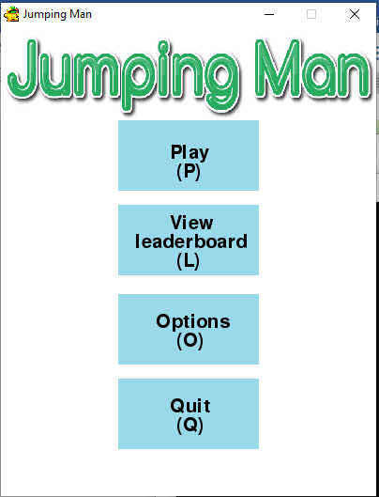

Leaderboard button, which can be pressed and also says the key they can press to use it

Play button, which can be pressed and also says the key they can press to use it

Options button, which can be pressed and also says the key they can press to use it

Quit button, which can be pressed and also says the key they can press to use it

Leaderboard screen

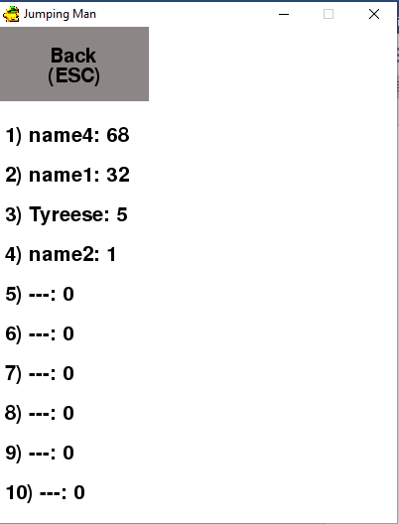

Scores being displayed in order from highest to lowest

Back button for the user to go back to the main menu, which also displays the key they can press to use the button

Options screen

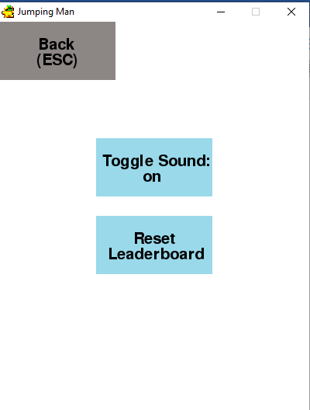

Button to enable or disable the sound

Button to reset the leaderboard

Back button for the user to go back to the main menu, which also displays the key they can press to use the button

Me:

In the interviews, Harley said that having a competitive aspect of the game would improve it as the users can be more competitive, I did this in the form of a leaderboard, which Harley also believed should be able to be viewed by the user so they can compare their scores and see who has the highest score. Harley also said that some settings could be added such as being able to enable and disable sounds and changing difficulty. I added the ability to disable or enable sounds however, I didn’t add a feature to change the difficulty as I couldn’t think of a way to apply it to the game as having too few platforms could cause the player to get stuck and too many platforms could cause the player to jump endlessly.

Harley:

All of the necessary features for a starting menu have been added and each feature is easily accessible through key board buttons. The leaderboard menu has a good layout as it only shows the top scores. However, there could have been more options in the options menu for the user to use such as being able to change controls but this wasn’t necessary because the user could use either “WASD” controls or arrow keys, which are the common ways to control players in most keyboard videogames.

Playing the game

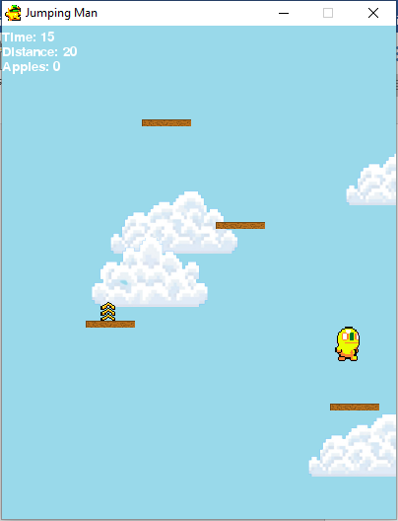

Background, which has moving clouds

Platforms which spawn when a platform goes off screen

Player statistics so they can see how well they are doing

Powerups, which spawn on platforms

Players sprite, which is animated

Pause menu

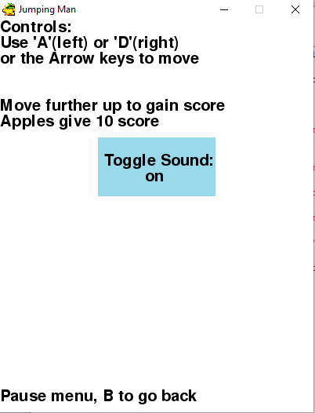

Option to enable/ disable sound

Information for the user so they know the controls to play the game

game

Game is paused when the menu is open

Me:

In the pause menu, I added the controls and basic game mechanics at the top so the user knew how to play the game if they were unsure. As said in the interview, I added a simple jumping animation for the player as this was requested in the interview. Also, I added features such as powerups and coins to make the game easier to progress through. However, I didn’t add any obstacles as I didn’t have much time left and I thought that there would be too many objects on the screen at once as the window is very small and it could make the game too hard to play with obstacles. Furthermore, I allowed the user to move their player using “A” and “D” or the arrow keys, which are the most common movement controls in modern games. I also added sound effects to most actions in the game such as jumping, collecting certain powerups and falling off the screen to make it easier for the user to understand what is happening. The clouds background was added to give the effect that the user was in the sky but I couldn’t make these move down during development as they moved too fast or wouldn’t move at all.

Harley:

Most of the features have been implemented and are good, the main game has a variety of features that most similar games would have. The players animation could have been clearer as it is hard to notice that the player has a jumping animation because only the legs of the sprite move. The sounds are good and represent each action well. For example, it is clear that the player has died with the game over sound because it is a negative sound. The current powerups are good, however, there could have been a wider variety of powerups such as powerups which could negatively affect the player by inverting controls or something similar. The score in the top left also represents how well the player is doing and helps them know their current score, it may have been better to add a total score at the top so the player didn’t have to add each part part of the score together. Finally, the background could have been slightly better as it is just clouds moving across the screen, the colour of the sky could have changed to represent how long the player has been playing for.

End game

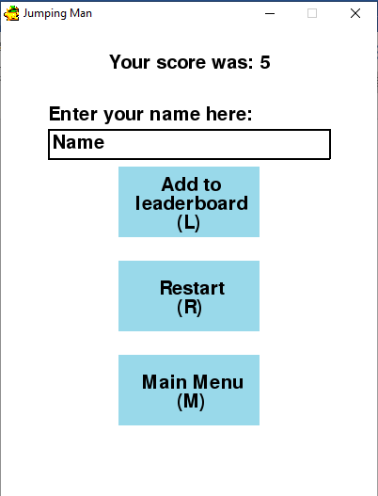

Button to restart the game, which also displays the key they can press to use the button

Button to go back to the main menu, which also displays the key they can press to use the button

Button to add the score to the leaderboard, which also displays the key they can press to use the button

Input box for the user to enter their name so it can be added to the leaderboard

Score is displayed at the top of the screen when the end game screen appears

Me:

In the end game screen, I believed that I added all of the necessary features for an end game screen and all of the features that were mentioned in the success criteria and the interviews. I also added the option to either press the button or press the associated key to make it easier to use.

Harley:

Tyreese has met all of the criteria for the end game screen as the user is able to add their score to the leaderboard, restart the game and go straight back to the main menu. A feature that could’ve been added is displaying if the user has reached the new high score if they have passed the previous high score but this isn’t a major issue as the user can easily access the leaderboard from the end game screen by going back to the main menu.l

## 3.4.2 Success of the solution

### Main menu

|  |  |  |  |
| --- | --- | --- | --- |
| Number | Requirement | Justification | Reference |
| 1 | Create a game window | Needed for the game to work | Game requirement |
| 2 | Menu screen with options to play and quit | Allows the user to interact with the game | Interview 1 |
| 10 | View leader board on menus | Allow the user to view the top 10 scores | Interview 2 |

The requirements in the success criteria have been met as the game window appears when the program is run and there are buttons to press on the main menu, which allow the user to play, open the options menu, open the leaderboard menu and quit the game. These buttons also have keys, which the user the can press to use the button.

### Playing the game

|  |  |  |  |
| --- | --- | --- | --- |
| Number | Requirement | Justification | Reference |
| 3 | Move the player using inputs | Used for the user to move the player | Interview 1 |
| 4 | Platforms spawn for the player to jump on | Needed to gain score and progress | “Doodle Jump” feature |
| 11 | Coins for the player to collect | Gives the player more options to get a higher score | Interview 1 |
| 12 | Player jumping | Needed to play the game | Interview 1 |
| 13 | Moving background | To make the game more visually appealing to the user | Interview 2 |
| 14 | Power ups that allow the player to do extra things such as super jump | Make the game more enjoyable for the user | Interview 2 |
| 9 | Different types of obstacles | Make the game more difficult | “Doodle Jump” Feature |

The requirements here have been fulfilled as the user can move the player using “A” and “D” or the arrow keys. When playing the game, platforms spawn in for the user to jump on. When the user collides with the top of a platform they jump. When a platform spawn in there is a chance of a powerup or apple spawning. Apples act as coins as they give additional score when they are collected. There are also gameplay powerups like jump boost and forcefields.

However, requirement 9 has not been met because I didn’t have enough time to add various obstacles or enemies and I believed that there wouldn’t be enough space on the game window to add obstacles without making it too difficult.

### End game screen

|  |  |  |  |
| --- | --- | --- | --- |
| Number | Requirement | Justification | Reference |
| 5 | End game screen | To display the users score and allow them to add it to a leader board | Interview 2 |
| ­6 | Button to play again on end game screen | Game is more accessible as the user doesn’t have to go back to the main menu to play | Interview 2 |
| 7 | Button to go to main menu on end game screen | If the user wants to quit through the main menu or view options | “Doodle Jump” Feature |
| 8 | Ability to add scores to leader board on end game screen | Allow the user to interact with other players’ score | Interview 1 |

Finally, the requirement here have been met as the end game screen displays when the user hits the bottom of the screen and the menu displays buttons such as: an add to leaderboard button, restart button and a main menu button. When the user presses on the “add to leaderboard” button. A text box appears, which allows the user to enter their name and save it to the leaderboard.

## 3.4.3 Describe the final product

## 3.4.4 Maintenance and development

### Maintenance

I only added one maintenance feature, which was being able to reset the leaderboard. This was because when transferring the leaderboard file between devices, the file where the leaderboard was saved would sometimes get corrupted and stop the game from working. Being able to reset the leaderboard would fix this issue and also allowed the user to reset their leaderboard if they wanted to. This issue would only occur when using the file on different devices.

### Limitations

|  |  |
| --- | --- |
| Requirement | Justification |
| Changing background | Changing the colour of the background would make the game more visually appealing to the player and give them the sense that they have been playing for some time. For example, it might get darker to represent that they have been playing for around 5 minutes, which would represent night time |

To add this, I would create three variables and they will be used in the pygame RGB colour format. As the game goes on for longer, they will tend towards (0, 0, 0), which represents night time then they will tend back toward the original background colour to represent daytime.

|  |  |
| --- | --- |
| Requirement | Justification |
| Menu music | This would improve the experience for the user so they can enjoy the game more and this was also mentioned in the interview |

To add this, I would add menu music to the assets file and it would play when the user is on the end game screen and the main menu screen. It could also play during the main game, however it would be at a lower volume so the user is able to hear the other sounds in the game.

|  |  |
| --- | --- |
| Requirement | Justification |
| Display total score | Displaying the total score would also improve the experience for the user as during the game they have to think about adding the time, distance and apples together to get their score and it would be easier to have their total score displayed |

I would create a variable called total score and this would be made up of distance + time + apples x 10. This would then be displayed at the top of the screen with the current score statistics

|  |  |
| --- | --- |
| Requirement | Justification |
| Display high score | This would improve the users experience as they can get a sense of achievement if they are told that they have reached the high score while playing the game. Also, in the game “Doodle Jump”, other scores are displayed when moving up the screen so the user knows that they have passed them |

I would do this by creating a variable and setting it to the top score in the leaderboard and then comparing it to the user’s current score. When the user’s current score has passed the top score, text will be displayed saying that they have passed the high score.

|  |  |
| --- | --- |
| Requirement | Justification |
| Obstacles | This would make the game more difficult and interesting as the user would have to think more while playing. |

I would add obstacles by creating an obstacles class. Each obstacle will have its own sprite and I would manage them using a pygame sprite group similar to the power ups and clouds. When the user collides with an obstacle, their forcefield will be broken if it is active or the game will end.

|  |  |
| --- | --- |
| Requirement | Justification |
| Improved animation | This would make the game more visually appealing to the user. |

I would do this by creating functions for specific animations and using a similar animation system to the current jumping animation. There could be different animations such as a forcefield breaking.

## Full code:

